2017 Pentille Comedy of Errors




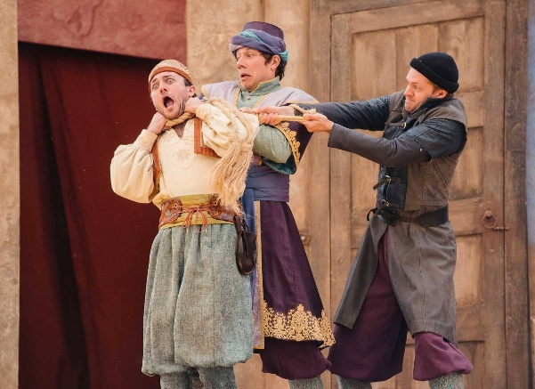
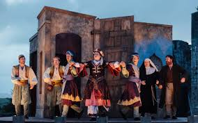
After both being separated from their twins in a shipwreck, Antipholus and his slave Dromio go to Ephesus to find them. The other set of twins lives in Ephesus, and the new arrivals cause a series of incidents of mistaken identity. At the end, the twins find each other and their parents and resolve all of the problems caused earlier.

