2025 St Andrews WI Carol service

Item taken from Devon WI newsletter
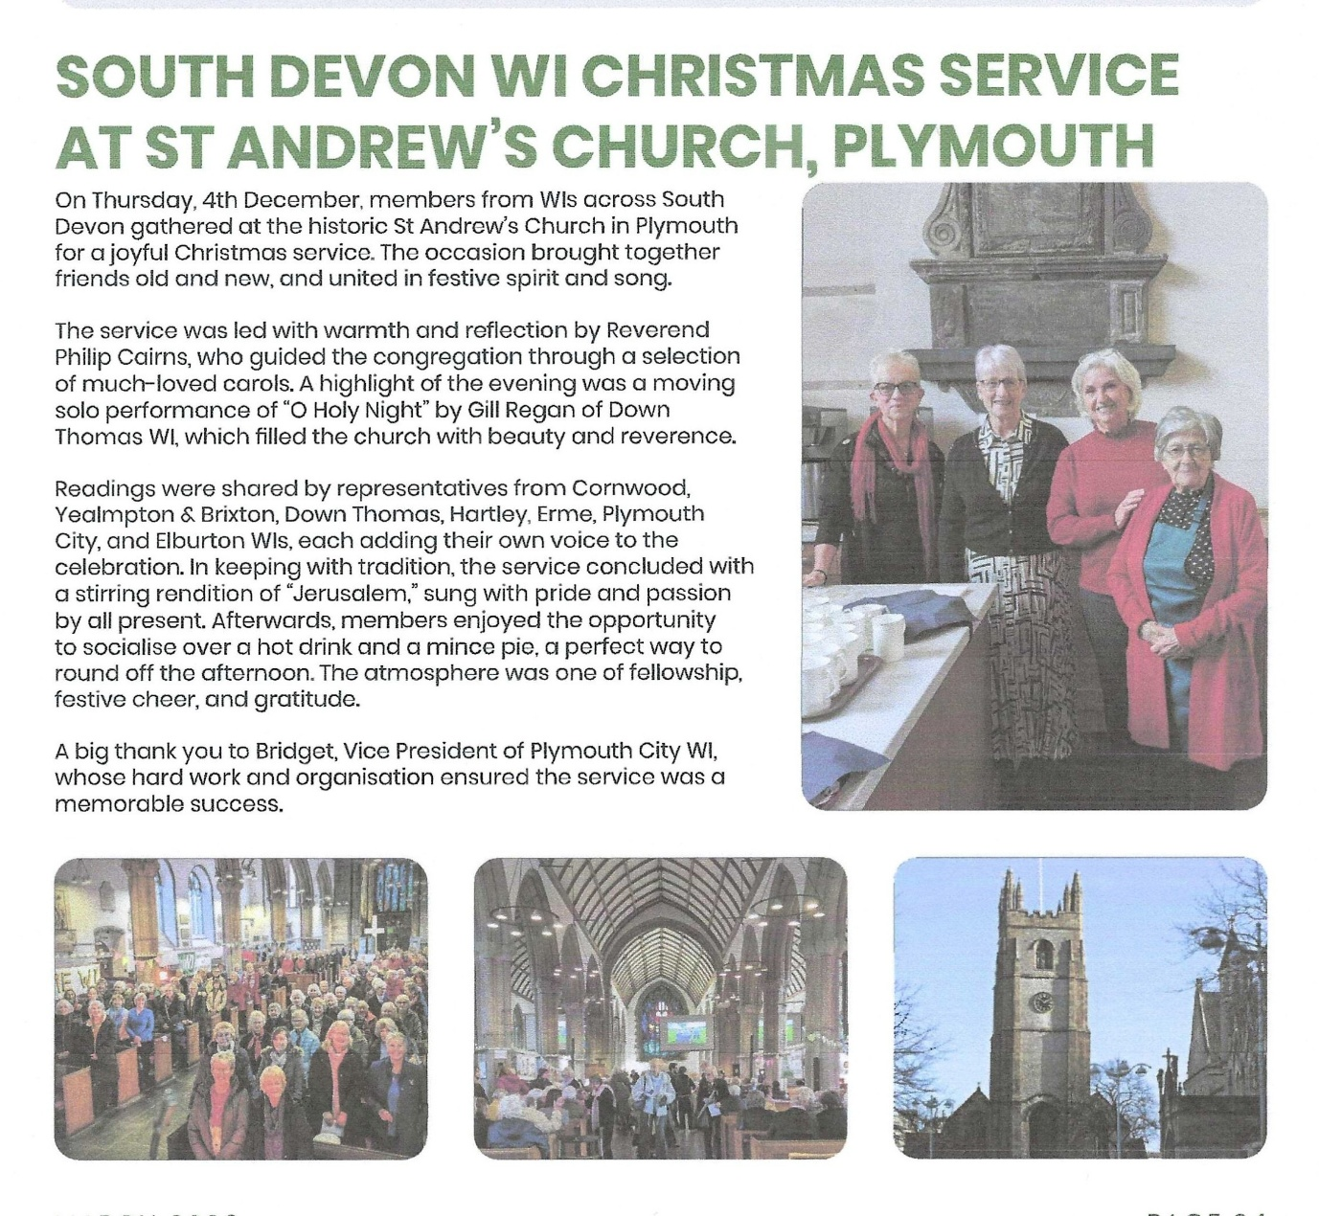
Our members enjoyed a lunch at the Treasury before the service

