2011 6th April Visit to Langage Farm

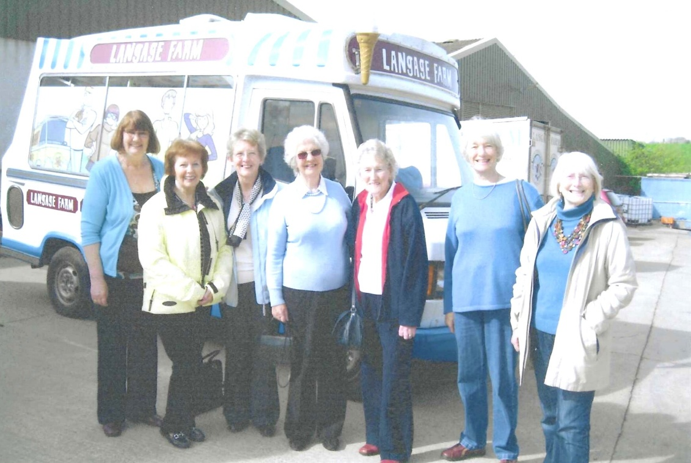
Language of Langage
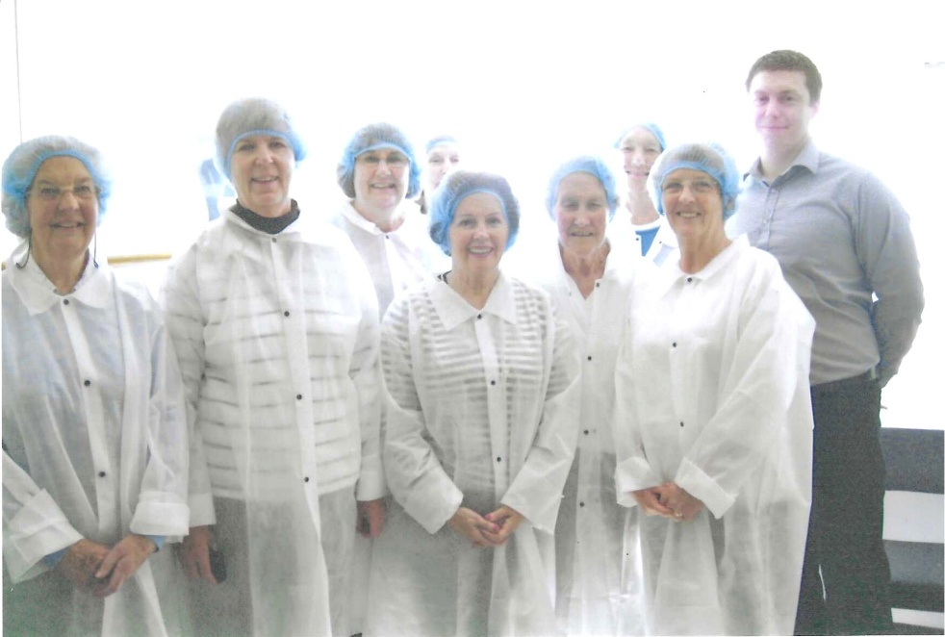
Here at our family farm nestled in the heart of beautiful Devon, we speak the ‘language of love’! Love for our long family heritage and our own beautiful Jersey and Guernsey herd of cows. Love for our carbon neutral dairy farm, with it’s eco-friendly initiatives. Love for our fabulous team that makes our multi-award winning, delicious products and love for our customers from small cafes and farm shops to nationwide supermarkets and even international customers who all speak the language of Langage. We absolutely love what we do and the products we create. Welcome to the home of artisan, multi award winning creams, milks & ice creams from the heart of Devon.

