2016 12th January – 95th Anniversary Lunch
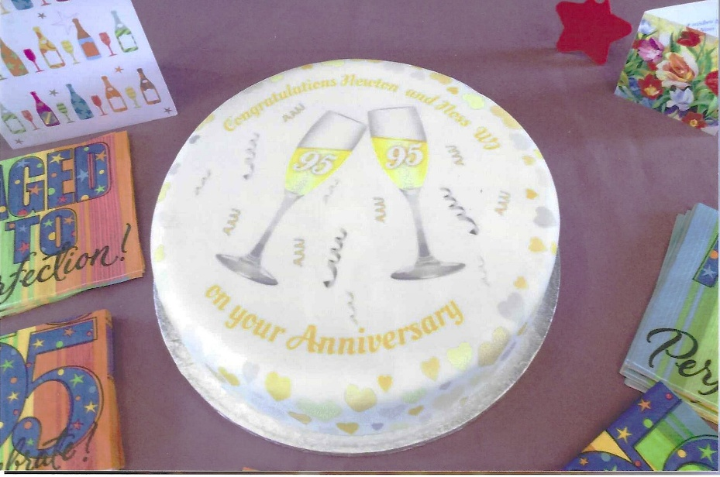

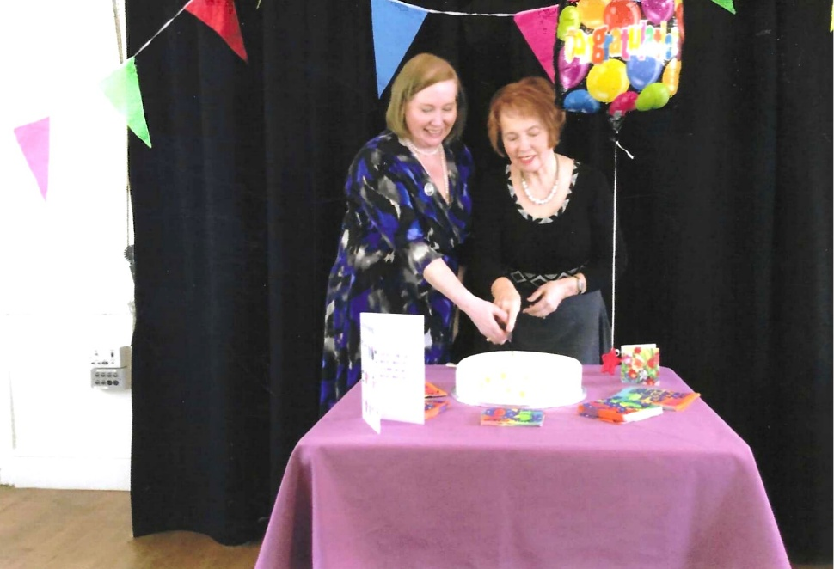

? & |Emma Parker

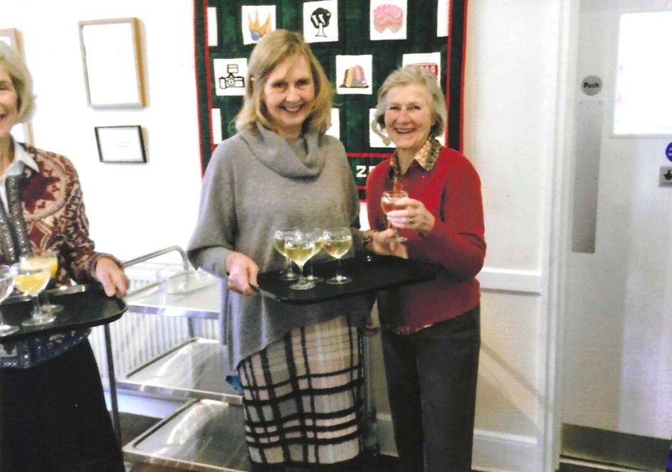

Margaret Pritchard;
Vikki Ingram &
Yvette Steward

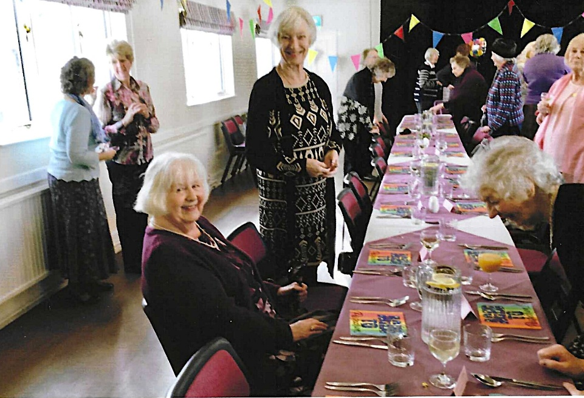
L-R: Sylvia Hunt;
Nikki McDougal (standing)

Joan Miller on R

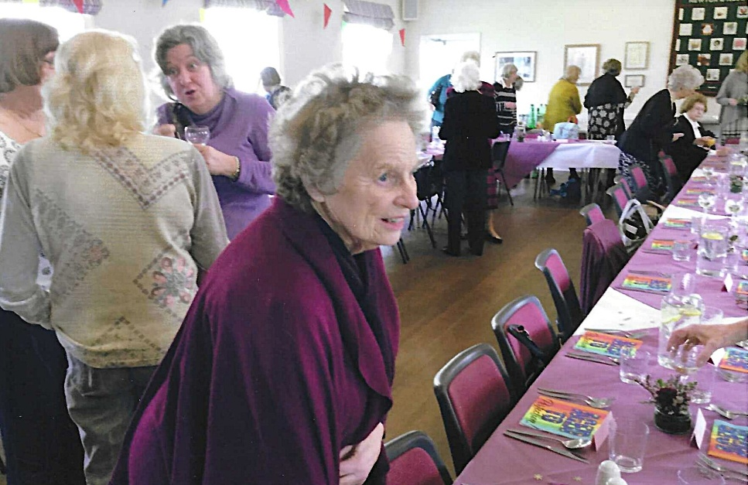

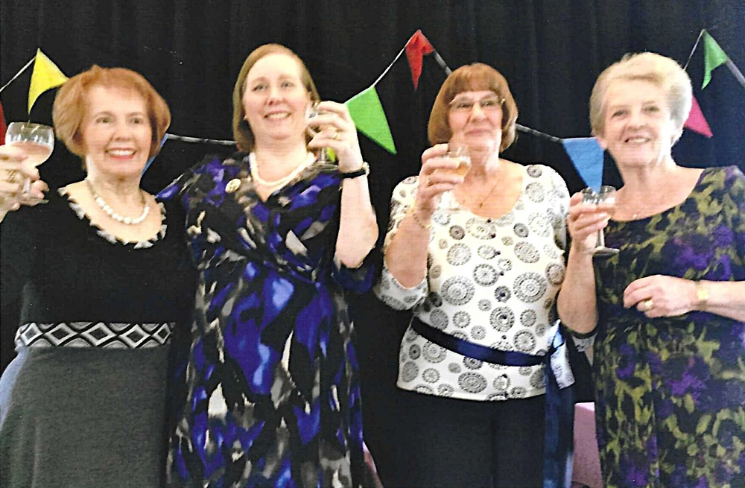

L-R: Emma Parker; ?; Jean Ellis; Janet Cattanach

