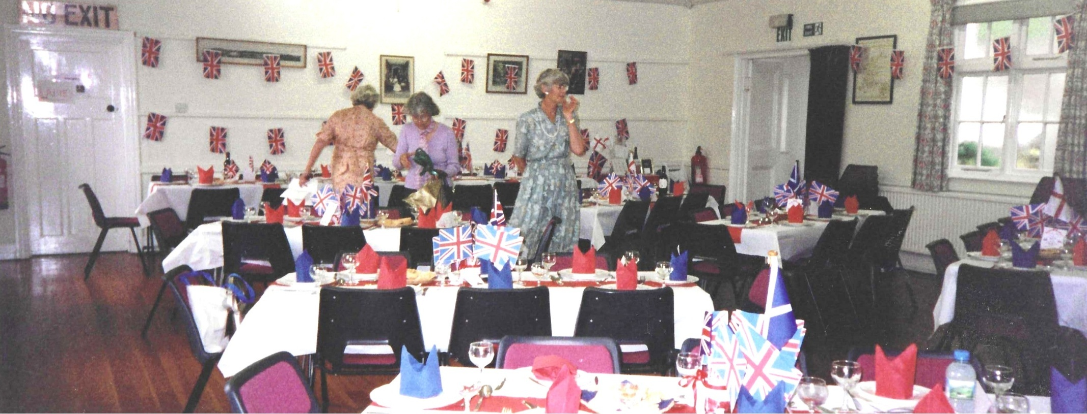
2012 Queens Jubilee Party

Setting up

The Choir

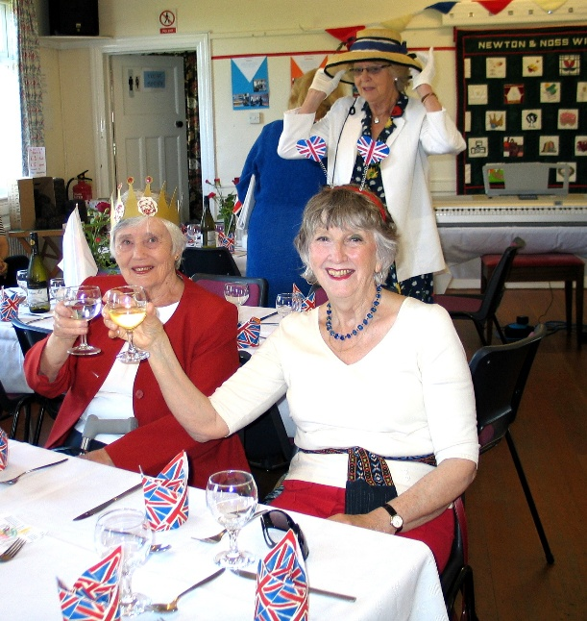
Emma Parker & Anne Crawford

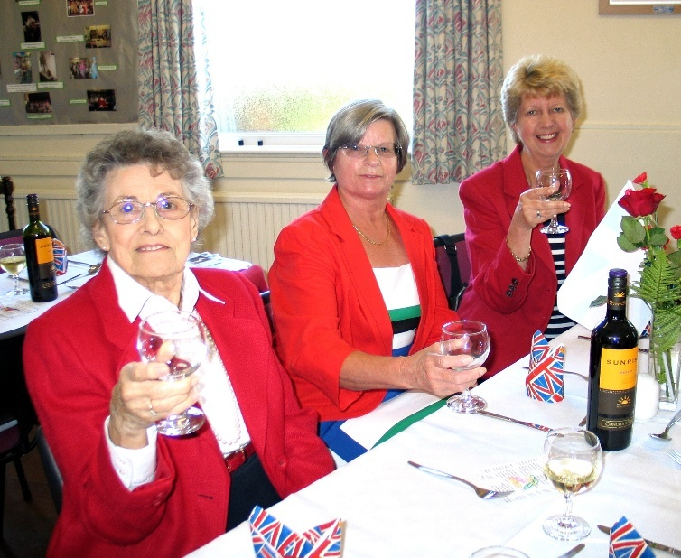
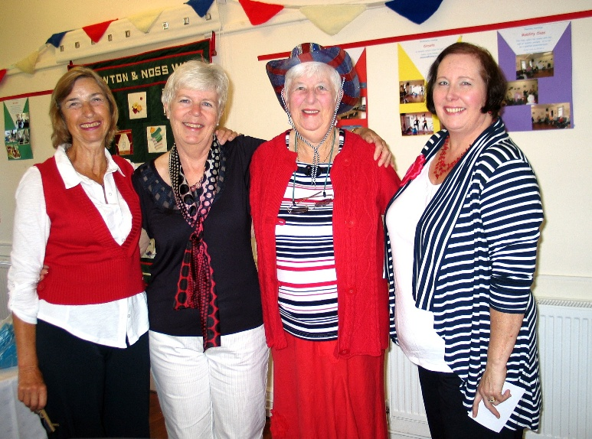

Jill Alexander;
Liz James
Elizabeth Stone

Brenda Merritt; ? Jill Johnson; Carrie Dixon
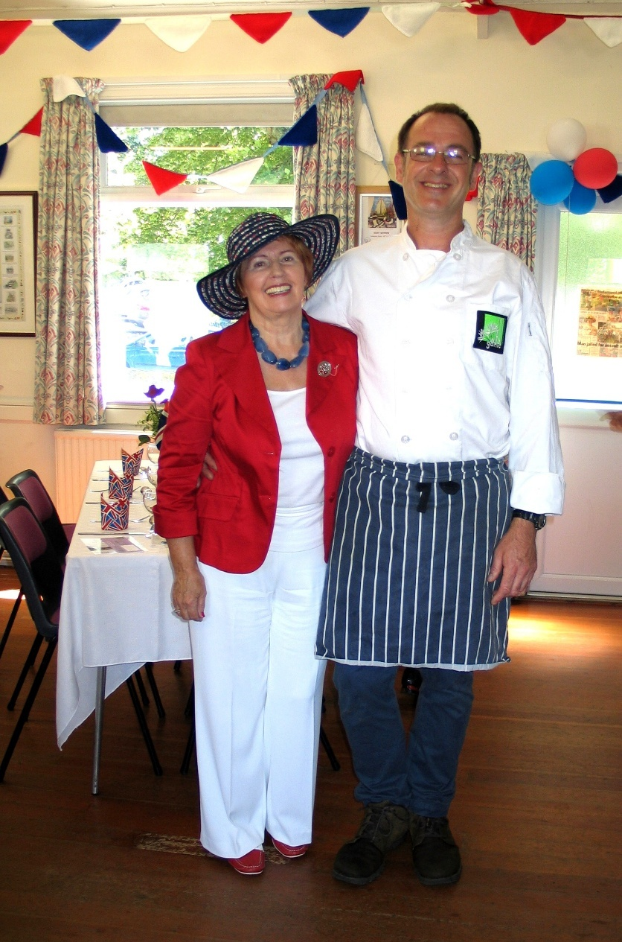
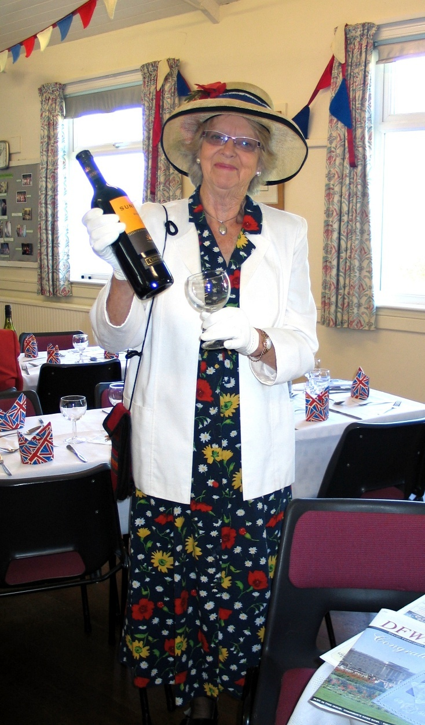
Emma Parker with Tom
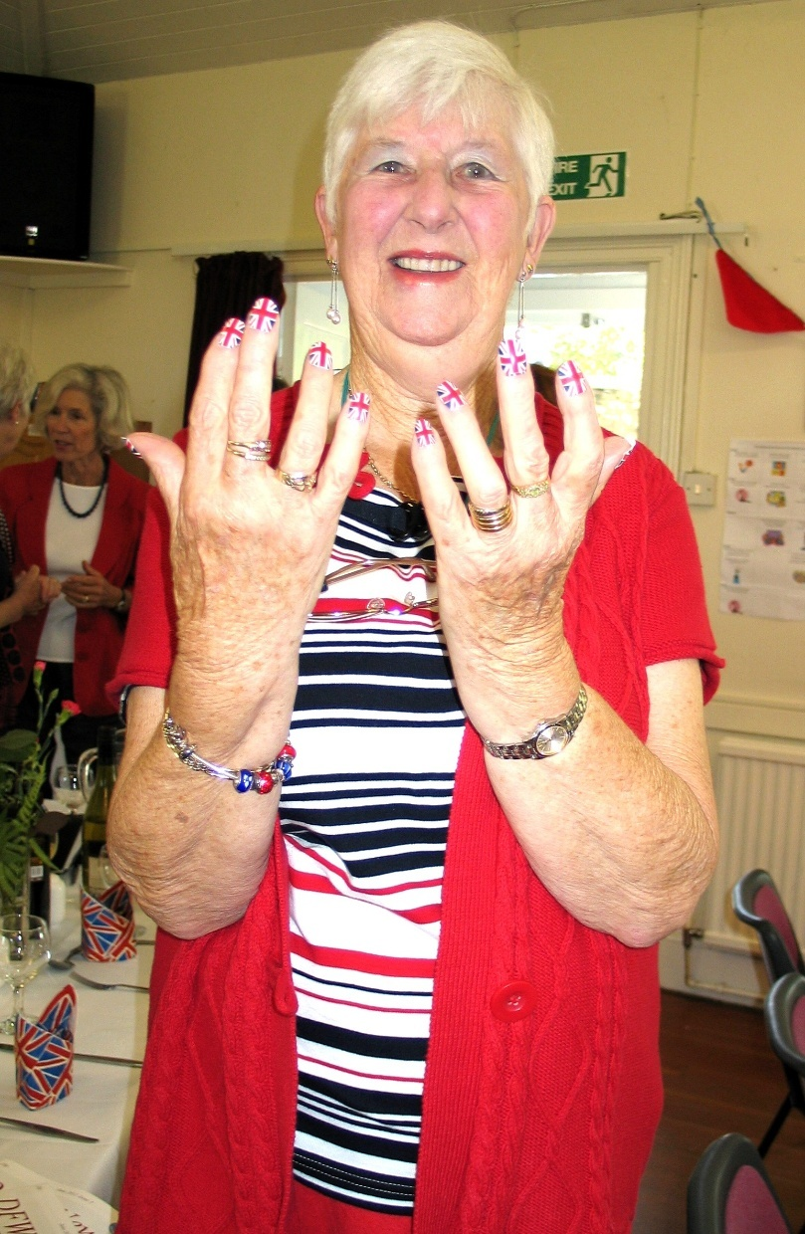
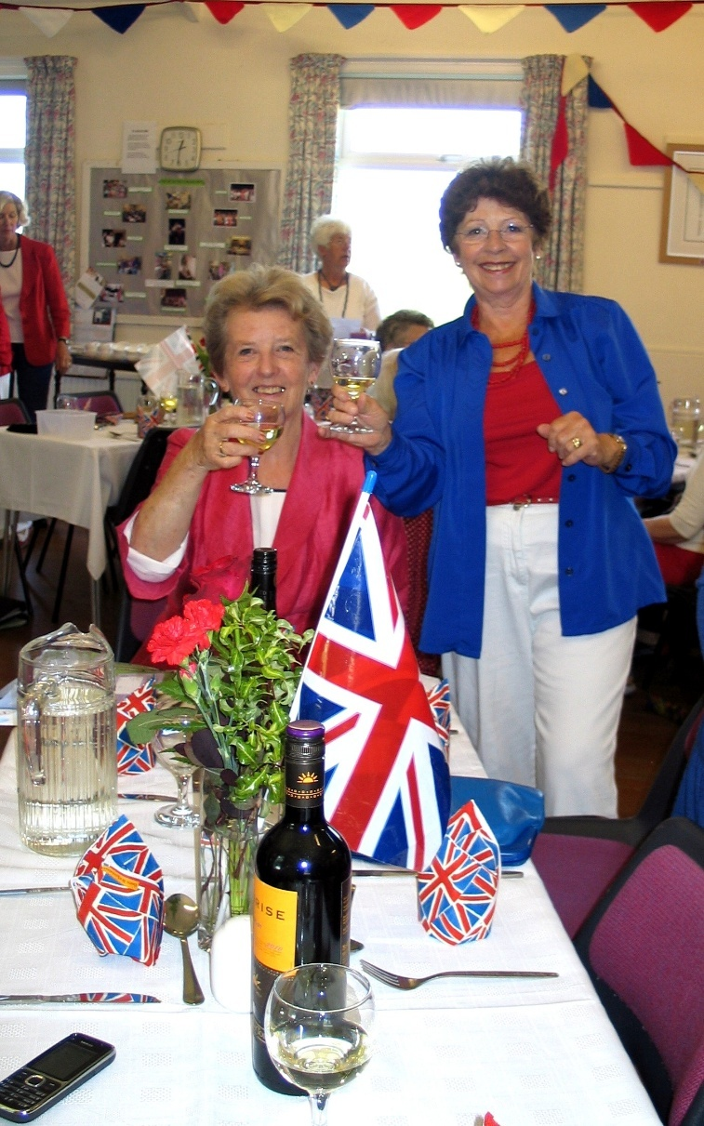

Janet Cattanach & Pam Carter Jill Johnson
Rosemary Furzeland; Pat Middleton & Cathy Matthews Jill Alexander; Liz James
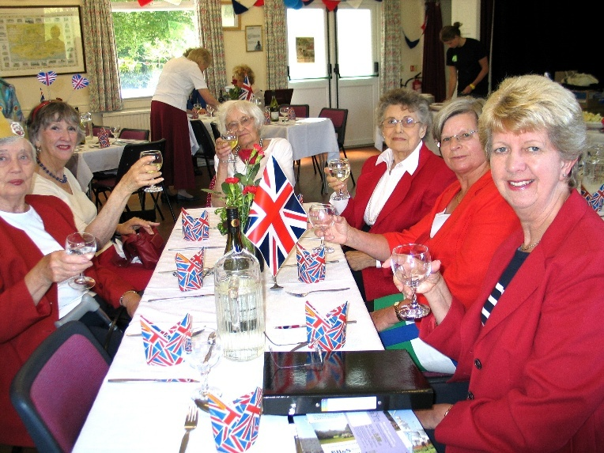
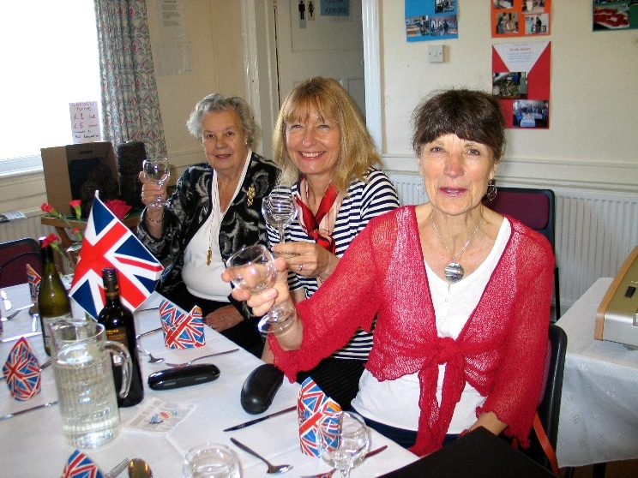

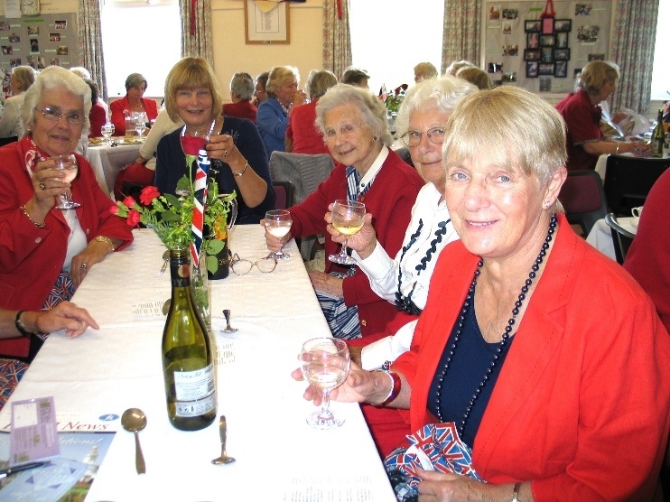
Below L-R ? Carol Williams Below: Janet Cattanach and Emma Parker
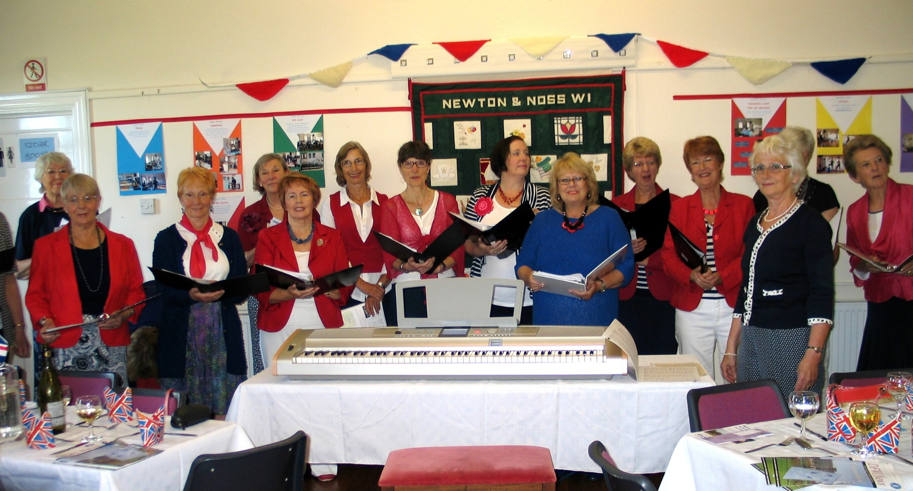
L-R

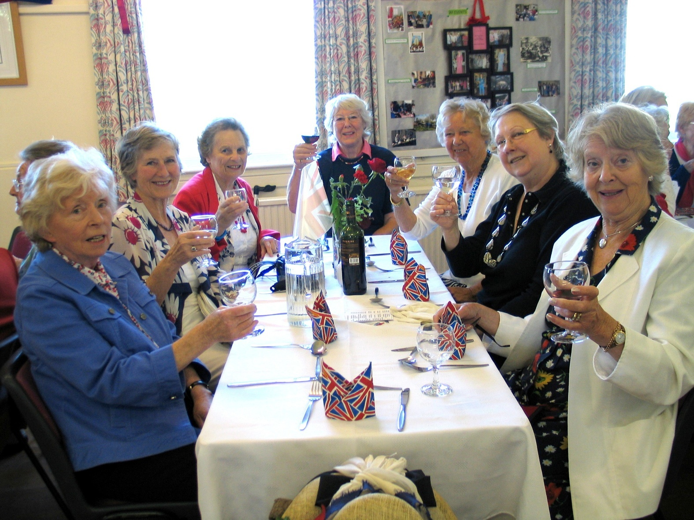

L-R: Wendy Plough; Yvette Steward; ?;?; Judy Thorne; Ann Stirrup in white jacket

Tom Serving lunch R-L Pat Middleton,? Shirley Pegg; Shiela Bensted-Smith; Hilda Julien

L-R Emma Parker; Margaret Pritchard; Hilda Julien; ? Jean Ellis
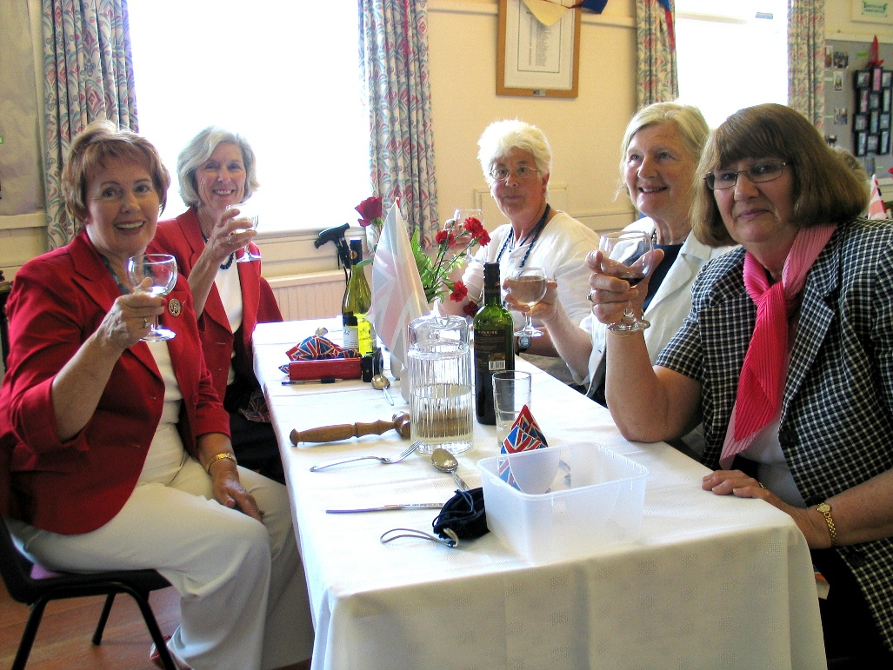

Margaret? & Felicity?

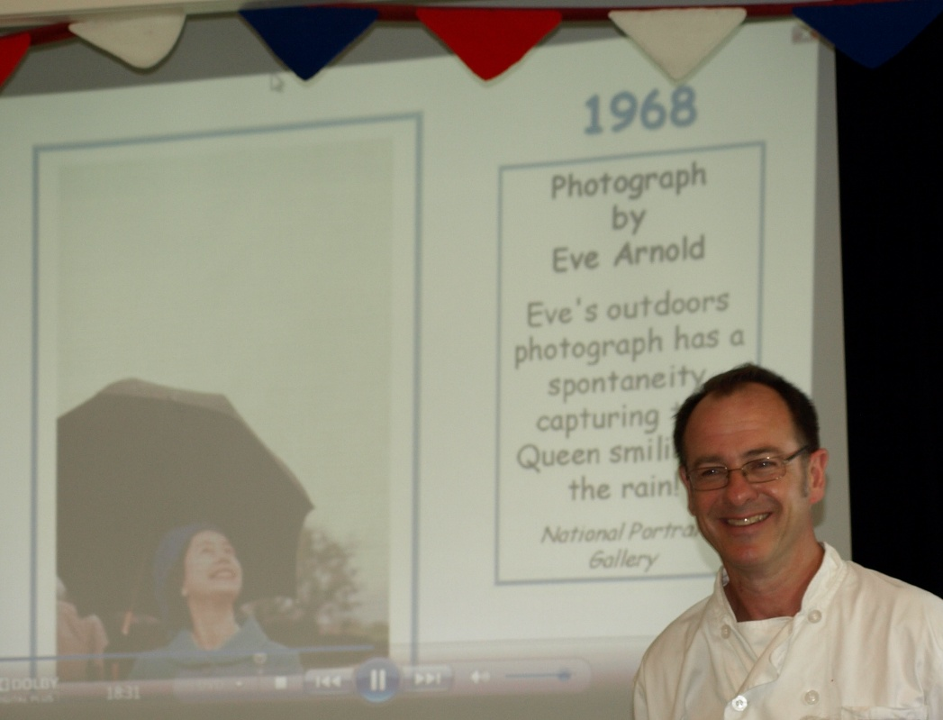
Tom & Slide show

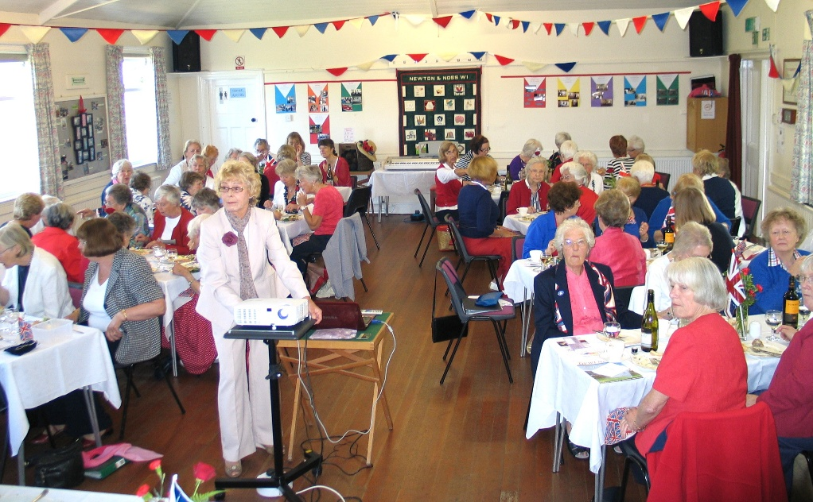

Rosemary Furzeland & Janet Cattanach Janet Cattanach and photo by Sue Brown
