2002 Pencarrow Trip

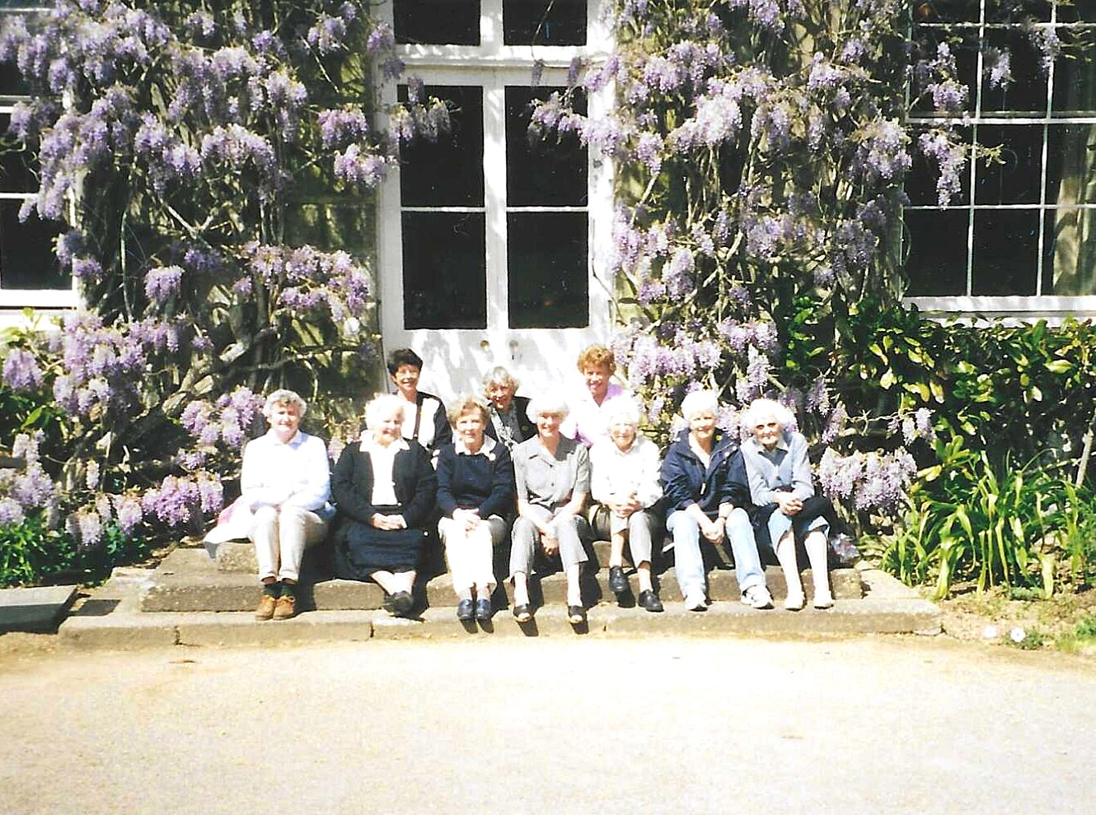
Front row from Left:- Rosemary Watts; Wendy Kennedy; ? Nikki McDougal; ?; ?; Catherine Bateman.
Back row from Left:- Pam Carter; ?; Christine Wilson

