2010 Yealmpton Show – First Place

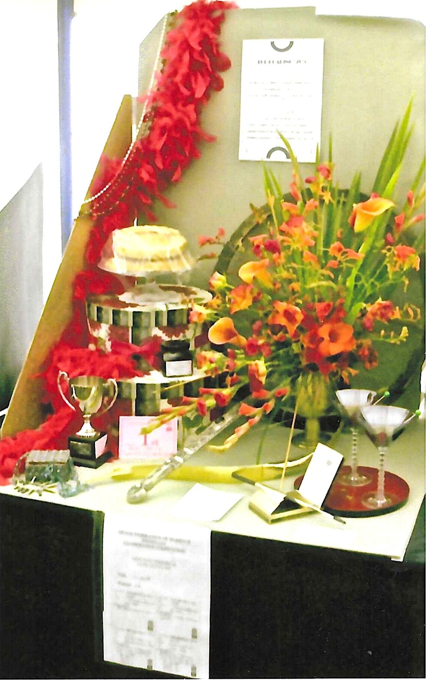

Show Judge with Carol Williams
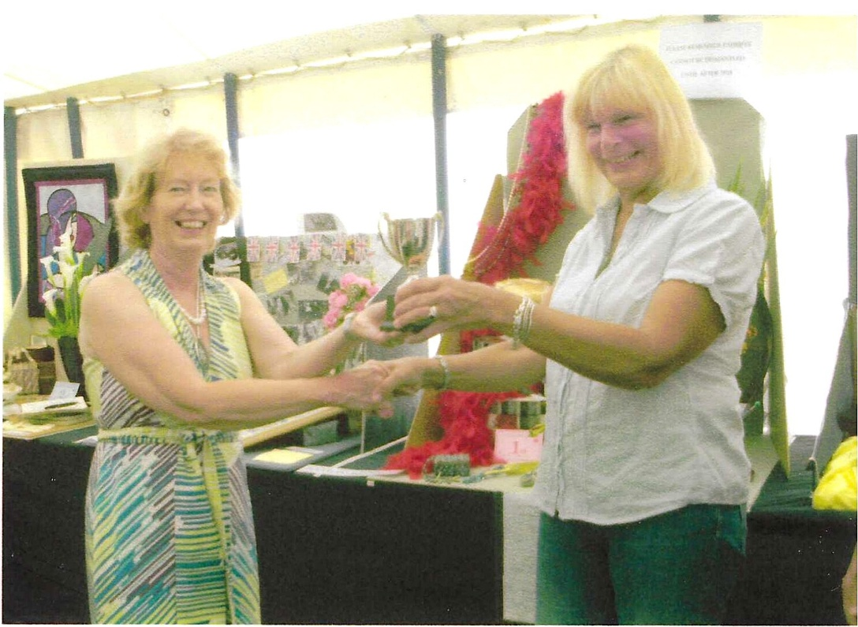

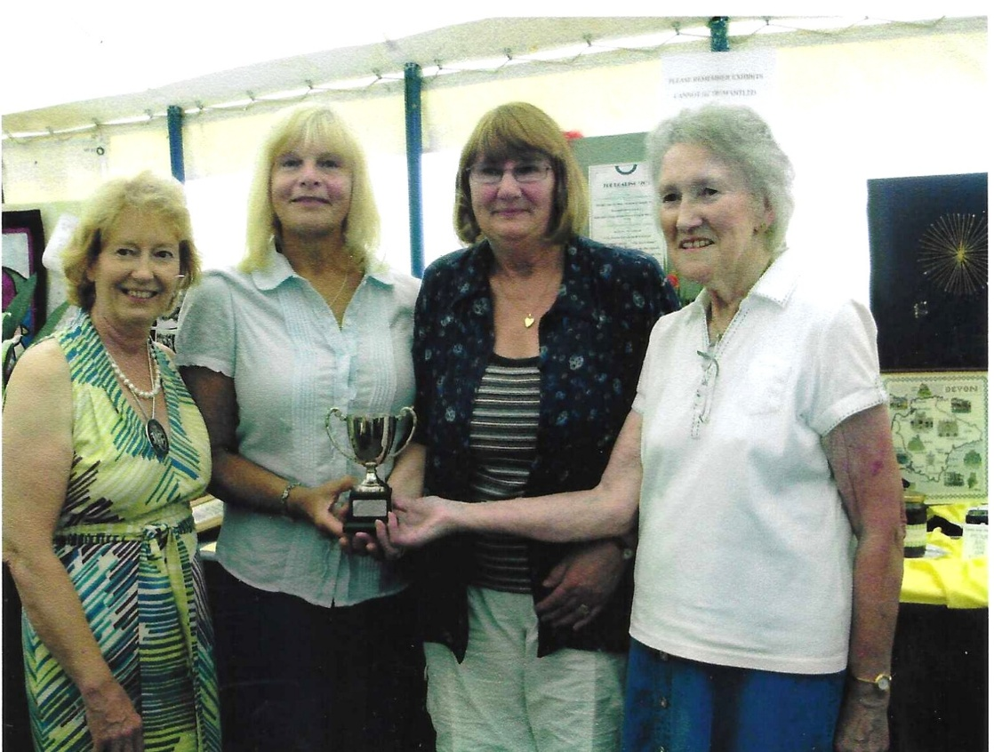

Show Judge with Carol Williams; Jean Ellis & Betty Christie

