The Pantaloons present: The (Almost) Complete History of Britain
3 Sep 2026 7pm
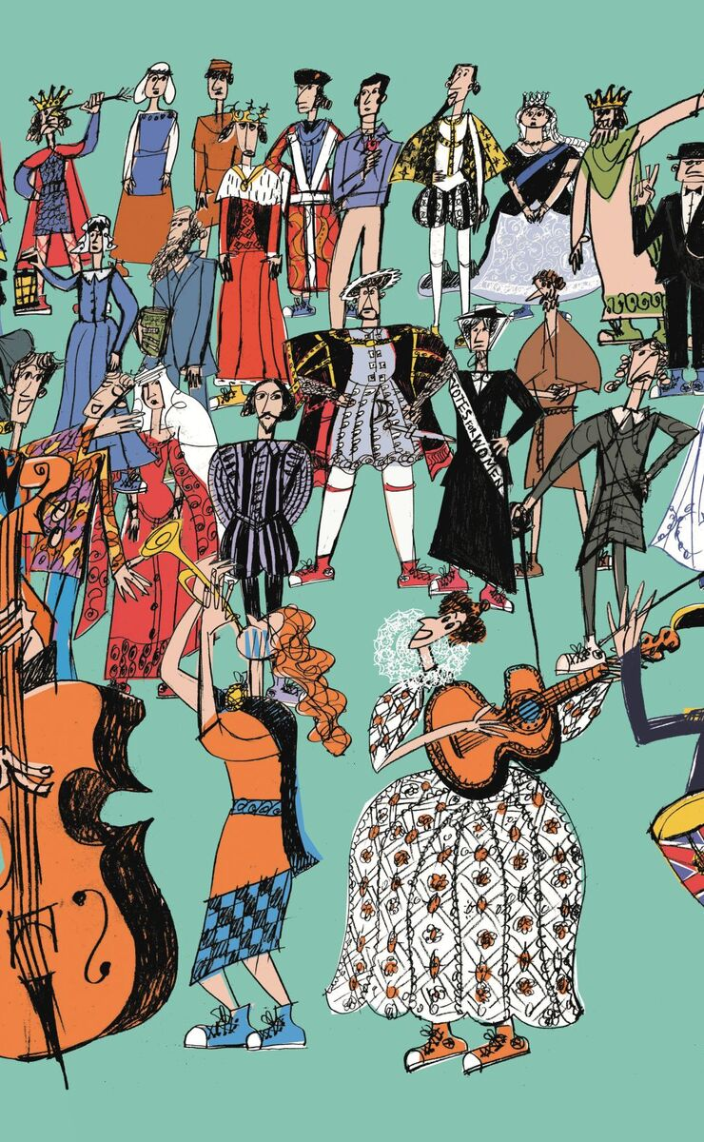
The Pantaloons came to Ivybridge again, and a few of us attended. We didn’t all sit together, due to booking tickets at different times.
In the 2nd row were Gill Tune, Shirley Pegg, Yvette Stewart, Myself, (Lesley Dempsey) and Barbara Geddes.
Further back were Cathy Matthews and Pat Middleton with their husbands, and Helen Dias-Williams with a friend.
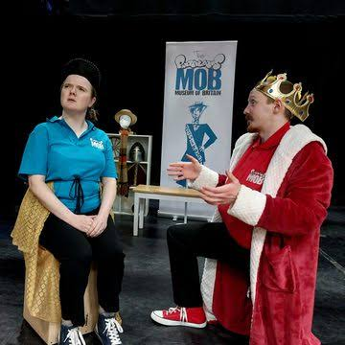
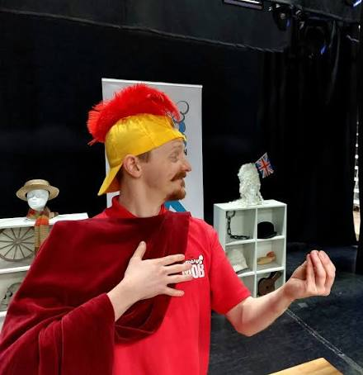
Mud, blood and stiff upper-lips! The critically-acclaimed Pantaloons Theatre Company took us on a breathless race through the centuries in this delightfully inventive show that tells the entire story of Britain in under 2 hours. Fram the cave man, the Vikings & the Romans to The life of Henry VIII told as a romantic comedy & the tale of the Spanish Armada reimagined as a light operetta. But The Pantaloons retold great moments from the country's past in a variety of surprising genres! Even local history was features. The "Ivybridge Bible uprisings" referred to the town's connection to the Prayer Book Rebellion of 1549 (also known as the Western Rebellion).
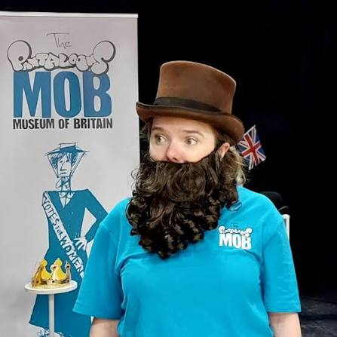
While the broader rebellion was sparked in the Devon village of Sampford Courtenay, Ivybridge played a prominent role in the uprising due to a local resident and land owner named John Bury. The rebellion was a fierce, popular revolt across Devon and Cornwall against the English Reformation. The primary trigger was the Act of Uniformity 1549, which made the introduction of Archbishop Thomas Cranmer’s new English Book of Common Prayer compulsory, effectively outlawing the traditional Latin Mass. (Now I didn’t know that!)
As ever, the Pantaloons featured live music, audience interaction and wild historical inaccuracy.

