Newton Ferrers and Noss Mayo WI

Newsletter

January 29th 2023

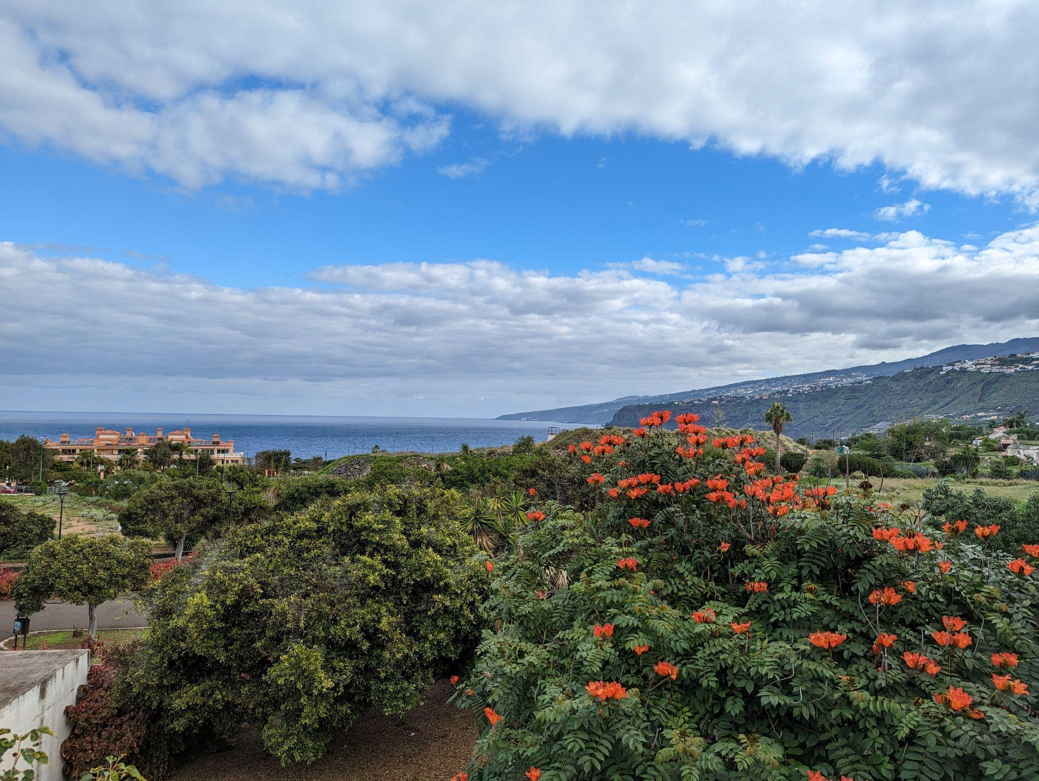
Hello everyone
We've just returned from holiday. The photo was taken on our last day in Tenerife.Two weeks of clear blue skies and warm sunshine. (It wasn’t all beer and skittles though - think of really early flights, airport security, long queues, airline food, bag retrieval, delays...it needs mentioning).

Anyway, I digress... Having arrived, we spent the holiday mainly ambling amongst the hilly evergreen woods and multicoloured lava fields of the island. I say ambling rather than rambling as I'm usually a good few yards behind him these days, our minds in neutral or at best checking the footpaths for trip hazards. Anyway, after a prolonged Sound of Silence, perhaps drinking in the scenery or more likely, thinking about the lack of benches and pubic loos, we resorted to a turn-taking list game. It can also be played individually - you’re welcome to have a go. I recommend it for long drives or walks when a bit of distraction from the long and winding road is necessary or for tedious tasks like cleaning the bathroom - my least favourite job. It's been an unparalleled success this time...British Prime Ministers, Beatles songs, Shakespeare plays, Gilbert and Sullivan, and towns beginning with C (that was a good one - there are hundreds of them!) We've come back well walked but still missing many PMs, at least 150 Beatles songs, Henry V1, HMS Pinafore, Camelford and Chagford, and many others too but oh well...who cares?! It's been mind games of the best kind on the road less travelled.

Now on to other items…
Our last meeting on 10th January was held on a cold, dark, wet and windy night with ‘flu and Covid re-circulating and understandably attendance was well down. Best to avoid attending our meetings if you feel unwell. Our speaker was Peter Edwards who gave us a fabulous talk about Turin and the making of the 1969 version of The Italian Job with Michael Caine. We were in a mix of awe, wonder and laughter at the antics the film crew got up to both on and off-screen and Peter brought it all to life in his humorous style. Our next meeting is on February 7th when we will be choosing one of the NFWI’s annual resolutions:

1. Save our water – every drop matters
2. Women to women – turning over a new leaf in the lives of women tea workers
3. Online gambling harm: time for action
4. Clean rivers for people and wildlife
The resolution with the most votes will be passed to DFWI and then on to NFWI to be voted on at the AGM in Cardiff to become the WI campaign for 2023-4. Anyone who cannot get to our next meeting and wants to vote can do so by emailing or phoning me their vote at pfmiddleton@gmail.com or tel: 872925 and I’ll add it to the others. (Please ignore the item in this month’s Devon WI News on P4 about cut-off dates for the submission of members’ votes). Further information can be found on MYWI website at https://mywi.thewi.org.uk

Our fabulous website thewi.online is to be launched with coffee and biscuits this coming Thursday 2nd February from 10.30am - 12.30pm in the WIC hall. Please bring your favourite device with you for logging on to the internet - laptop, tablet or mobile phone. Lesley Dempsey is now kindly managing our website and she will go through how to log on to it, how to access each page of activities and interests, and how to create a shortcut for speedy use. It will soon be the hub for all we do in our WI while providing a record of meetings and events and future plans. It’s really very easy to use so do come, try it out and see for yourselves!

Fundraising: An Easter Fair and tabletop sale are planned for the WIC hall on Easter Saturday 8th April from 10am - 1pm with stalls including cakes, biscuits and savouries, recycled gifts such as children’s toys and books, books for adults, a craft table, a raffle, a children’s Easter bonnet competition and refreshments. A board will be circulated at the next two meetings for members to pledge offers of cakes or savouries or help and the school will be asked to encourage children to enter the Easter bonnet competition (with prizes for all entries!) Cathy and others are busy knitting Easter gonks and egg cosies. We need spare egg cups for the cosies! If you have some spare egg cups please bring them with you to our next two meetings or pass them on to another member who’s coming. Many thanks!

DFWI: This year’s Spring Council meeting on Wednesday 26th April is at the Riviera Centre, Torquay when Baroness Floella Benjamin DBE will be the guest speaker. Tickets are £19.50, and a hot lunch is £17.50. The closing date for applications is Friday 31st March. I sent an application form to all members by email. Please let Cathy or me know if you are interested and book through our WI.

The Molly Nosworthy competition in 2023 is a decorated cake, no larger than 8” (20cm). One entry per WI. The cake can be brought to the Riviera Centre Torquay by 10 am on the day of the meeting. Judging will take place that morning and the winner will be announced that afternoon. Entry: £3.00. Closing date: 28th March 2023

Radio Devon Cup Writing Competition. A short entry of 26 words. Each word begins with the next letter of the alphabet. eg A Boy Came. For details see me or the noticeboard. Closing date 24th February.

A themed lunch with Pashy Pops - Covering music from the 1940s to now in every genre, Monday 30th January at Rattery Village Hall. Four of our members are going.

St George’s Day Trophy Competition 2023. Winter photographs no larger than A4 taken between 1st November and 1st February. Not necessarily this year’s work but must be the owner’s own work in colour, B&W, or sepia. Cost £5. Closing date 24th February. For details see me or the noticeboard.

A current list of DFWI visits and events is available on the back cover of the monthly Devon WI News, and available on the noticeboard at each meeting. Devon WI News is emailed each month to all members as well as available in hard copy at our meetings. DFWI events etc can also be reached at https://www.devonwi.org.uk and NFWI at https://mywi.thewi.org.uk

The NFWI Annual Meeting will take place in St David’s Hall in Cardiff on 25th May 2023 10am - 4.30pm. This will be with both virtual and in-person attendance. In-person tickets are £22 and online observer tickets are £5 and are now available. Please let Cathy or me know if you would like to go or to observe online - it may be possible to have a group of us observe online during the day.

Our forthcoming events:

Our next meeting is on February 7th when our speaker has yet to be confirmed. Other than the Easter fair - we have more plans for the Spring and Summer though dates have yet to be announced. We are thinking of arranging a trip to The Box - Plymouth’s new interactive museum on North Hill. It has an excellent restaurant for light lunches, morning coffee or afternoon tea.

We would also like to take up Margaret Griggs’s offer of her guided tour of the gardens at Dartington with a cream tea to follow. Both trips would have car shares and are likely to be popular.

Pentillie Castle is the setting for Romeo and Juliet this summer with the Lord Chamberlain’s men. More about this soon.

Groups:
Book Group
Our next meeting (for Book Group members only ) will be held on Thursday March 23rd 2023 in the WI Hall at 2.45 for a 3 pm start. We will be discussing A Man Called Ove. Please see our website for the reading list and reviews.

Choir
Choir meets each Wednesday at 2 pm for a 2.15 pm start in the WIC hall. We sing a variety of modern and traditional songs led by Joyce on the piano. Apart from being a very uplifting and enjoyable hour or so, it’s good for the brain and lovely to sing in two or three-part harmony. New members who enjoy singing are always welcome.

Craft group: 14/02/2023 - Bring your own project & chat
28/02/2023 - Sunrise Thread Art with Lesley

That’s all for now so keep warm, ‘Flu and Covid-free and I look forward to seeing you soon. If you have anything you would like to add to the Newsletter please send it to me for inclusion.
Bye for now, Pat

