2007 The Amazing Tale of Cinderella
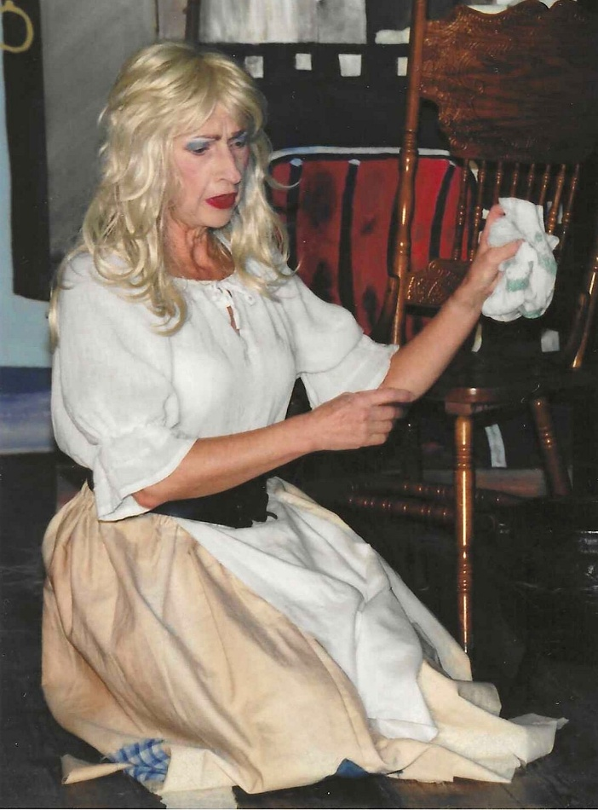

Brenda Merritt

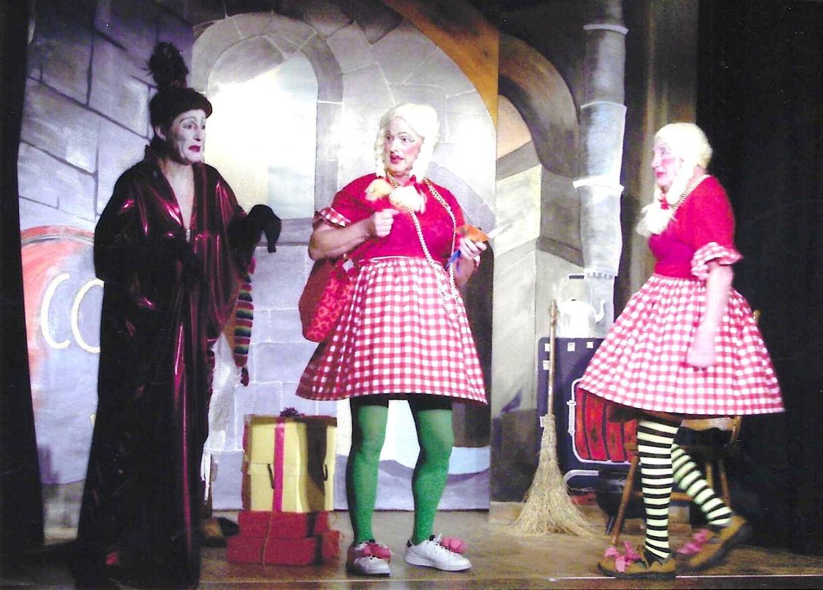

2 Hilary Walker, Rod Carter, Mike Steward

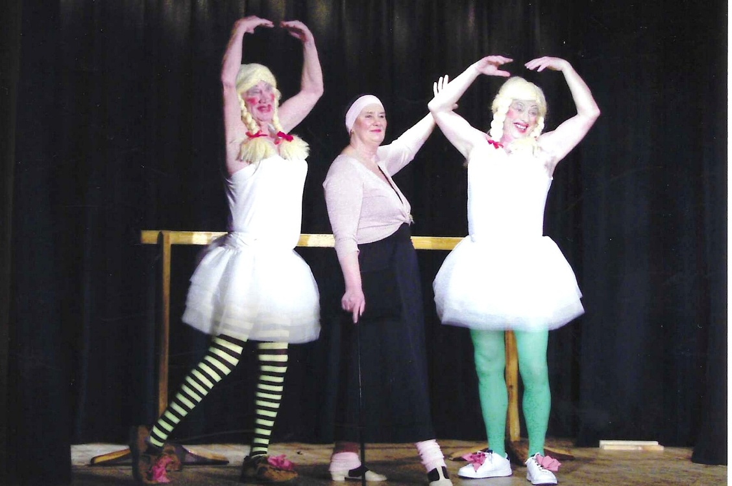

3

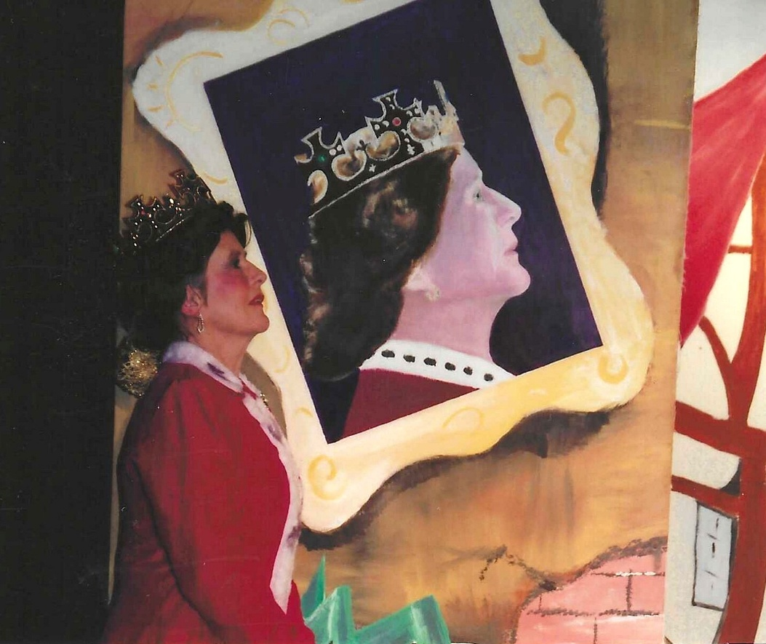

Janet Cattanach

5
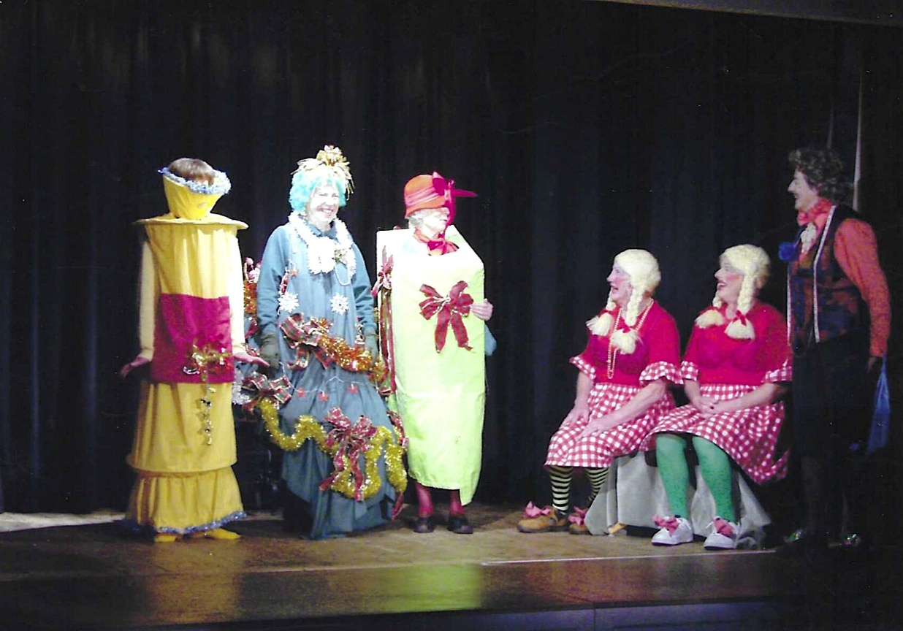

6
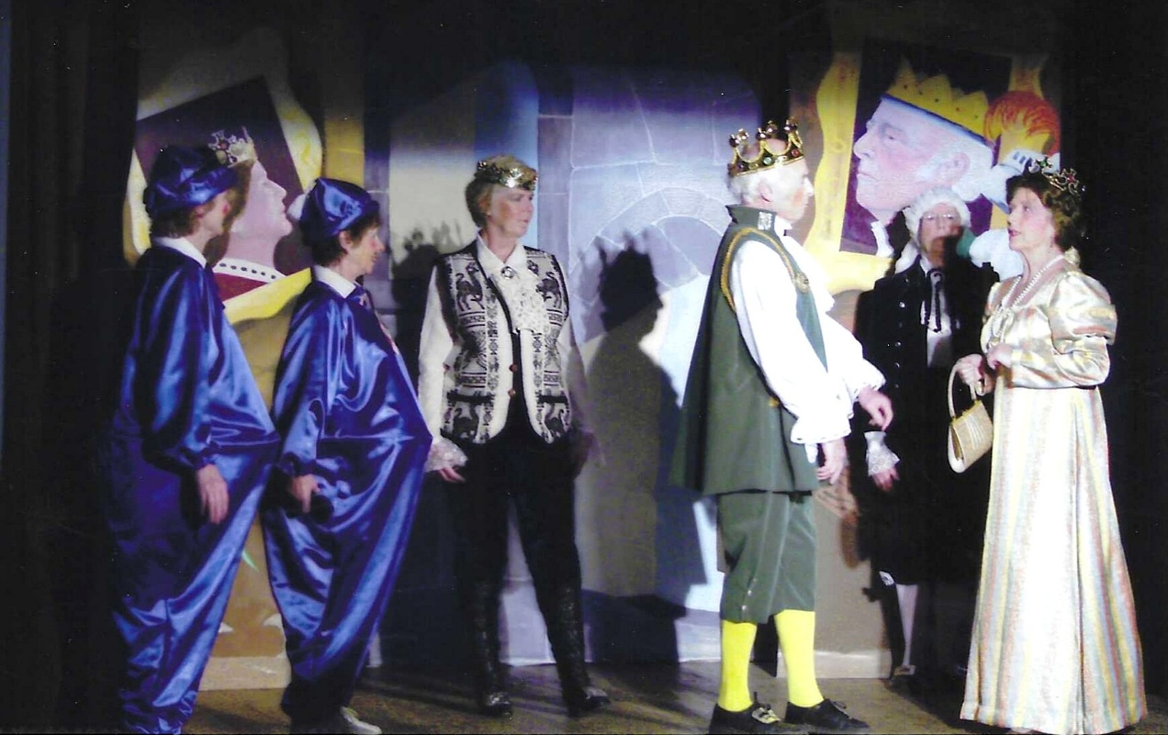
Yvette Steward, Pam Carter, Kate Lawley, Ron Carr, Janet Cattanach
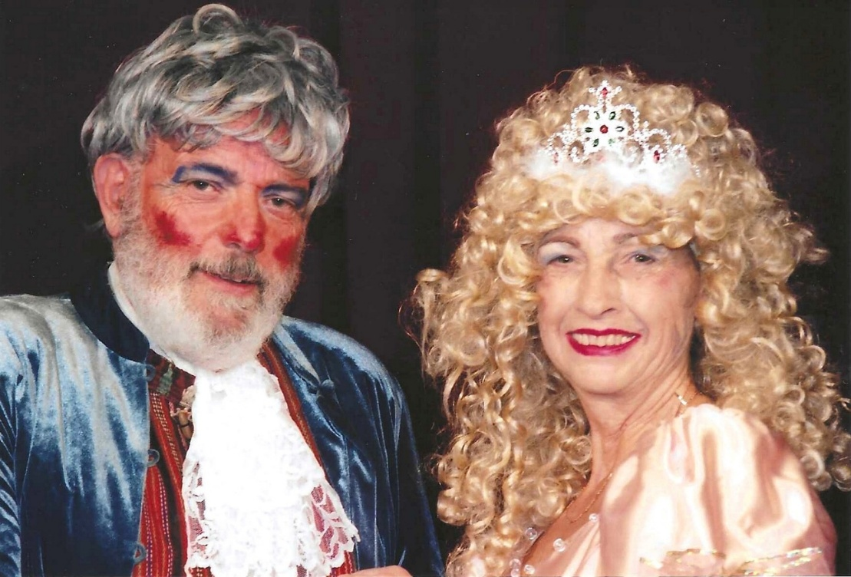

Brenda Merritt and John Alexander
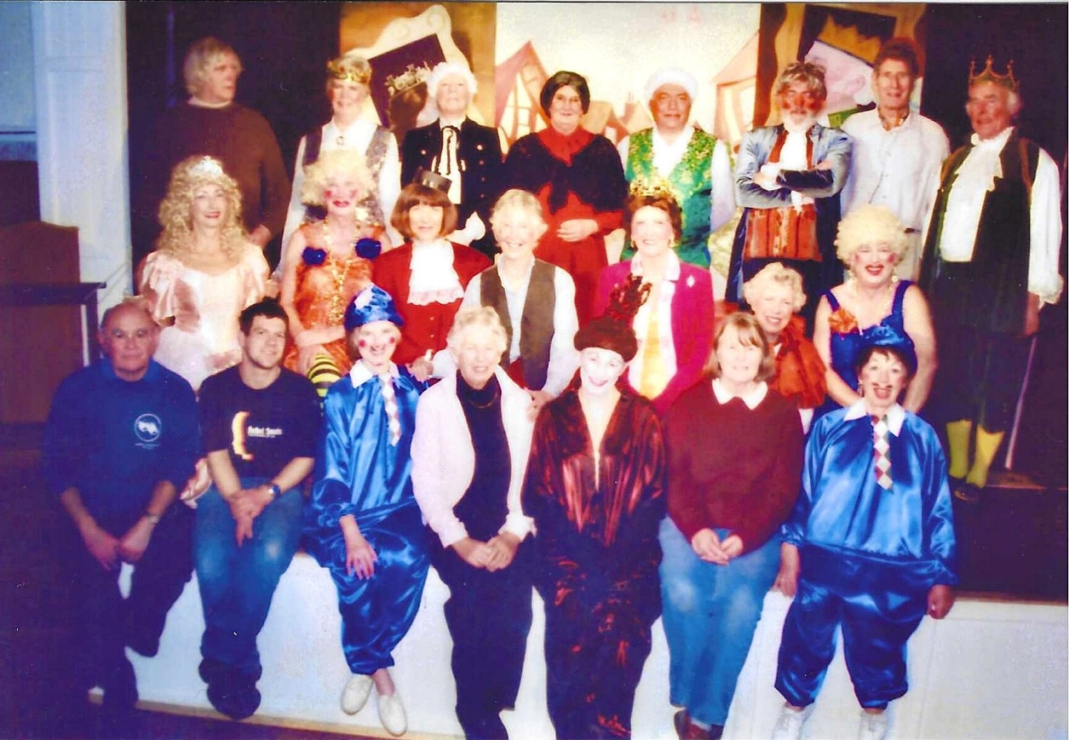

8 Back Row L-R Val Venning, Kate Lawley, ?, Jean Ellis, Dick Page, Peter Sims, Kate Lawley’s husband, Ron Carr
Middle Row Brenda Merritt, Mike Steward, Kathy Matthews, Joan Thomson, Janet Cattanach, Christine Wilson, Rod Carter
Front Row; Mel Ellis, man from Event(ual!) Services, Yvette Steward, Judy Shore, Hilary Walker, Jeanne Venning, Pam Carter

