Devon WI Carol Service at Exeter Cathedral
& the Christmas Market

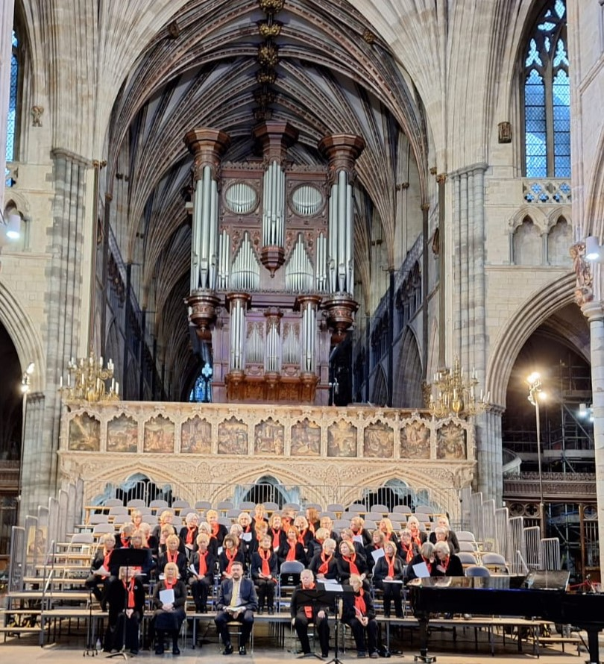
On Wednesday 6th December , Exeter Cathedral was closed to the public for the annual DFWI carol concert.
It was a smaller choir than usual, but there was lots of illness around.
There was also a signer for the deaf from Zeal Monachorum WI

