On Thursday 12th September 2024 we said our final farewell to Caroline Parsons.
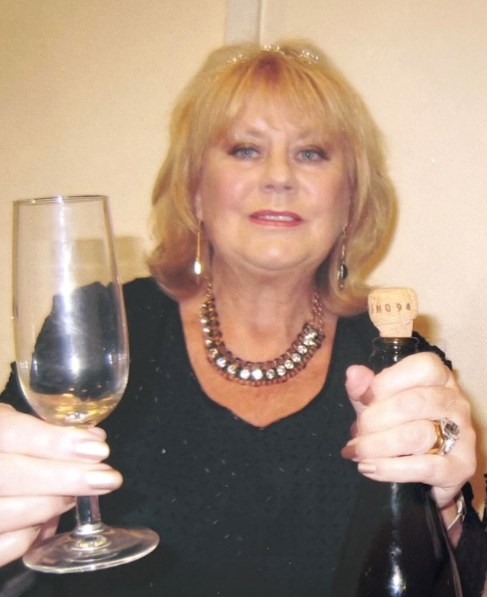

Caroline was an enthusiastic and dynamic stalwart of the WI. Caroline was an important part of so many village events and performed memorably in a whole series of WI productions in the village hall over many years. She threw herself into anything and everything. A couple of weeks before her death, she was with WI friends at an open-air production of Hamlet, smiling through the rain, and worrying about every one else’s comfort.
In recent years she has been stoic and determined in the face of failing health, persevering with trips, singing in the choir, devouring books and sharing opinions.
The funeral at Holy Cross was followed by a tea in the WI Community hall.
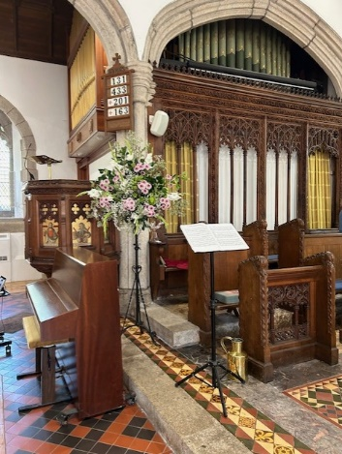
Caroline will be missed.
