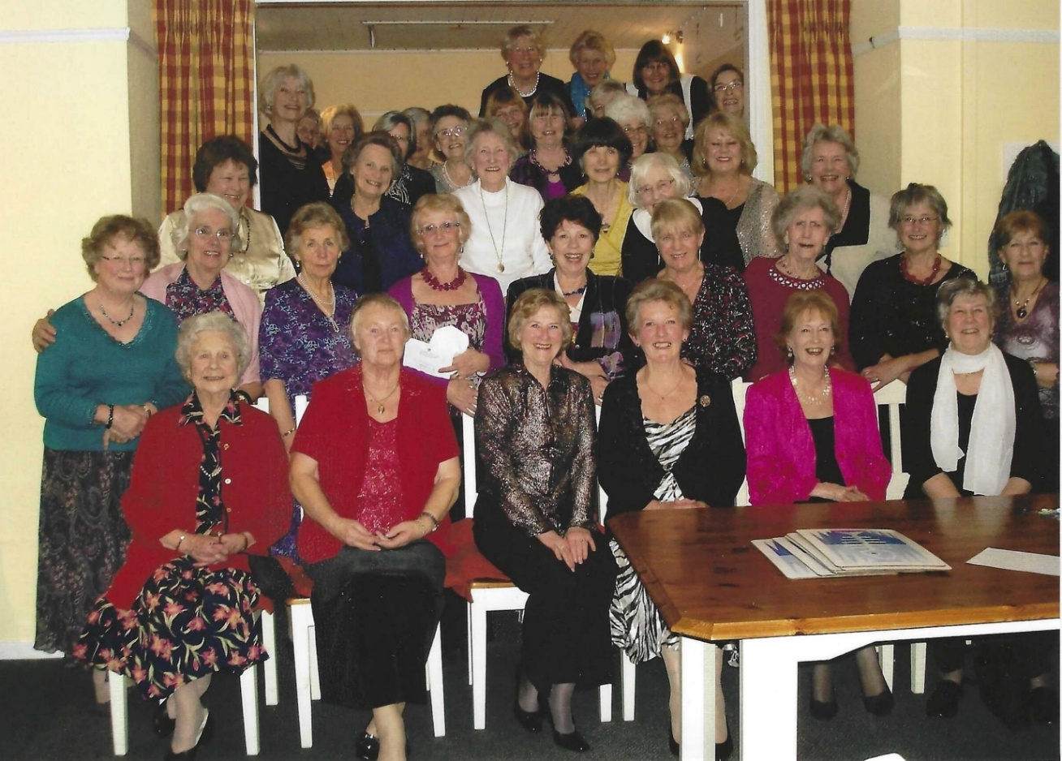
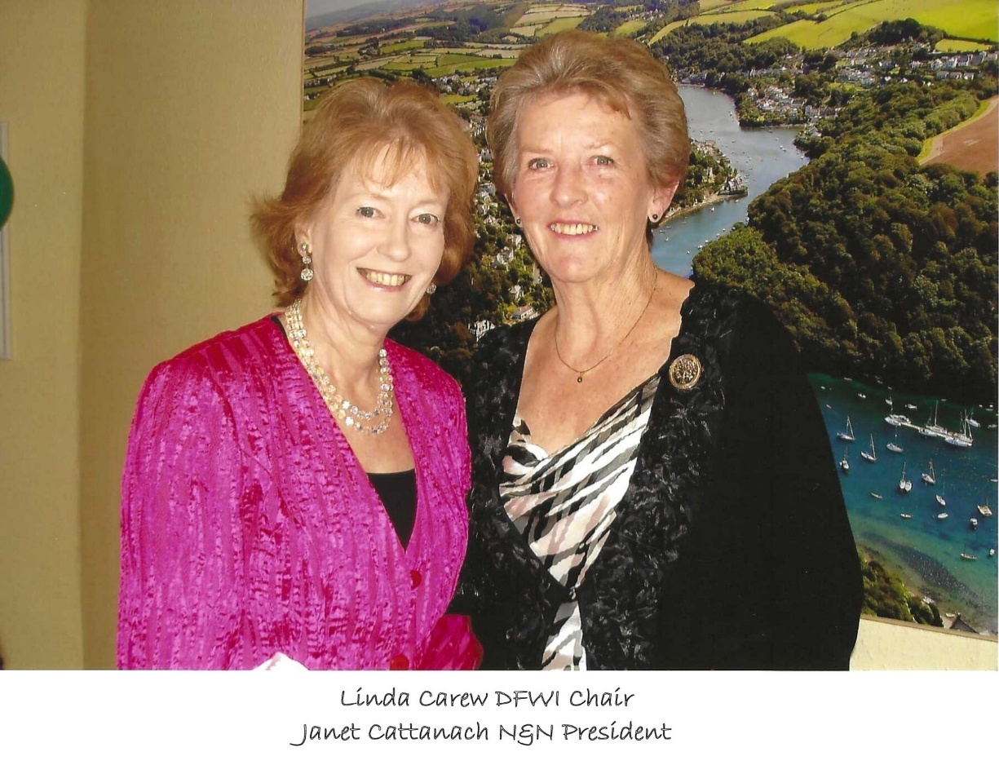
90th Anniversary Dinner 09/01/2011
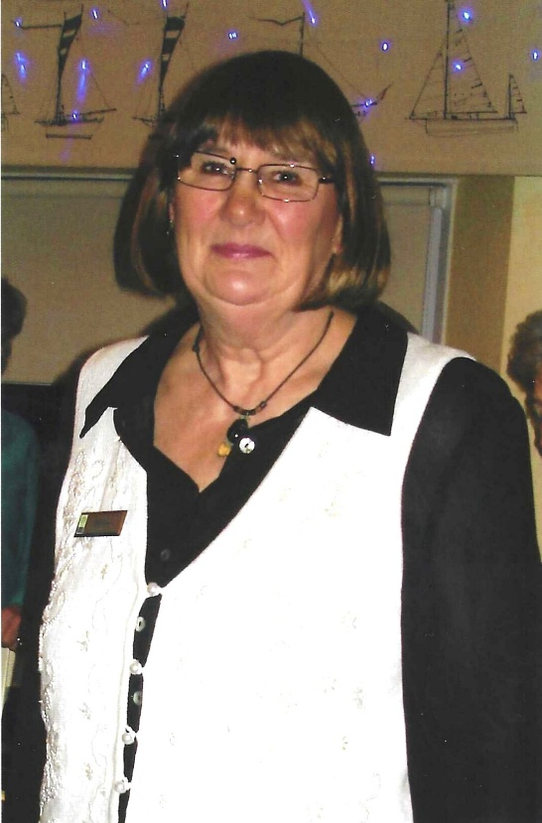
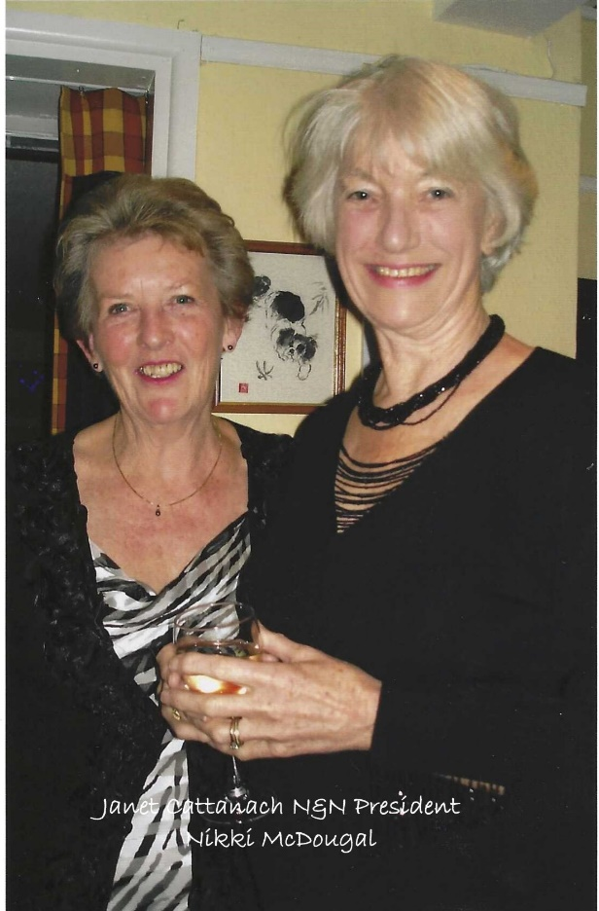
Jean Ellis

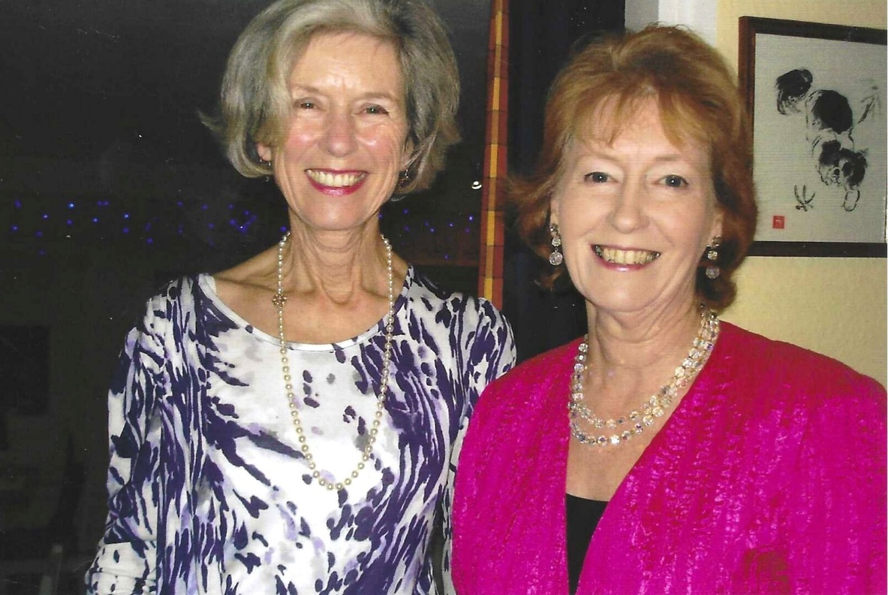
Margaret Pritchard & Linda Carew

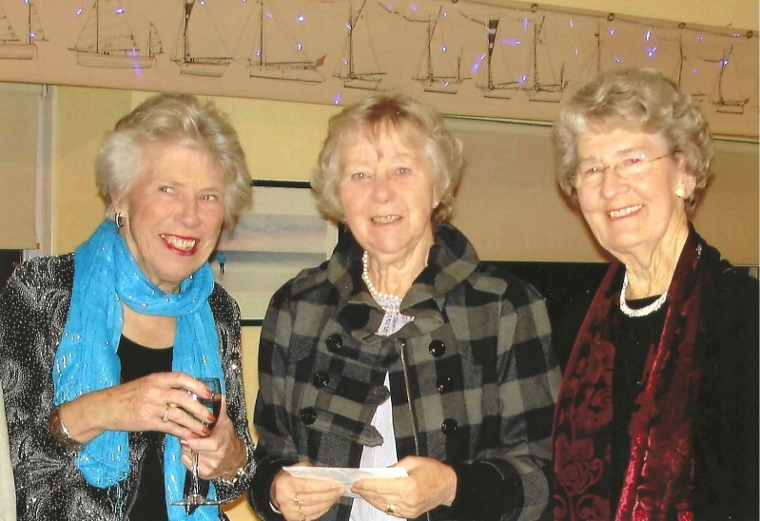

Christine Wilson; Leslie Davenport
& ?

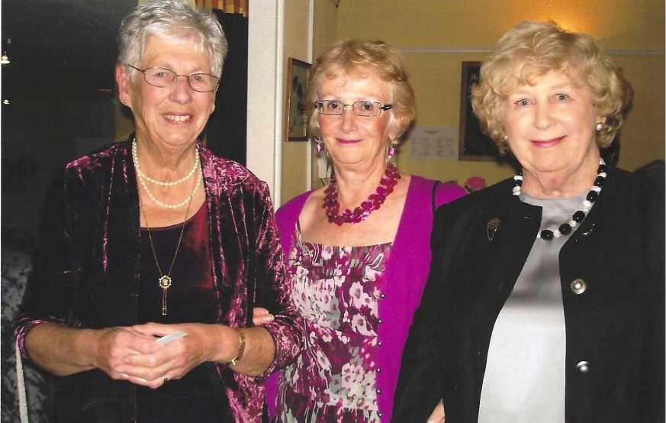
?
Joyce Stickley
& Sylvia Hunt

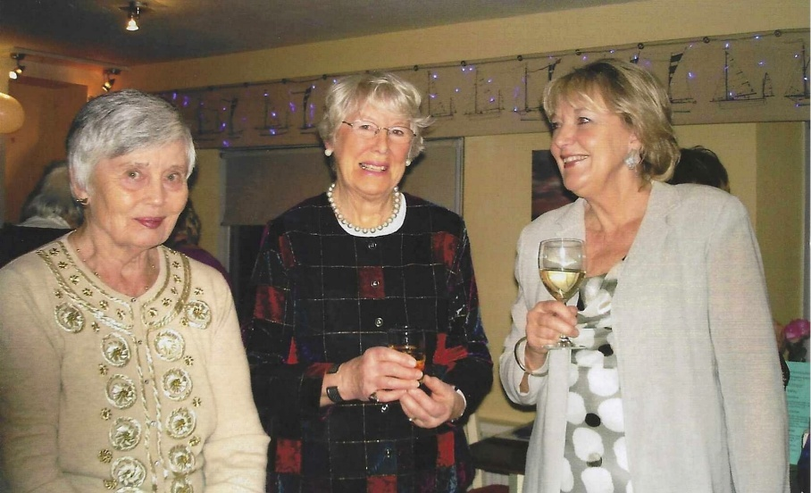

?

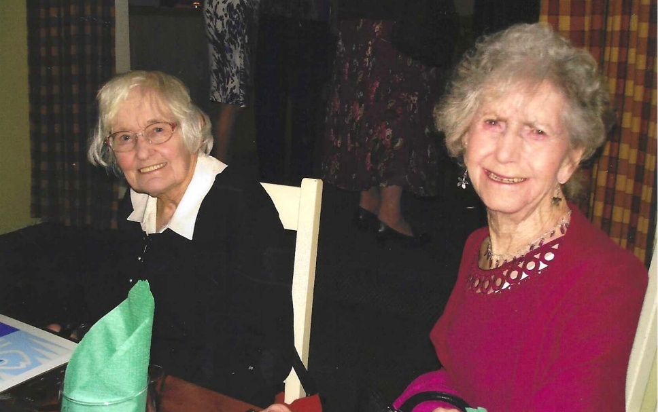
Caroline Bateman
Paddy Scammell

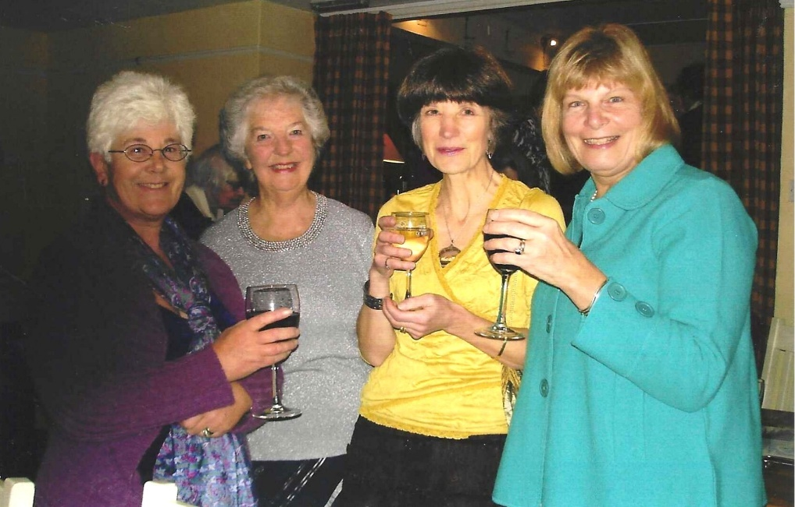

Hilda Julien
Joan Miller
Cathy Matthews
Carol Williams

?
Joyce Stickley
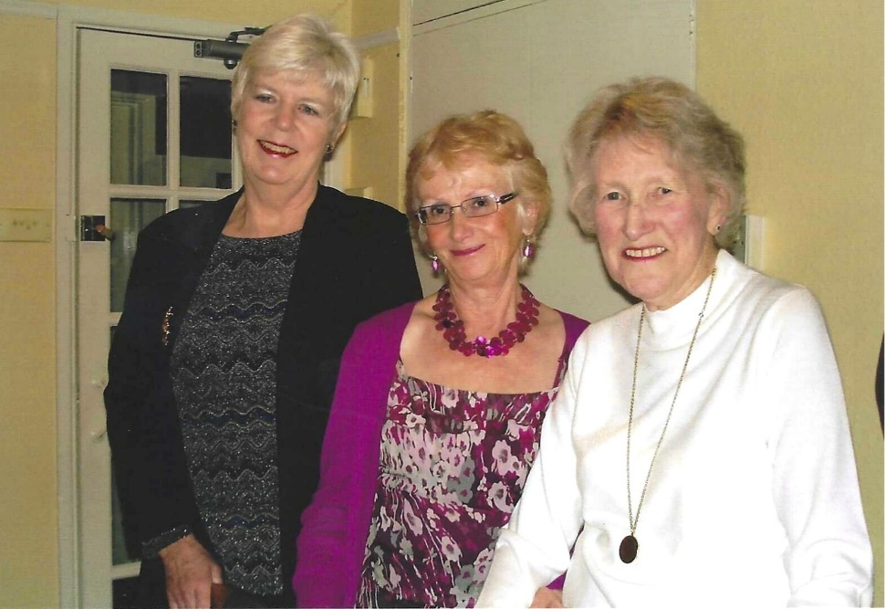
Betty Christie

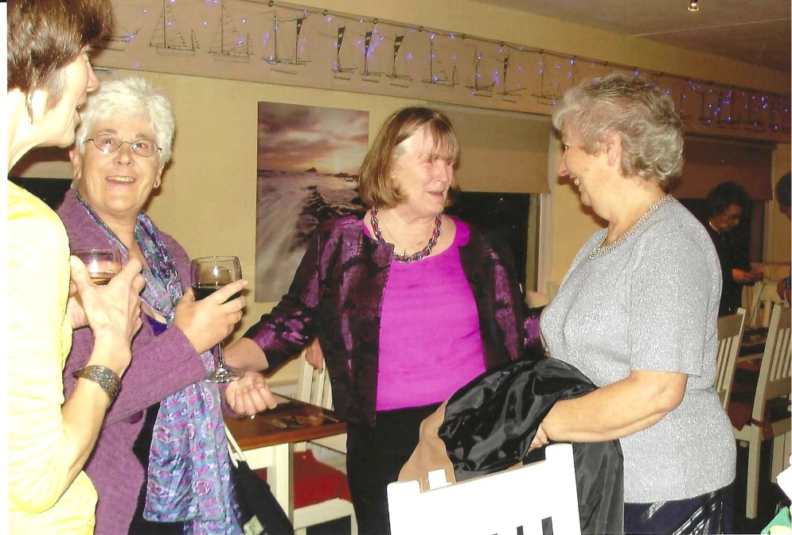
Cathy Matthews
Hilda Julien
Jeanne Venning
?

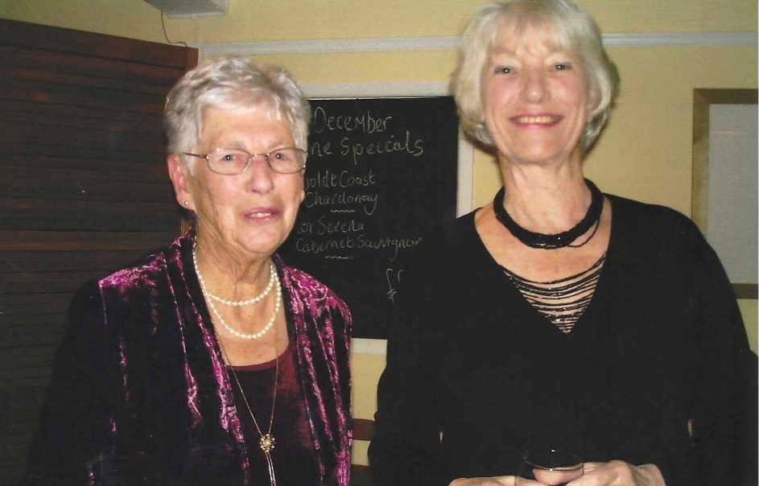

?
Nikki McDougal

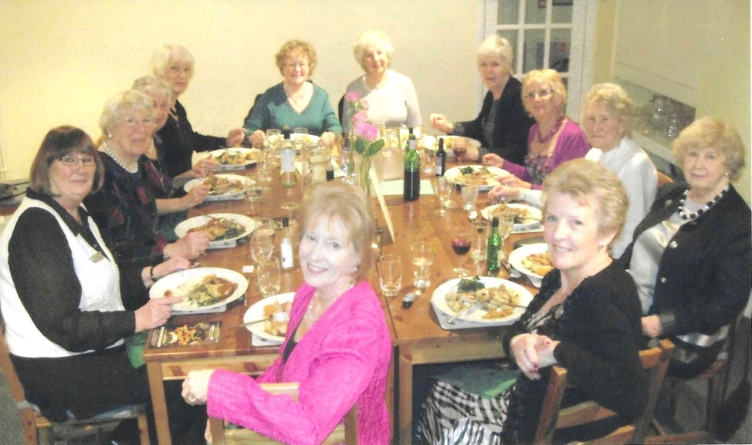

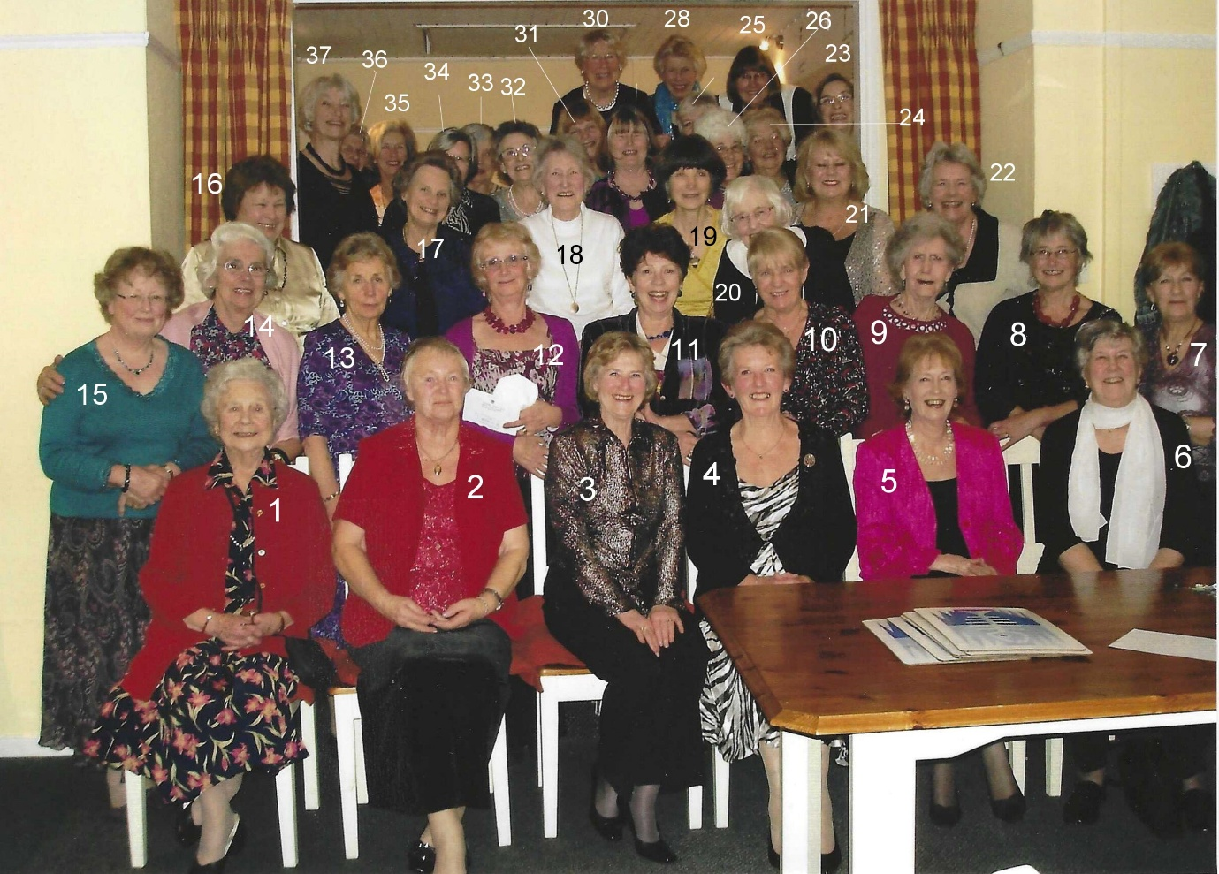

1 Mary Thomas
2 Pat Urry
3 Yvette Steward
4 Janet Cattanach
5 Linda Carew
6
7
8 Helen Wilson
9 Paddy Scammell
10 Sheila Pearce
11 Pam Carter
12 Joyce Stickley
13
14 Clare Pead
15 Joan Westall
16 Marion Sherlock
17 Enid Whiteman
18 Betty Christie
19 Cathy Matthews
20 Katherine Bateman
21 Caroline Parsons
22 Tessa Fenner
23 Brenda Merritt
24 Joan Miller
25 Jean Ellis
26 Hilda Julien
27
28 Christine Wilson
29 Jeanne Venning
30 Anne Crawford
31 Carol Williams
32 Elizabeth Stone
33 Brenda Scott
34 Liz James
35
36 Margaret Pritchard
37 Nikki McDougal




