2010 Signing the lease of the hall in the spring
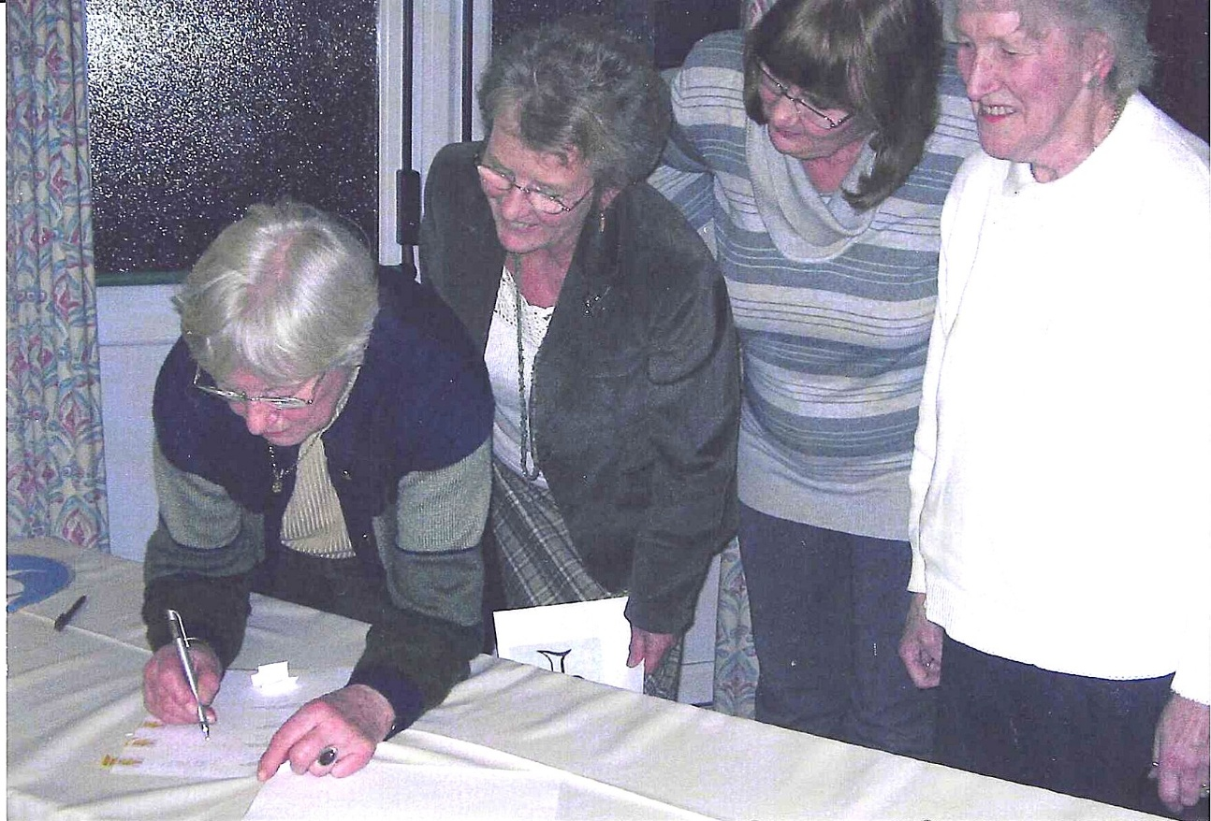
Treasurer, Anne Crawford; President, Janet Cattanach; Secretary, Jean Ellis; Committee member, Betty Christie
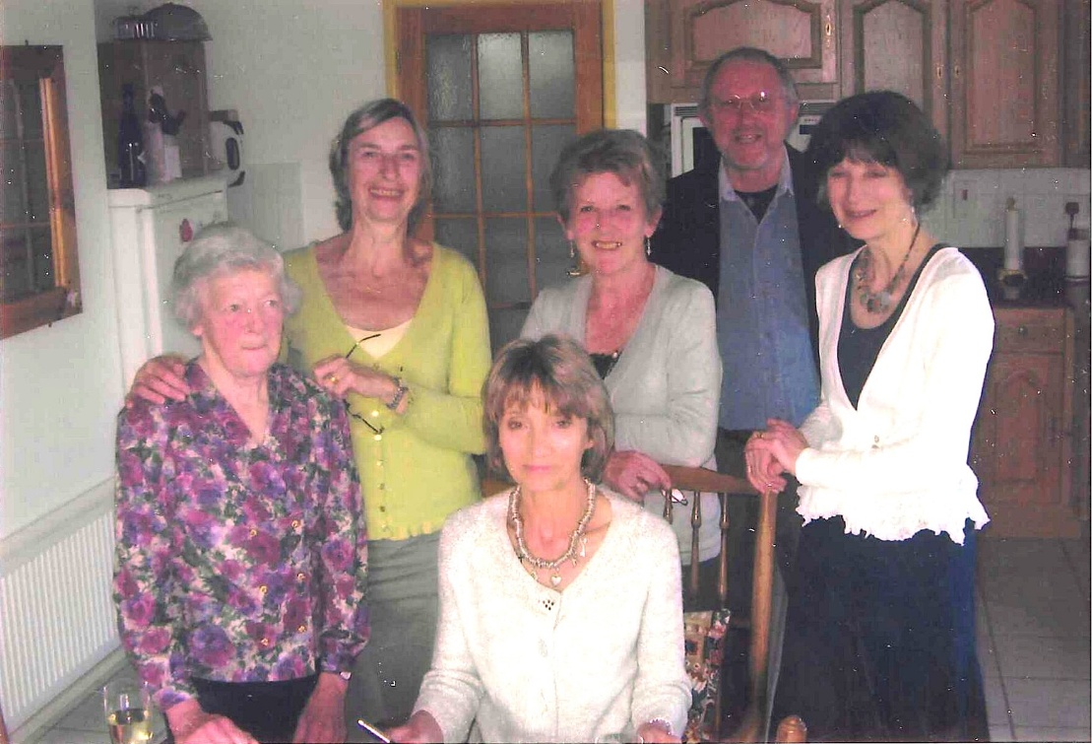

L-R- ?; Brenda Merritt;, Vicky Phipps (Seated);Janet Cattanach; Alan Cooper & Cathy Matthews

