The Queens Platinum Jubilee

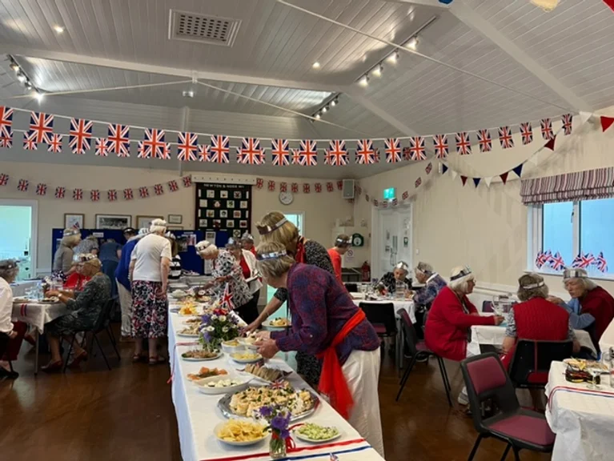
As this month’s WI meeting was a special occasion at which we celebrated the Queen’s Platinum Jubilee, there aren’t any formal minutes. However, here is an outline of what we got up to. We decorated the hall with lots of bunting during the day and the Craft Group put red, white and blue flowers on each table.
On arrival, each member was given a glass of bubbles and invited to sit at the tables where there were crowns for us to decorate with stick on jewels. We all wore our crowns for the evening.
We began the proceedings by singing the National Anthem and toasting the Queen.
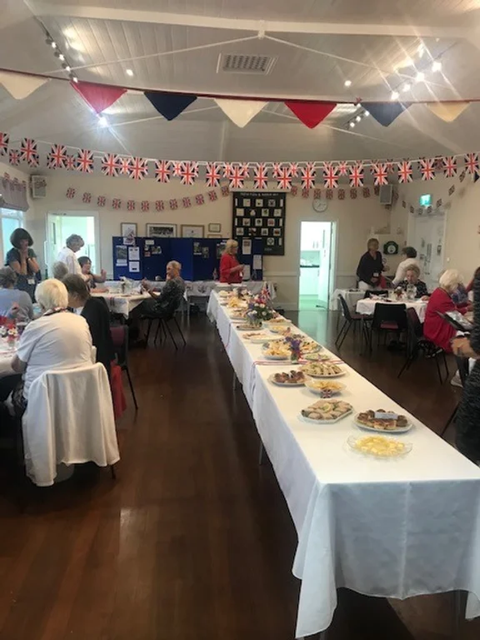
Members had provided savoury finger food and an amazing array of desserts, featuring lots of strawberries and cream. There was meant to be a 1950s theme but I don’t think anybody took rationing into account! Once we had eaten the entertainment began. With a couple of helpers, Judith Stephenson read an excerpt from Alan Bennett’s book “The Uncommon Reader” which is an amusing book imagining what might happen if the Queen became an obsessive reader. This was followed by the WI choir under Joyce Stickley’s direction who sang a few songs from musicals and Rosemary Furzeland who read a lovely poem by a Cornish poet . After Nan Lowden had given us the answers to her quiz about the Queen, some of the members of the Drama Group presented a short sketch under the direction of Caroline Parsons.

