The Bridge restaurant, Mount Batten, Plymouth 23/01/2026

The Bridge occupies a stunning waterside spot, overlooking the busy Yacht Haven Marina and with unrivalled views. We were seated on the 1st floor, which we had all to ourselves. Jackie Ross, our events organizer, had booked a table for 19 of us.
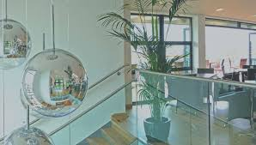
The day we went was grey and stormy, but there was still activity on the water.
The food was good, with a varied menu. Or group had local haddock fillet (Caught by Rachel of Ladram) with peas and chips; Beef rib (which had been slow cooked for 18hrs), with creamy mash and seasonal veg; Steak and ale pie (a piece of, not pre made individual pies) with creamy mash and seasonal veg; a seafood chowder; and burger with Gruyère cheese, baby gem, tomato served with chips and onion rings.
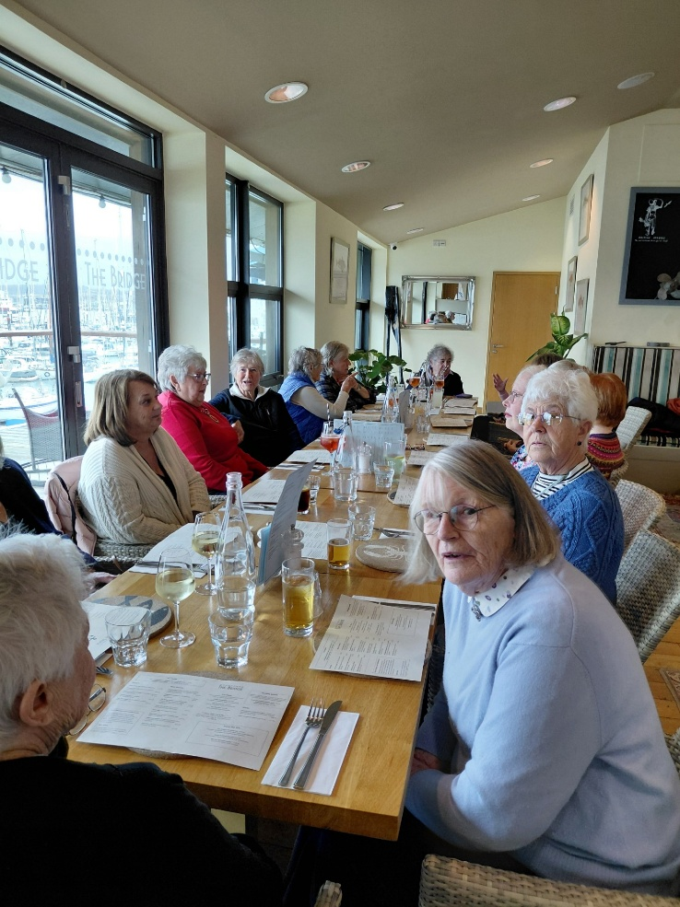
L side of table: Julie Thomas; Jackie Ross; Yvette Steward; Helen James; June Blackburn & Stella Gullen at head of table.
R side of table: With her back to the camera, Yvonne Mustoe; Jeanne Venning; Hilda Julien; Carrie Dixon & Emma Parker.

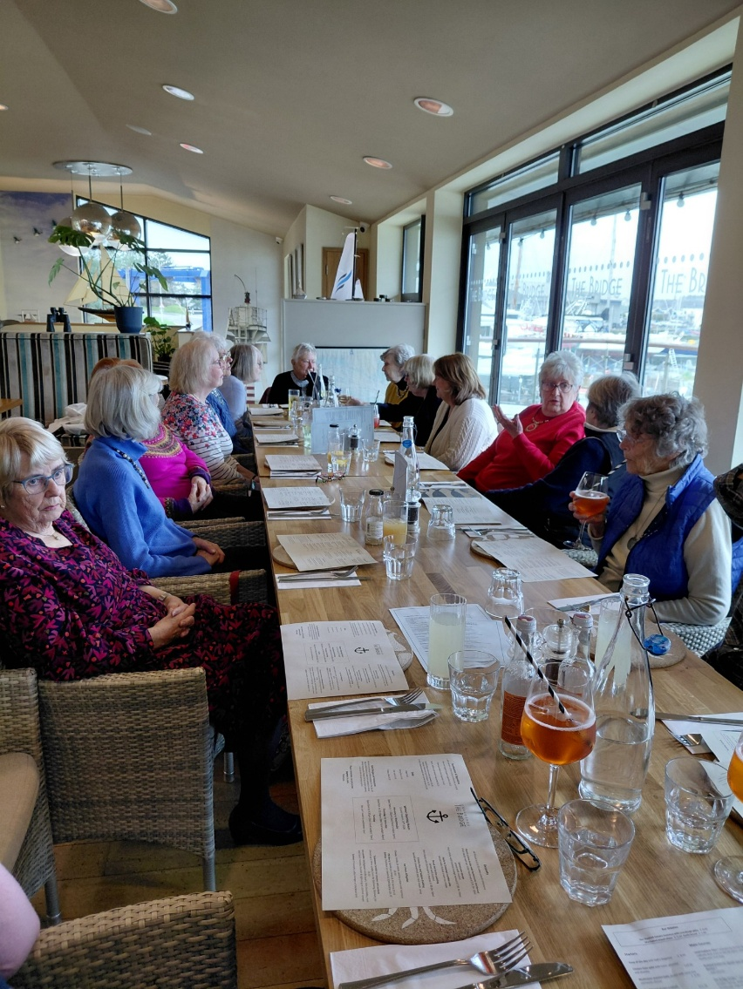
L side of Table: Diana Chapman; Margaret Pritchard; Emma Parker; Carrie Dixon; Hilda Julien; Jeanne Venning & Yvonne Mustoe at head of the table.
R side of the table: Jane Barnett; Jean Ellis; Julie Thomas; Jackie Ross; Yette Steward & Helen James.

Desert was equally delicious with spiced pear sponge & custard; apple and cinnamon crumble cake with ice cream; bread & butter pudding (the portions were huge); & a variety of ice creams.
Coffee followed, before we braved the cold wet & windy weather; feeling very full. I doubt any of us would need any supper!

