2009 Awards for All @ Denman College 5-8 February
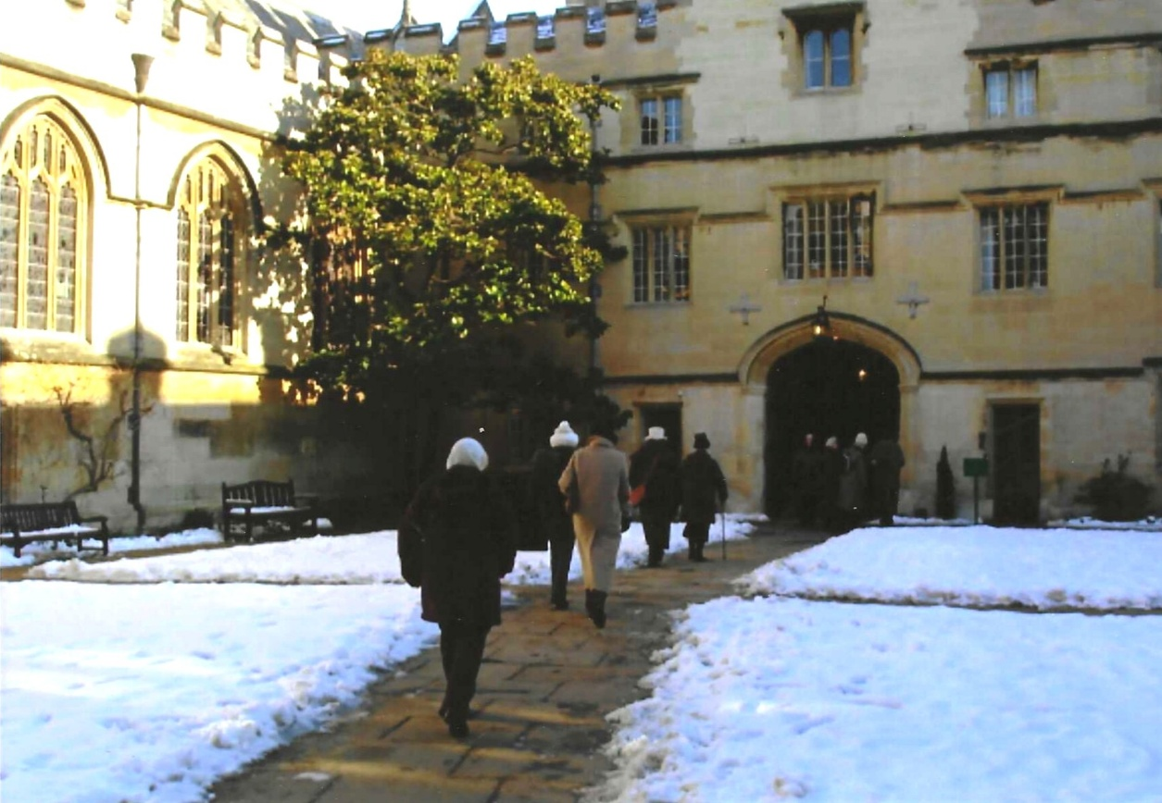

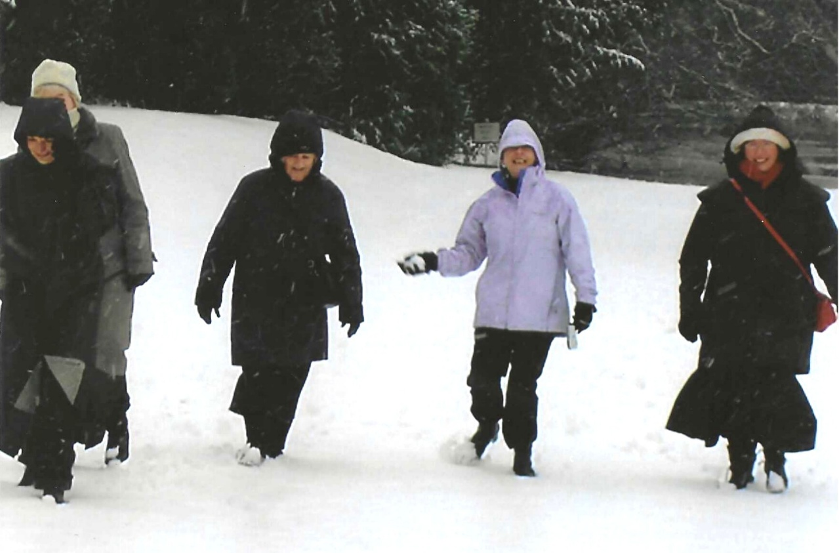
l-r:- Cathy Matthews with Kate Lawley behind; Sylvia Hunt; Janet Cattanach & Carrie Dixon

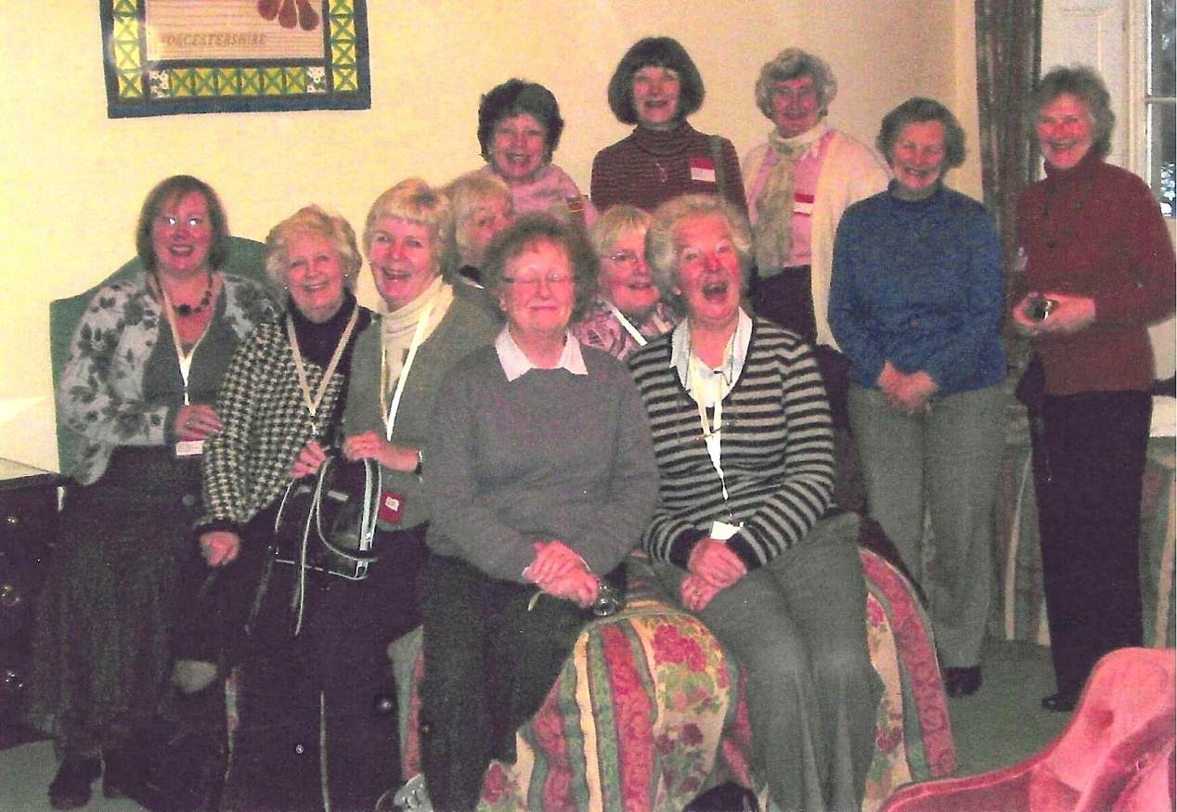

L-R:- Carrie Dixon; Sylvia Hunt; Kate Lawley; Nicki Mc Dougal; Rosemary Furzeland
Front- Joan Westall Joan Miller
Back:--Pam Carte;r Cathy Matthews; Rosemary Watts; Enid Whitman and Yvette Steward

