2001 Presidents Tea Party
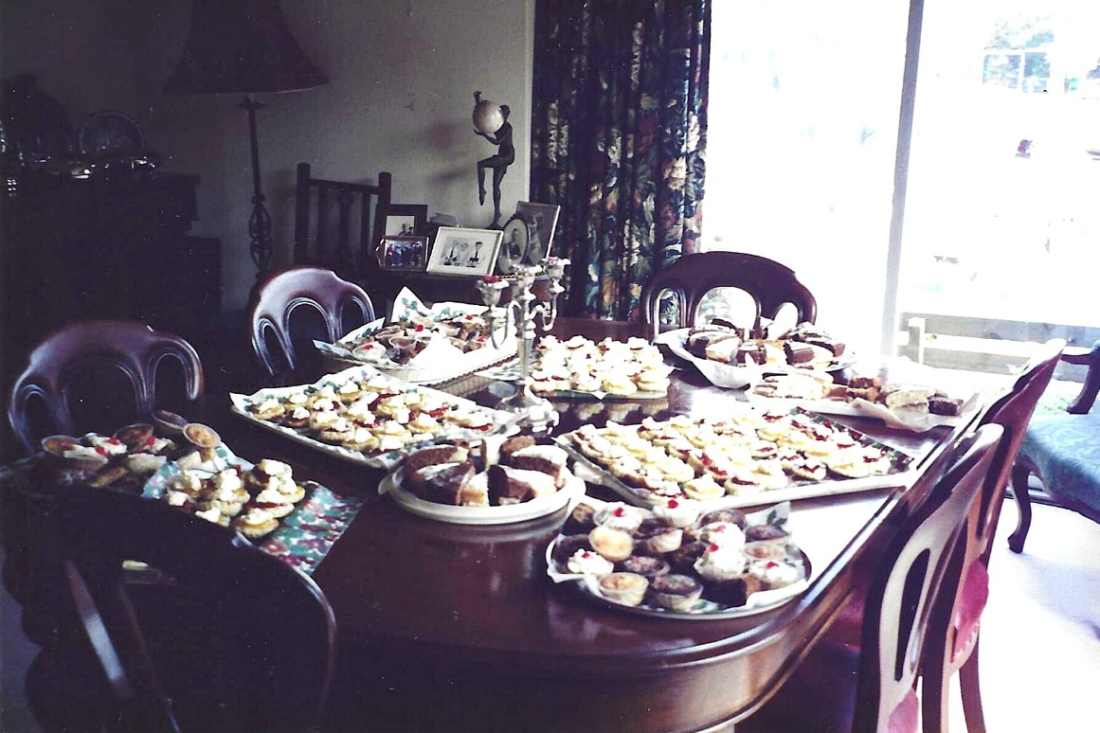

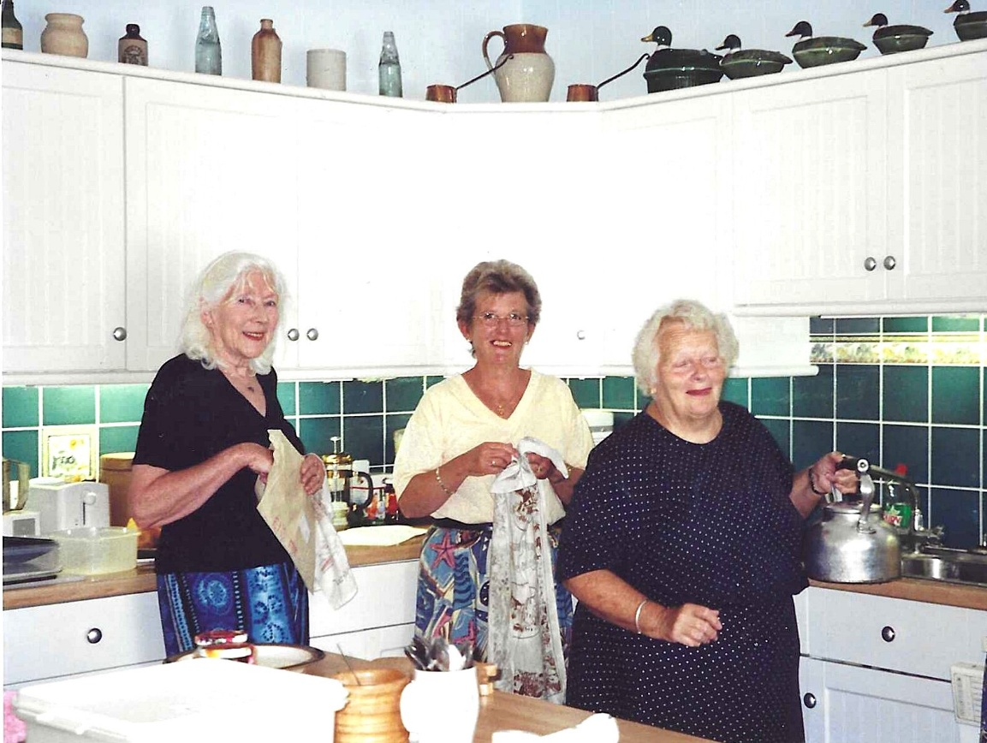

Janet Cattanach (centre); Wendy Kennedy (on the right) & ?

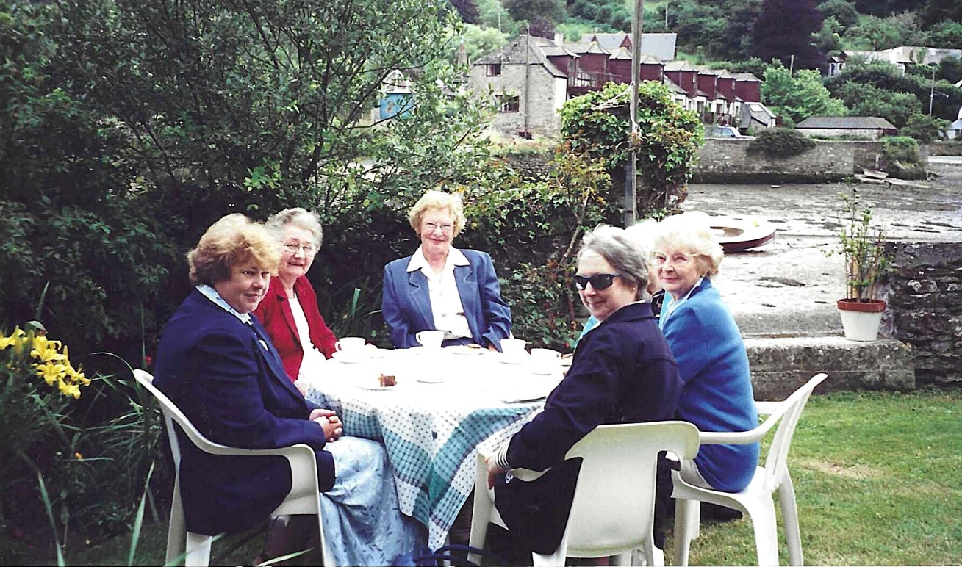
Marilyn Sherlock (L blue jacket); Audrey Makin (facing camera white blouse, blue jacket) ; & ?

Trish Davies; Marion Mead
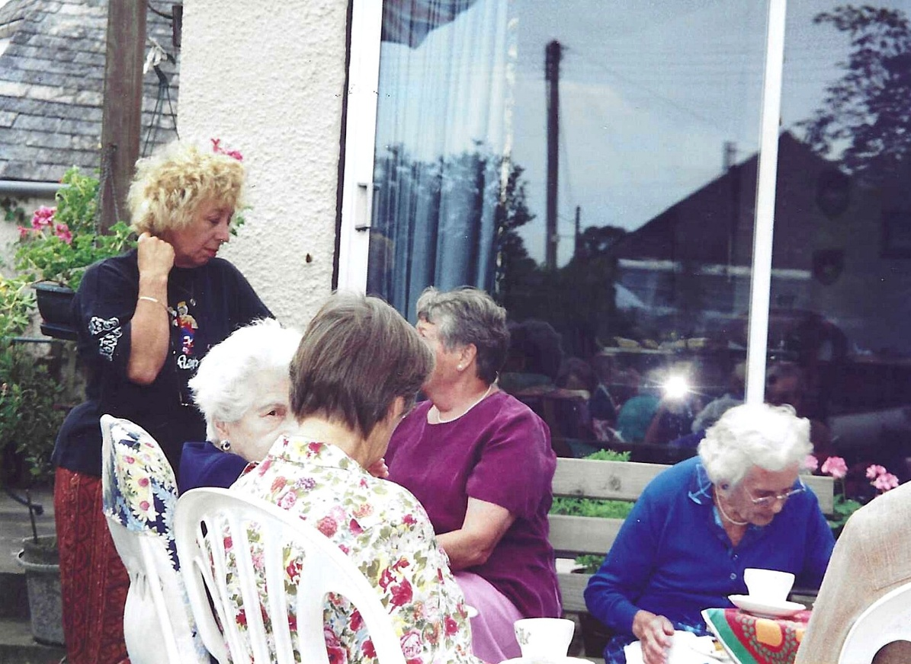

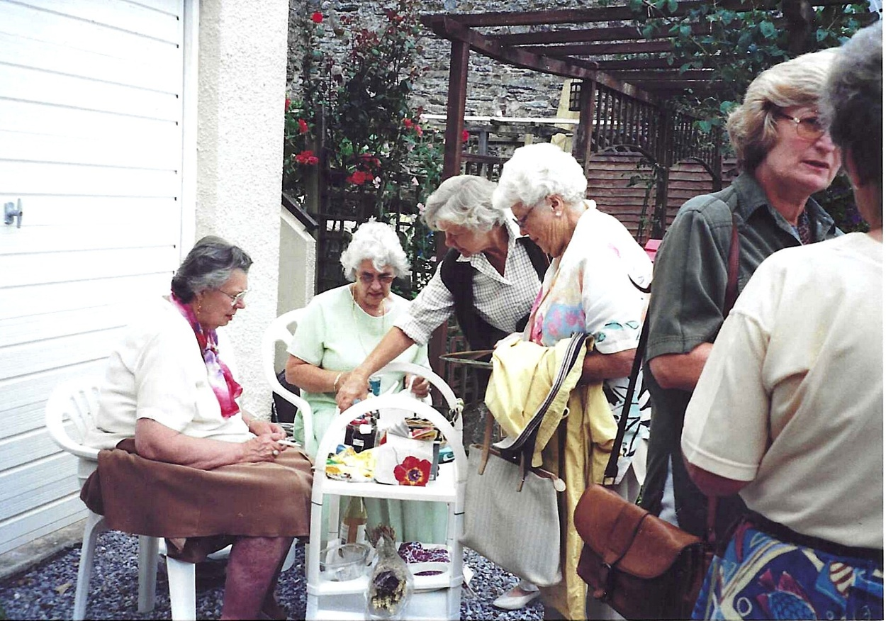
Janet Cattanach (back to camera) Jane Jary; Kay Barber; Clare Pead; Leslie Davenport &?

