Devon Conference 2023

Torquay

Newton & Noss WI was represented by Nan Lowden

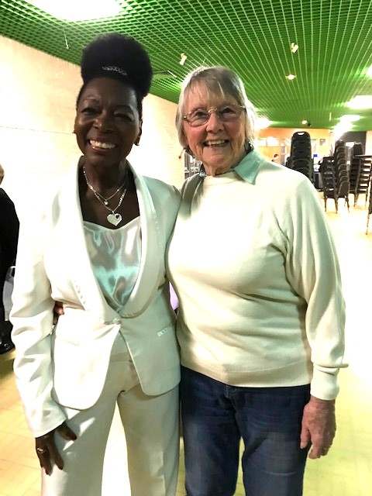

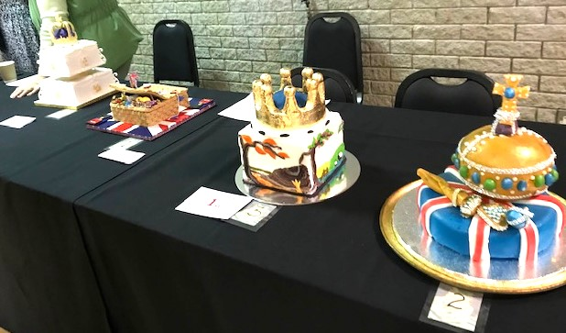

Cake competition