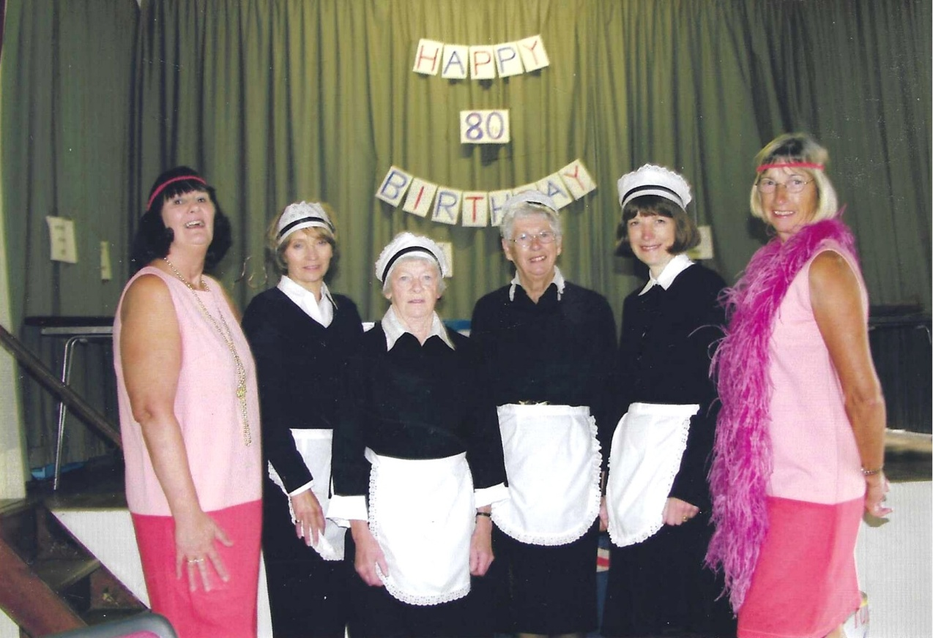
2004 80th Anniversary
L-R:- Jean Ellis; ?;?;? Cathy Matthews & Brenda Merritt

