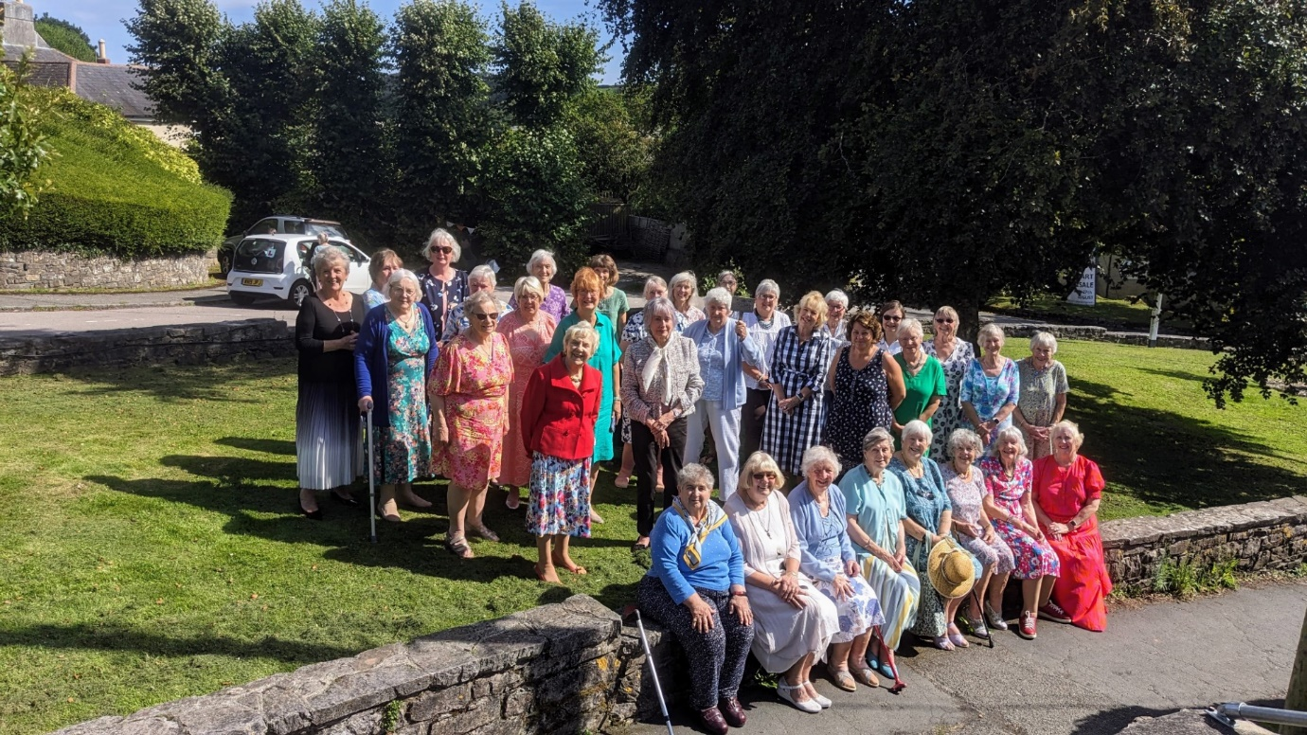
The President’s Tea Party 2023

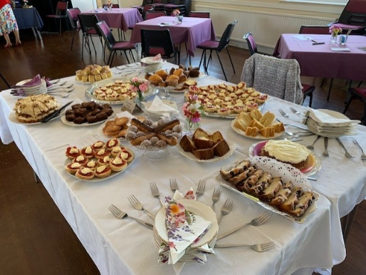
Narrative By Yvonne Mustoe
Photos By Pat Middleton & Gill Tune

Our President’s Tea Party was held on Tuesday afternoon in the WI Hall. It was well attended with beautifully decorated tables. A tempting centre table was laden with cakes and scones. Tea, coffee, Prosecco and soft drinks were also served.
A quiz was held, guessing the names of the reigning Monarchs relating to the objects brought in by various WI members, with a prize to Jean Ellis who got the highest number of points out of 10. Well done Jean.

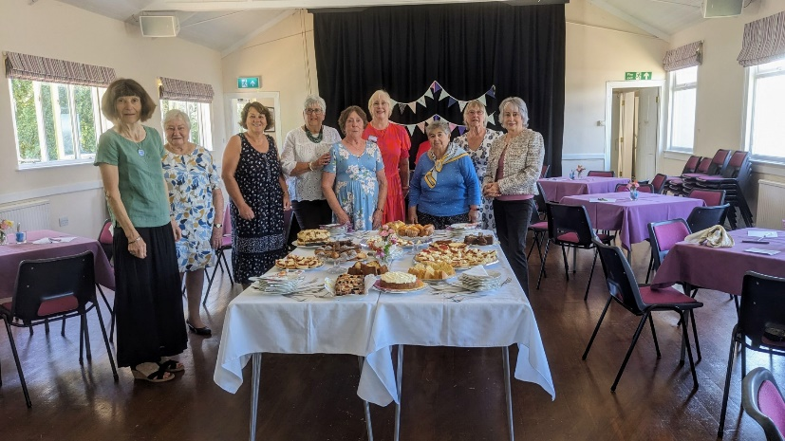
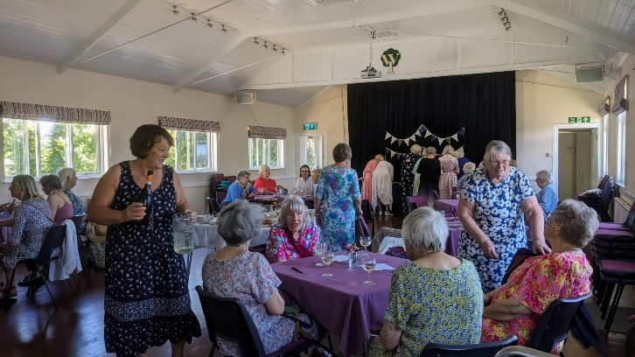

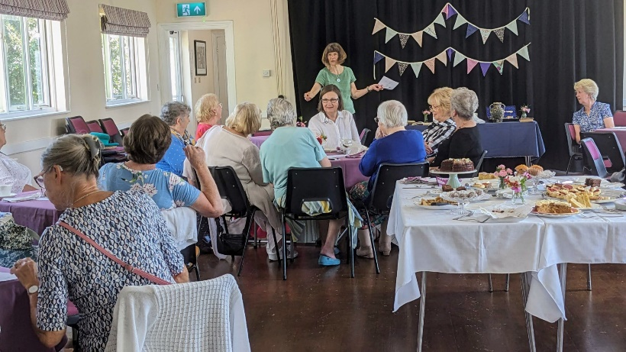

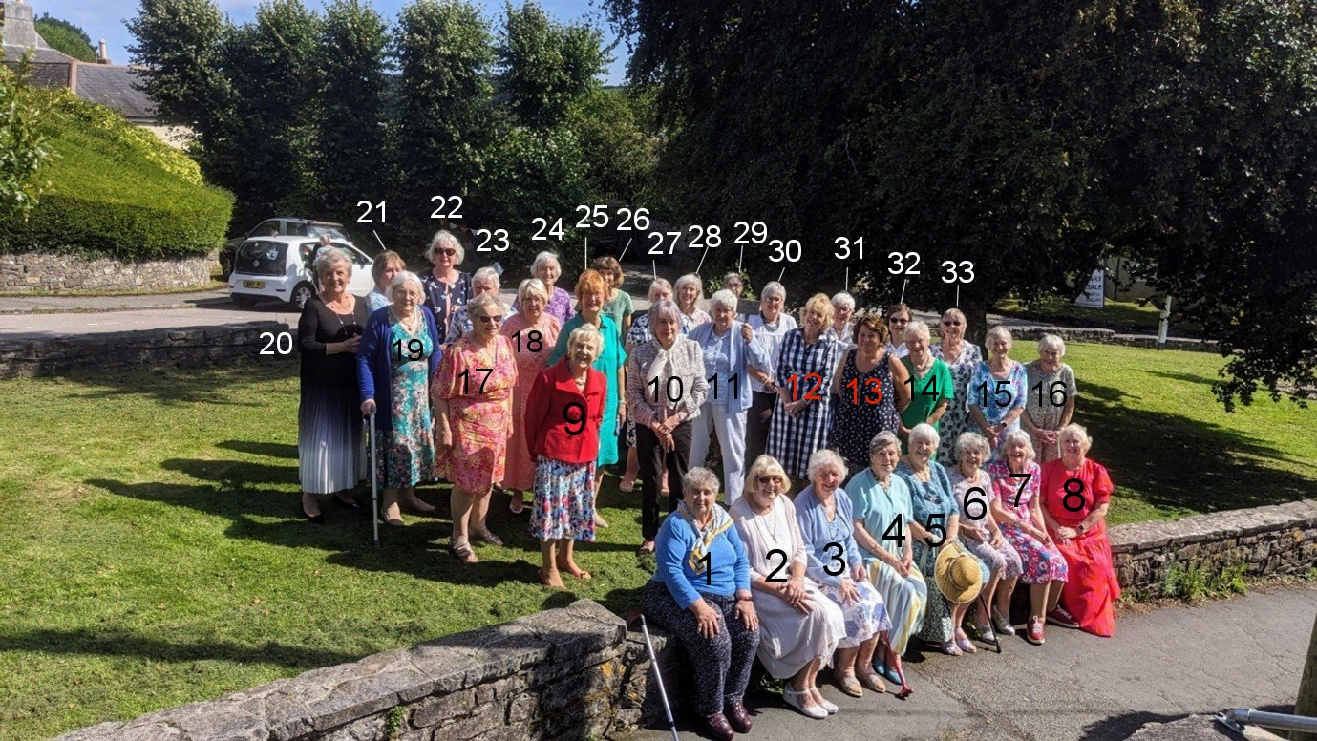

- Stella Gullen
- Jean Ellis
- Joan Miller
- Jane Barnett
- Jill Johnson
- Pam Carter
- Tessa Fenner
- Carrie Dixon
- .
- Marcia Webster
- .
- .
- Julie Thomas
- Angela MacPherson
- Yvette Steward
- Christine Wilson
- Enid Whiteman
- .Diane Chapman
- Rosemary Furzeland
- Janet Cattanach
- Gill Tune

- Wendy Barratt
- Nikki McDougal
- Judith Stephenson
- Cathy Matthews
- Jeanne Venning
- Margaret Pritchard
- Brend Merritt
- Jackie Ross
- Shirley Pegg
- Diana Little
- Nan Lowden

