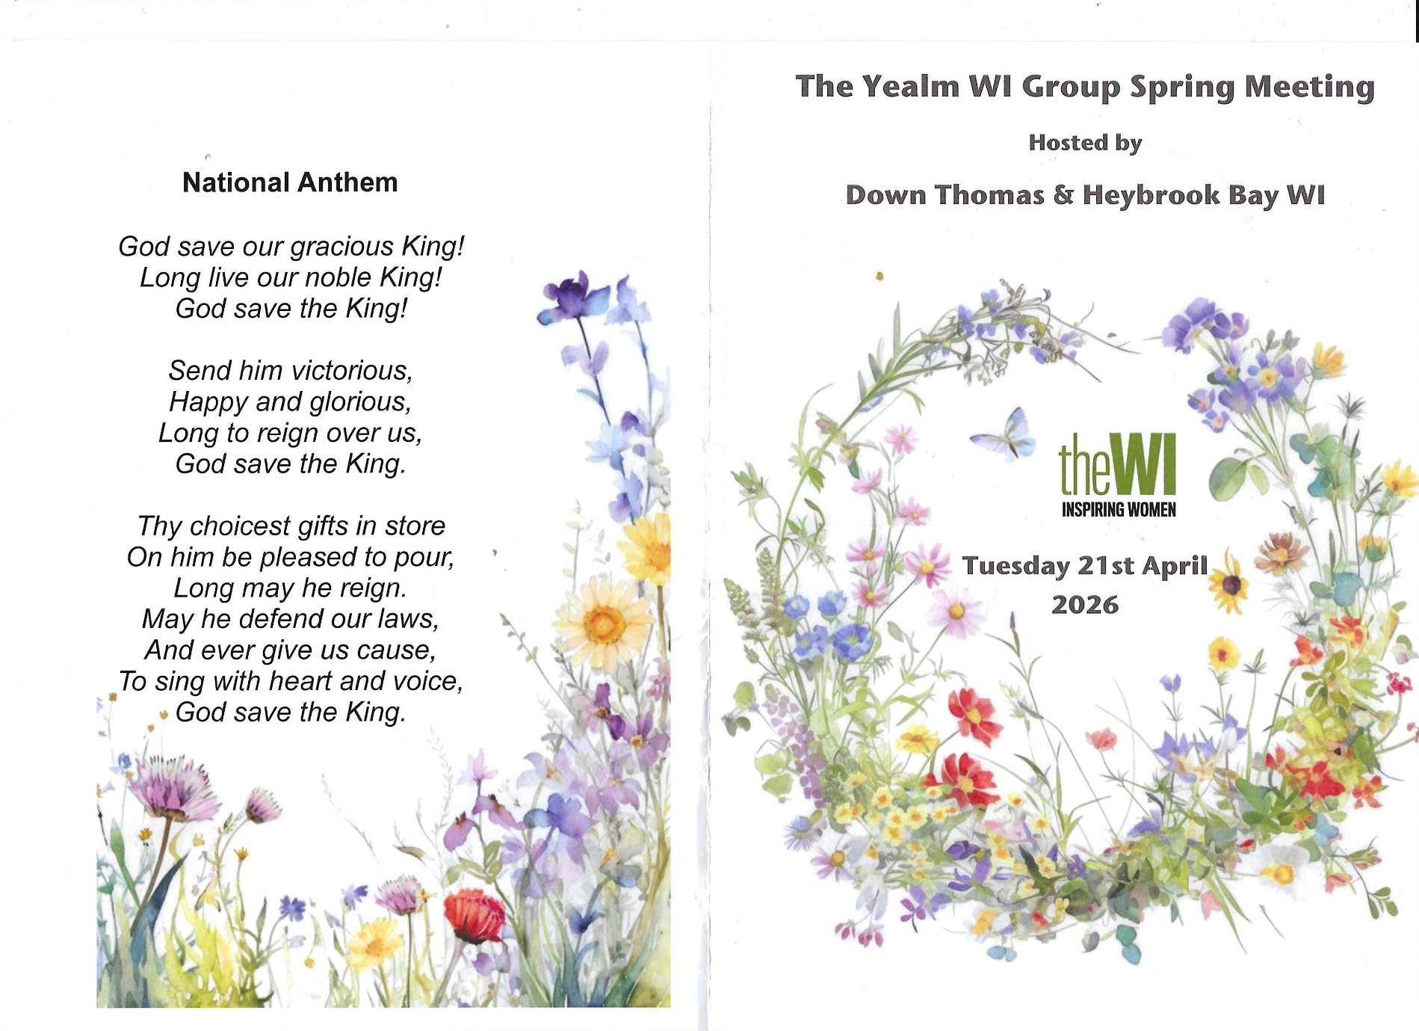
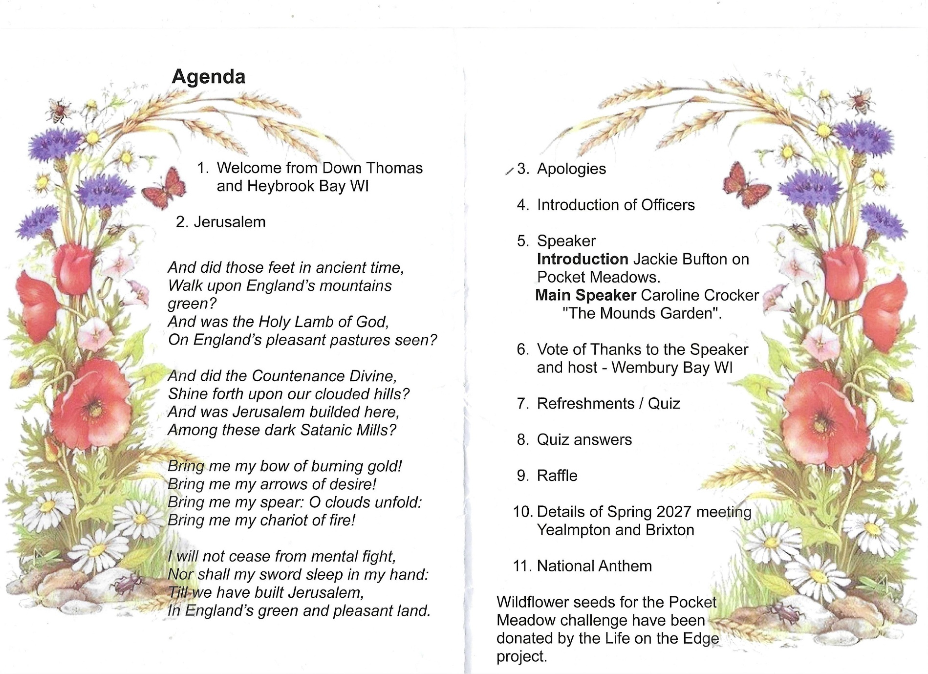
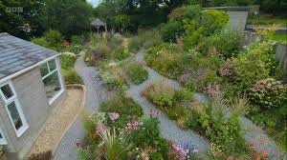

Caroline Crocker, the main speaker for the evening lives in Plymstock, & runs Duck Garden Plants from her home and was featured on Gardeners’ World last year for the way she transformed her garden, inspired by Wildside Garden near Yelverton.
She dug up her entire lawn with the help of her husband and father, turned the turf upside down and planted it, making a garden of mounds with slate paths winding between them. Which gave her different planting directions. It took her a year which was incredible. It is called Duck garden plants because f the ducks that live in her garden.
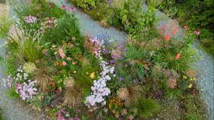
We also had a short talk by Jackie Bufton about wild flower meadows and the seeds that were issued by DFWI.
There was a short quiz all based on plants and horticulture.
Seven of us from Newton & Noss went over to Down Thomas. We were split into a maximum of 3 members from the same WI per table. Hilda & Jeanne sat up the front; Jackie & Yvonne sat half way down; and June, Nan & I sat at the back.
We were given a raffle ticket on arrival (I won with first ticket pulled out). The floral table decorations on each table were given to the person with a birthday nearest that days date.
The cakes were nice, especially the coffee & walnut which was so light. The tea was very welcome. However it was a late finish; 10.00pm
The roads were appalling, with huge potholes. A challenge for driving home in the dark

Written by Lesley Dempsey

