2006 1st April Committee

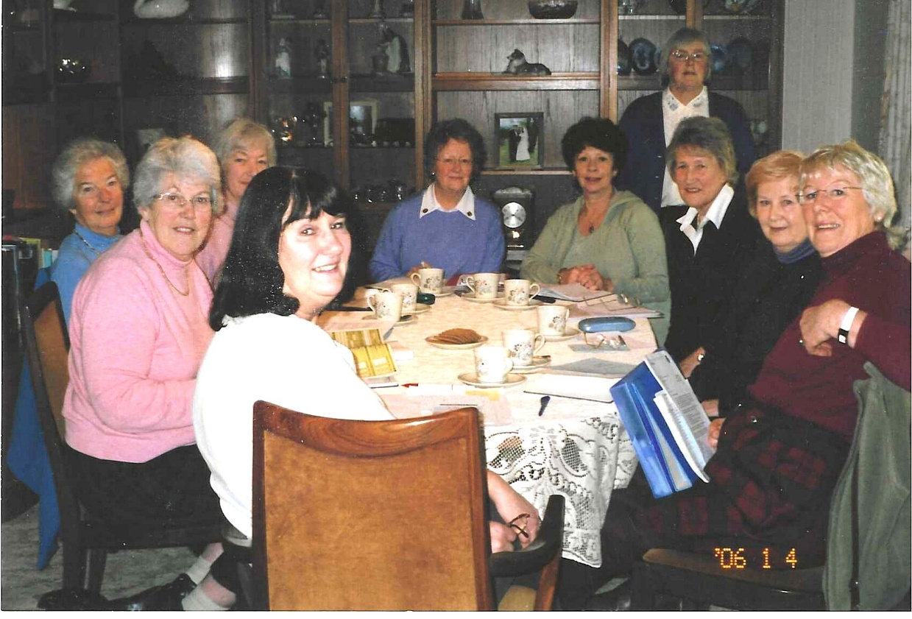

Julie Thomas; Jean Ellis; Joan Miller; Joan Westall; Pam Carter; Betty Christie; Ann Crawford; Sheila Painton; Nicki McDougal

