Giselle 3rd 2026 March
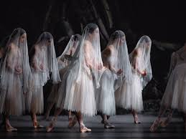
Four of us went to the watermark in Ivybridge to see a live screening of Royal Ballet’s production of Giselle.

Giselle is a two-act Romantic ballet about a peasant girl who dies of a broken heart after discovering her lover, Albrecht, is disguised and betrothed to another. In Act II, she returns as a vengeful spirit (known as a Wili) but saves Albrecht from a similar deadly fate through her love, finally finding peace.

We had fabulous seats, - sofas at the front, and were surprised and delighted to find we were next to a former WI member, Marcia, and her husband Douglas.

We caught up on news before the performance and during the interval, over a glass of wine.

foreground moving backwards
Lesley Dempsey; Gill Tune; Cathy Matthews; Marcia & Douglas Webster
Photo taken by Stella Gullen

