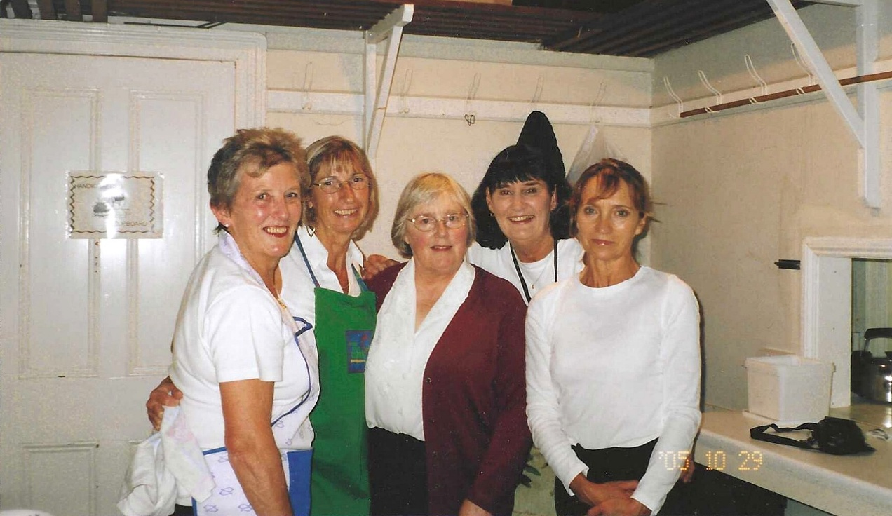
2005 29th October Trafalgar Dinner
L-R : Janet Cattanach; Brenda Merritt; Rosemary Furzeland; Julie Thomas; ?
