2006 Beauty & the Beast pantomime
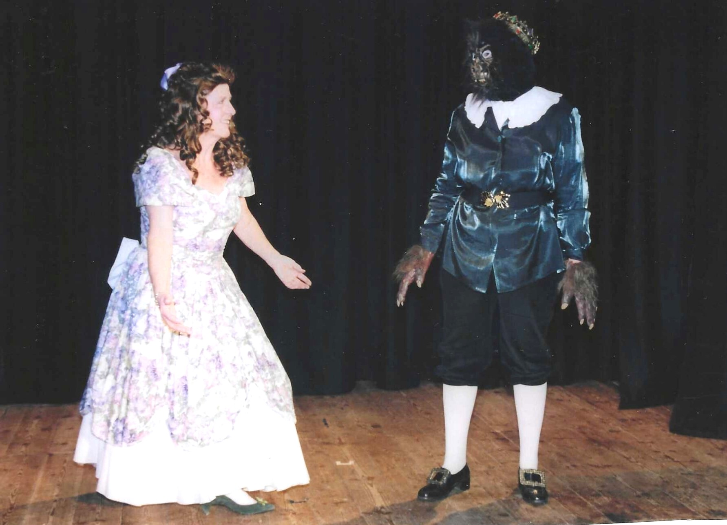
Janet Cattanach and the Beast played by Jean Ellis

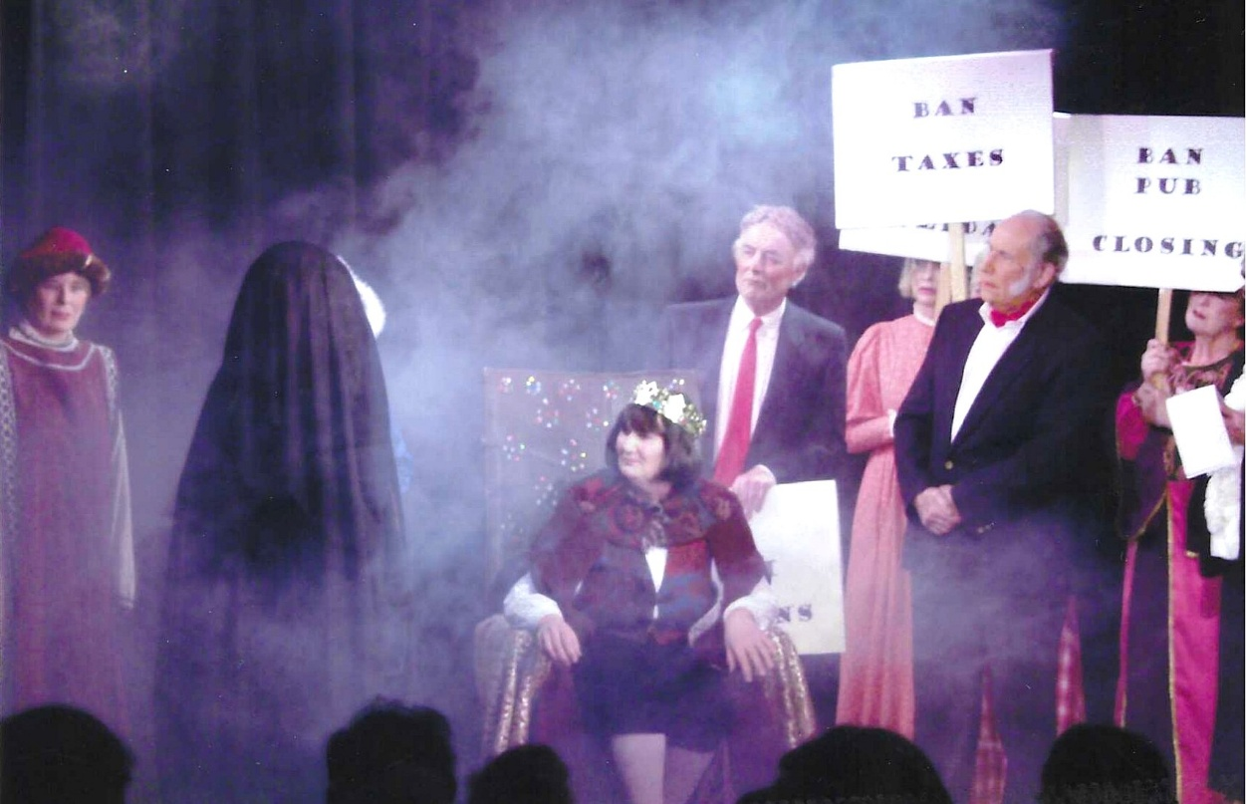
2
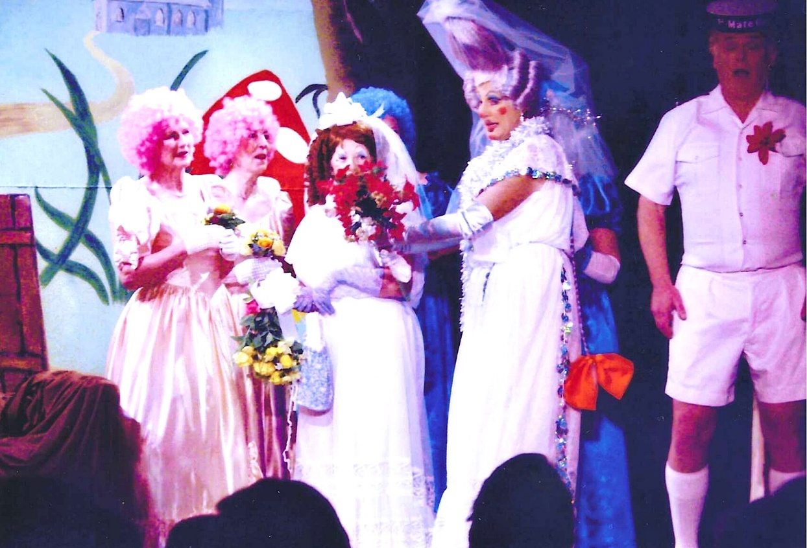
L-R Yvette Steward, Joan Thomson, Pam Carter, Hilary Walker, Rod Carter

4
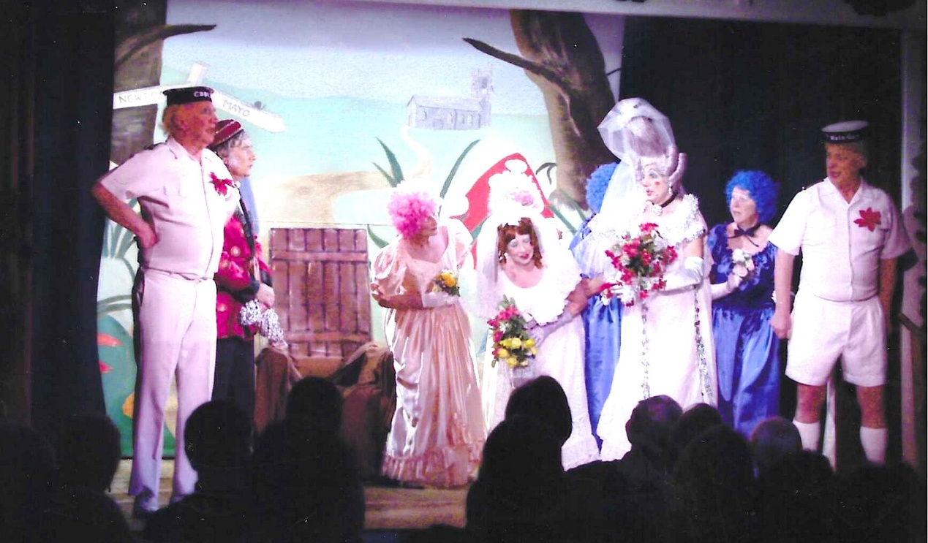
Mike Steward, Dennis Shore, ?, Pam Carter, Hilary Walker, Lesley Davenport, Rod Carter

5
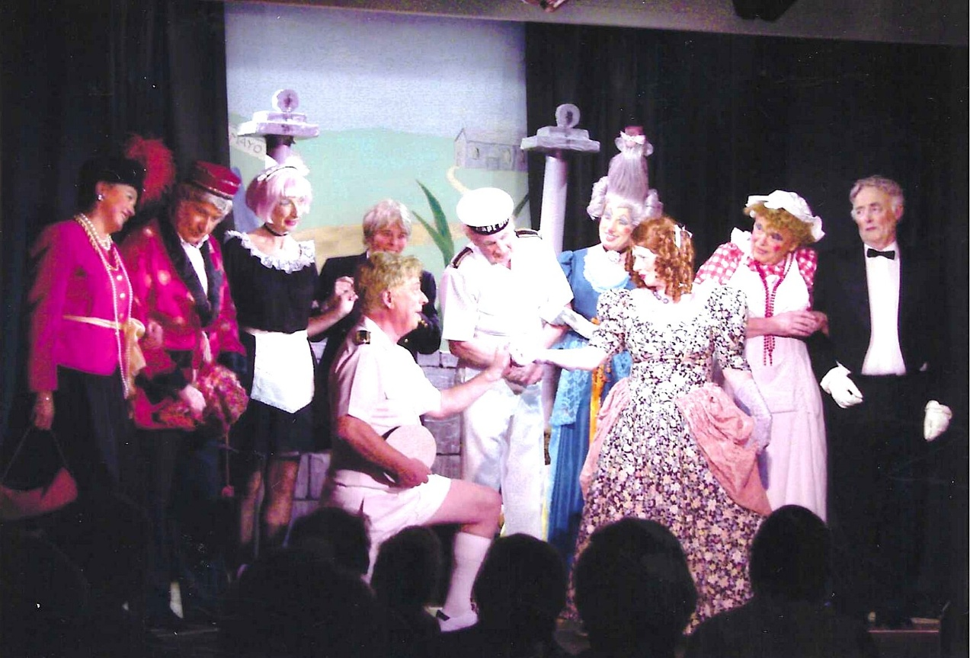
Janet Cattanach, Dennis Shore, Brenda Merritt, Ruth Thrush, Rod Carter, Mike Steward, Hilary Walker, Pam Carter, ?, Ron Carr

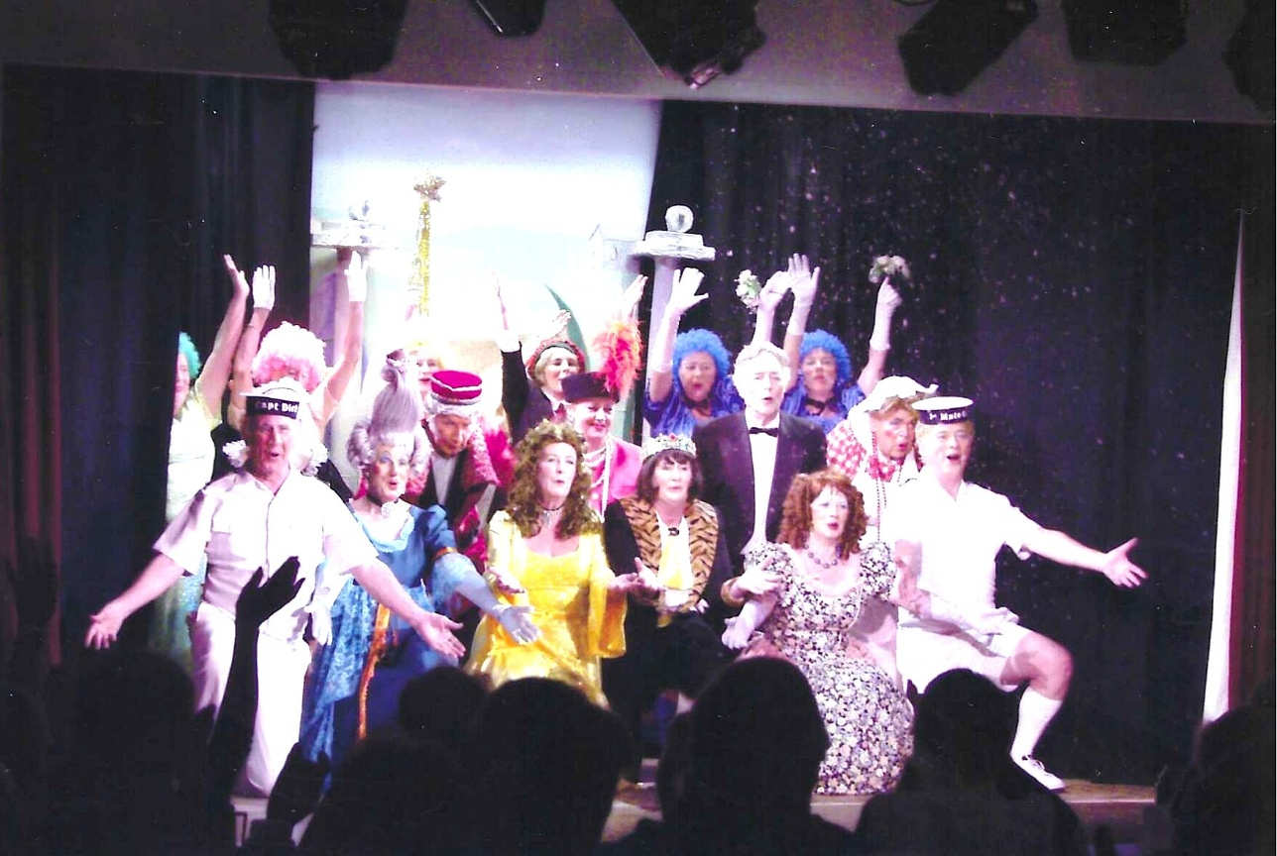
6
7
