2009 Beauty day at Exeter
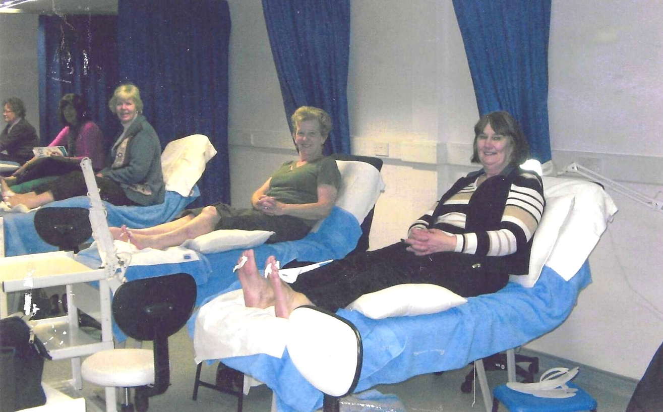
R-L Jean Ellis; Janet Cattanach; Kate Lawley

