*Twelfth Night by the Lord Chamberlains Men*

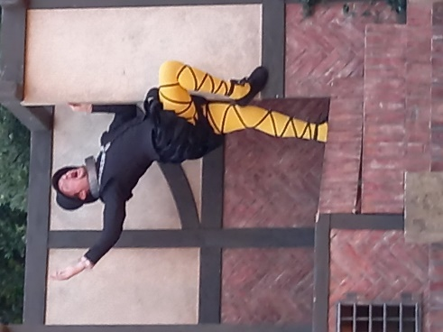Hilarity and romance ensue in the kingdom of Illyria. Meanwhile, there has been a terrible shipwreck....

*Twelfth Night* is a beautifully messy comedy of mistaken identity and romantic entanglements. Set in the mythical land of Illyria, twins Viola and Sebastian are violently separated by a storm, spending the whole play undergoing various romantic adventures.

Themes of love, disguise an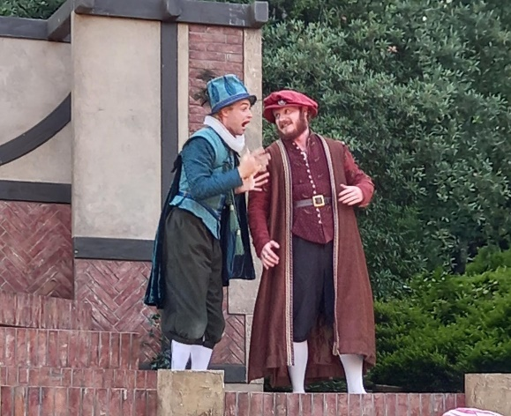d the fluidity of gender are wittily explored in *Twelfth Night*, making it a charming story. The play is hilarious, chaotic and sweet, and includes compelling characters such as Viola, Orsino, Malvolio and Sir Toby Belch.

**Viola**

* 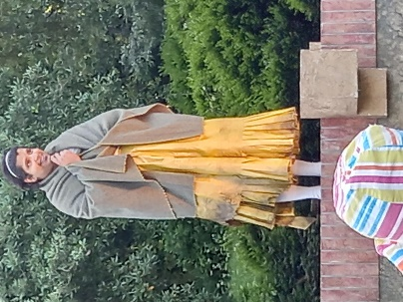She starts the story washed up on the shore of Illyria when her ship is wrecked in a storm
* Viola decides to make her own way in the world.
* She disguises herself as a young man, "Cesario," and begins to work for Duke Orsino.
* She falls in love with Orsino even as Olivia, the woman Orsino is in love with, falls in love with Cesario.
* Viola finds that her disguise is now causing her problems: she cannot tell Orsino that she loves him, and she cannot tell Olivia why she, as Cesario, cannot love her.

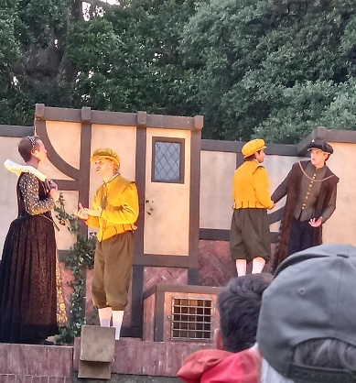Sebastion (Viola’s twin) is mistaken for Viola. Andrew thought Sebastion was Cesario. Starts to unveil the ending of the story, because you start to think that Viola and Sebastion are going to reunite.

* Duke Orsino gives his thought on love. He thinks that love is a game. He is in love with the thought of being in love. He wants to pursue the love of Lady Olivia, a wealthy and noble lady. But she is mourning the death of her brother for seven years and is heartbroken
* Viola’s arrival as Cesario allows Olivia to break her oath.
* Olivia begins to pursue the love of Cesario, Not knowing that he is actually a she (Viola).