BELL RINGING TASTER DAY
AT BUCKFAST ABBEY TQ11 OEE
TUESDAY 1st AUGUST 2023 FROM 10am to 4pm. 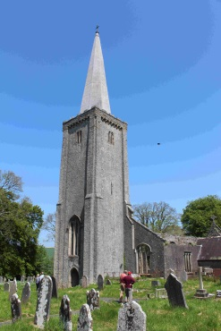
Nicola Jones, Publicity Officer of the Guild of Devonshire Ringers and Geoff Pring, Buckfast Abbey Warden, invite you to a bell ringing taster session at the Abbey.
Nicola and Geoff will be in charge of the day. They will be supported by Guild ringers and teachers from all around the local area. Timings of activities are worked around the Abbey service times.
The day begins with coffee at the Grange before 10am
Morning session 10am -1pm. Lunch 1pm-2pm. Afternoon session 2pm-4pm.
We start at 10am with an introduction to the basics of bell ringing, with videos, a mini ring and a demo bell, before members move to the “Ringing Room” up in the tower. Here we will see and hear some of Devon’s best ringers ringing the Abbey’s magnificent bells. A quick climb further up the tower to see the bells close up may also be possible.
Members need to be mobile enough to walk up a lot of steps, along an exposed balcony, and have a head for heights. Less mobile members will be able to see the ringing room by live camera feed down in the class room. We will then have some more teaching to prepare us for the afternoon session.
After lunch we will go to “the tower” nearby. Holy Trinity tower is surrounded by the atmospheric ruins of the church which burnt down in 1992.

Page 2.
The tower has been fully refurbished. Approximately a mile down the road, it is far enough away for us to all practise and not upset the neighbours or disturb the monks! Here we will divide into smaller groups and expert teachers will get us to have a go on full size bells. Members will need to drive to the tower or it is a 20 minute walk.
We suggest members find their own food and coffee in the Abbey Restaurant or bring a packed lunch. I suggest ear plugs too.
COST of the day £6.00.

Tickets available from Pat Wyatt, 27 Langstone Close, Torquay TQ1 3TX.
Email : tishawyatt@googlemail.com

PLEASE send an SAE for tickets and make cheques payable to DFWI
Closing date 4th July 2023

Booking slip
Number of tickets………@ £6.00 ………….. WI ……………………………………………
Contact email or telephone number ………………………………………………………………

