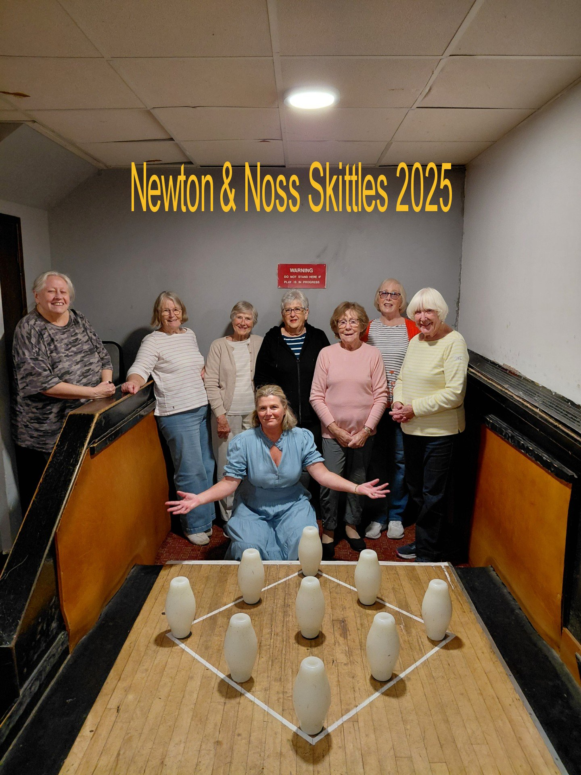

The skittles team had a match this morning 29/10/2025, against Yealmpton.
L-R June Blackburn; Jeanne Venning; Yvette Steward; Jackie Ross; Gill Tune; Carrie Dixon & Barbara Geddes: Kneeling in Front is Fran Brunton
To say we were thrashed is an understatement, but the better team won!

So our match days are over, and we set up an opportunity to play purely for fun.

