Yealm Group Spring Meeting 2025

On the 13th May 2025, Newton Ferrers & Noss Mayo hosted the Yealm Group Spring Meeting 2025.
It was a lot of work. Initially we didn’t think we would make a profit, or have large enough turn out.
It was especially difficult because only 1 committee member had ever been (Carrie), and the rest of us had never heard of them!
Perhaps it was good we didn’t know what went on before as we did it “our way”.
Some committee members had a job to supervise;
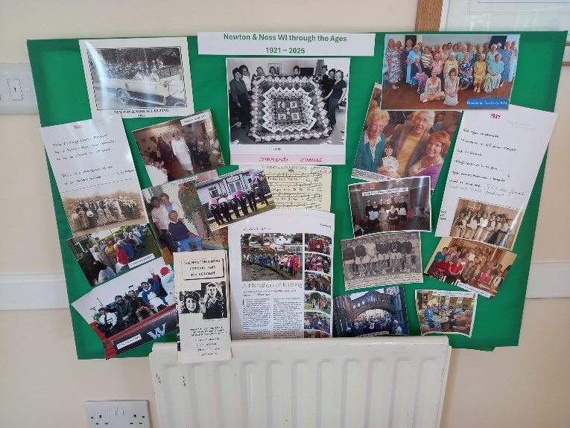
Brenda was in charge of supervising the catering.
Carrie was in charge of the raffle with the help of Jackie
Julie & Stella were meet and greet at the door.
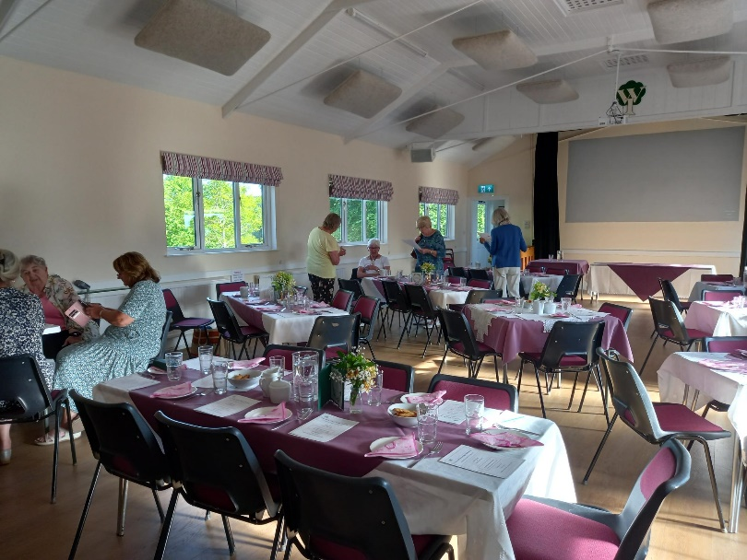
Lesley did the quiz and decided to do table numbers with the name of the table host on them; as well as doing a photo board showing the history of Newton and Noss from 1921 to present day.
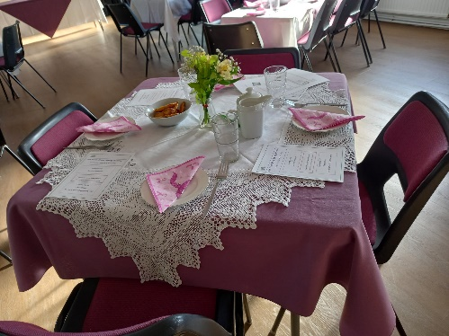
Gill was in charge of the flowers with the help of Lesley.
However, before we got that far, it was all hands on deck to set up the tables and chairs; lay the tables with our monogrammed crockery, cut up donated cakes from our members, and generally make it look nice.
As WI ladies arrived they gave in bags of old or unwanted bras for recycling.
Unfortunately, we had 6 difficult ladies from 1 WI group, who insisted on sitting together. The whole idea is to sit with members from other groups and get to know them.
This completely messed up the seating plan, and delayed some people from sitting while Julie, Lesley & Stella frantically rejigged the seating plan. Their excuse was that some of them were deaf. Lesley explained that we did have a hearing loop, but that wasn’t good enough. They still wanted to sit together.
We opened with Jerusalem.
Our speaker was Caroline Hemmings from De Bora in Exeter, talking about bra’s and their construction; the different body shapes, and surprisingly a red lingerie set that doesn’t show under white!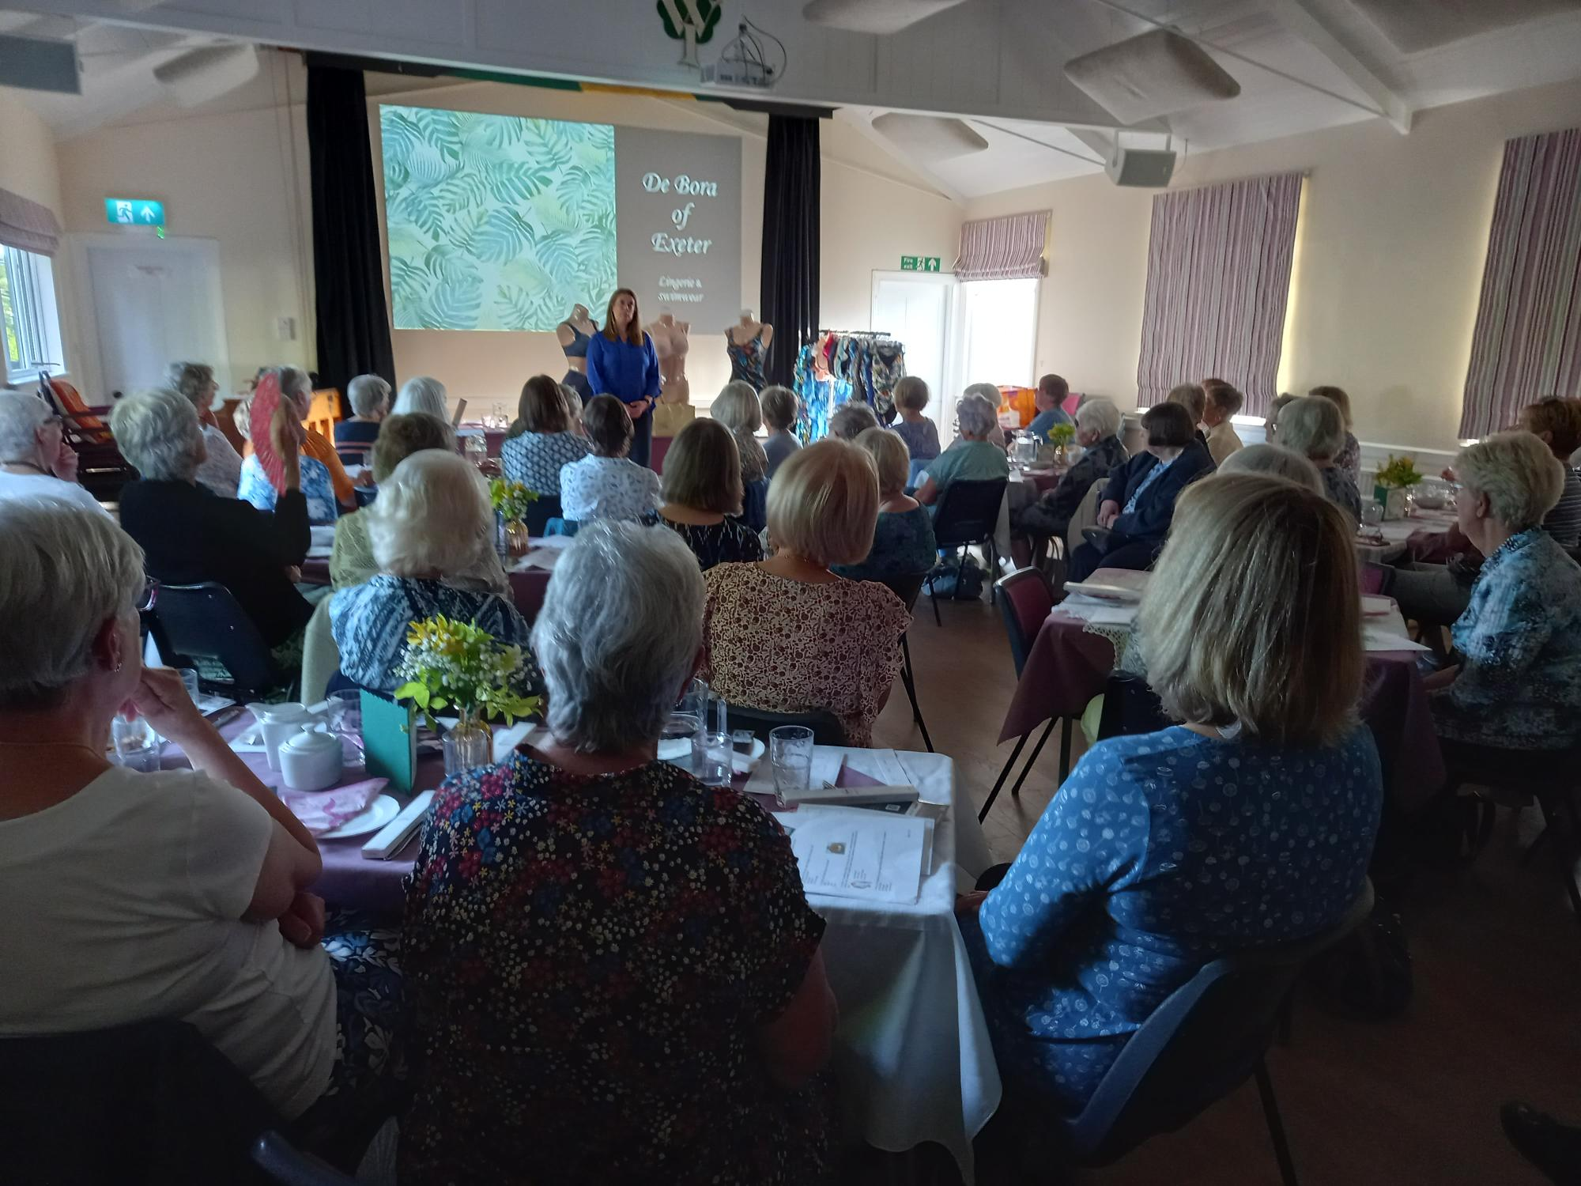
Caroline went down really well, and had lots of questions afterwards, and she stayed until the end.
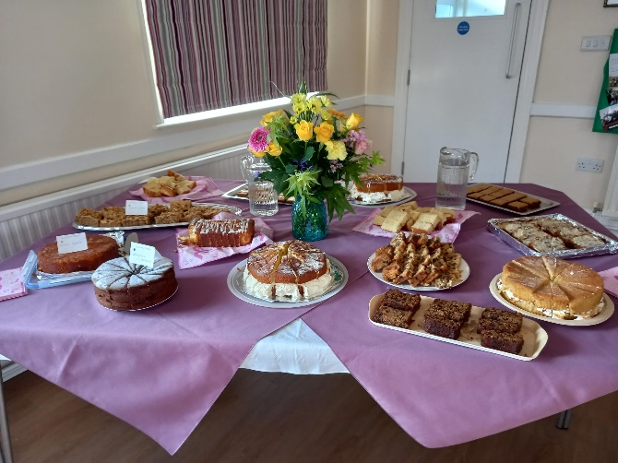
Our members had baked cakes, and there was a lot of choice even for gluten and dairy free people. After tea, which with hindsight we could improve on (service wise), we had the quiz, with 1 table getting 13 out of 19 questions correct, about various forms of underwear. They won little organdie bags of chocolate which Nan had put together.
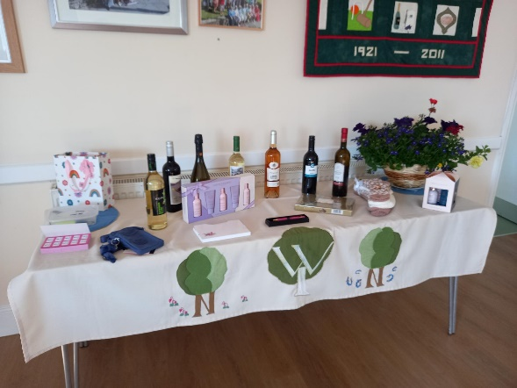
The raffle raised £155. (The notes were given to Caroline- on top of her fee) which went to her charity which recycles bras. The good ones going to a charity which provides essentials to women who have lost everything – possibly due to a fire or other emergency etc.
The cash, plus the share that the other groups waived went to Breast Cancer research (the profits – or losses; are shared between the 6 groups, but if it is a small profit they donate it to charity) So at the time of writing £57 is on its way to BCR.
It took us until 10.30 pm to clear up, and we were all very tired afterwards
However, we had lots of compliments from the other groups, and our own members; which made all the sleepless nights and worry worthwhile.

