On Tuesday 21st April we held our 1st line dance taster session.
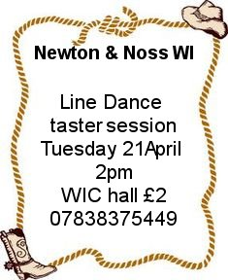
We had done a little advertising, but not much. It was designed as a recruitment drive for younger women, proving the WI isn’t all jam and knitting.
Barbara Geddes offered to teach, and bought 2 friend along to help.
Lesley had the music all set up on her laptop.
None of us knew how it would turn out.
We had a hitch within our first 10 minutes. – the music wouldn’t play over the projector system. Trisha came to the rescue with a blue tooth speaker. I need to go back to the hall committee to find out why! The microphone worked, but wasn’t needed.
We had 24 ladies who had shown interest, and knew some of them were unwell; however, we were completely taken by surprise when we had a queue at the door and 30 ladies poured in.
Barbara started us off with the “Electric Slide” ; moving on to “Cowboy Charleston” “Four Corners” and finishing with “My lady rhumba” before enjoying a much needed cup of tea made by Gill Tune and Jill Johnson.
After tea we went through the dances again, with a very brief reminder. Before we finished Barbara and her friends showed us a dance called “A si” which we will attempt next month.
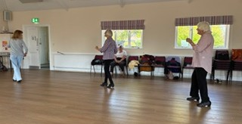

It was amusing for us, but not so much the demonstrators, the music download had a hiccup in the middle and kept going back to the beginning. It was nearly an endless dance!
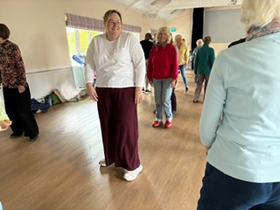
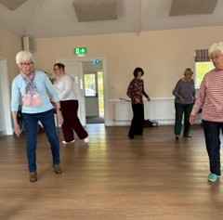
Here are some photos taken by Gill Tune of the event showing the concentration, laughs and yes … dance

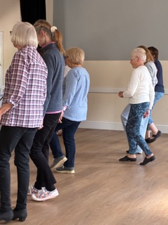
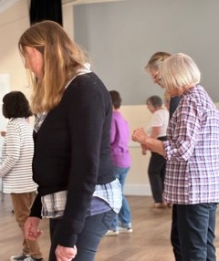
This looks like “My ladies Rhumba”

The feet are all in sync!
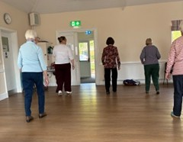
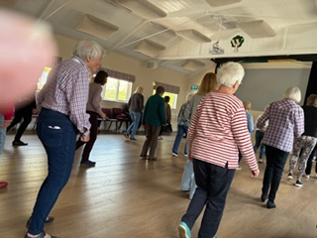

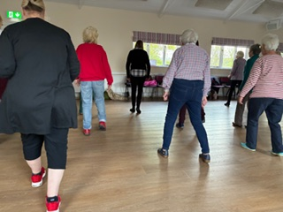
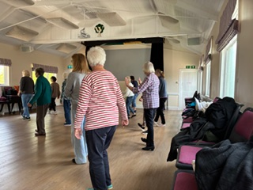
“Cowboy Charlston”

