A Visit to Lady Aster’s House
7th June 2024
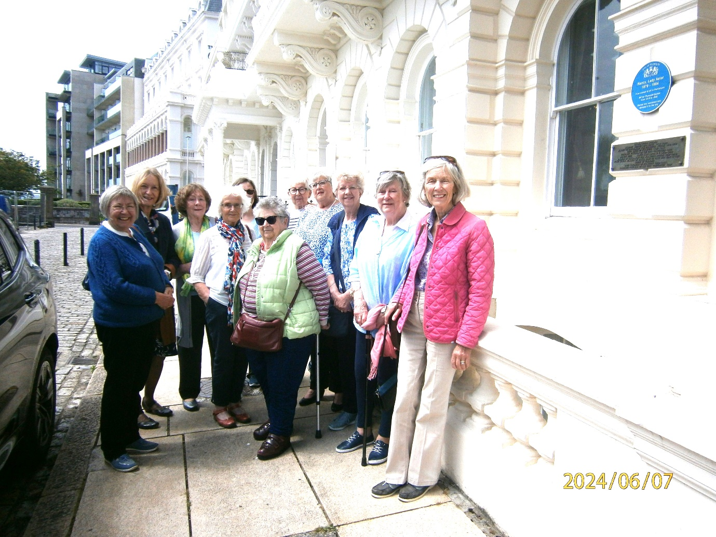A group of 12 of us met at the green before making our way to 3 Elliot Terrace. It was on street parking, so I erred on the side of caution when deciding the departure time. Needless to say, parking was easy, and we were half an hour early.
There was lots of building work going on, and Lady Astor’s statue on the Hoe was cordoned off. (It was unveiled by Theresa May in November 2019.)
Number 3 Elliot Terrace on The Hoe is the Lord Mayor's official residence. It is used for civic events and it's also stayed in by visiting dignitaries and circuit judges.
We were taken round by Steve, the Lord Mayors Mace Bearer/chauffeur. He was a fountain of knowledge, and I cant remember half of what he told us. He was humerous and his enthusiasm for his job bubbled over.
Built in the late 19th century by leading Victorian property developer John Pethick, 3 Elliot Terrace was bought in 1908 by Waldorf Astor who was Mayor of Plymouth between 1939 and 1944. His wife Nancy became MP for Plymouth Sutton in 1919 and made history as the first woman MP to sit in the Commons. Nancy gave 3 Elliot Terrace to the city as a residence for future Lord Mayors.
Born in Virginia in 1879, Nancy Langhorne, as she was known then, was part of a large family and daughter of a businessman. Nancy’s father at the time of her birth had been struggling to make money: feeling the effects of the American Civil War and the abolition of slavery, the family were struggling to make ends meet. Fortunately, her father’s railroad business prospects blossomed after she was born and after a winning a lucrative contract, the family’s wealth and prosperity was restored.
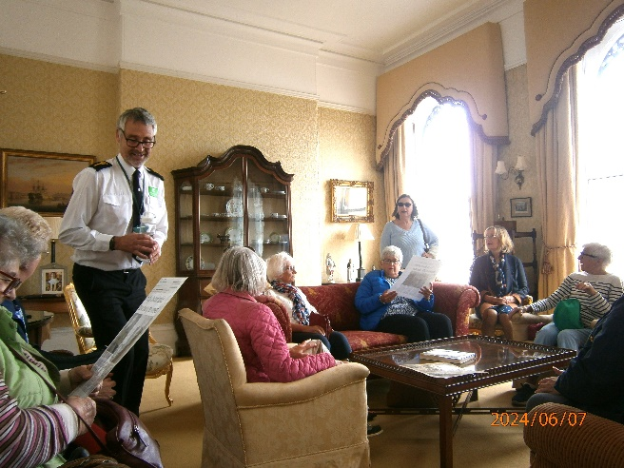
In the 1890s, Nancy attended a prestigious finishing school in New York, the place where she would meet her first husband, Robert Gould Shaw II. The relationship progressed quickly and by the age of eighteen she had married Robert in October 1897 and in the following year gave birth to their only son, Robert Gould Shaw III. The marriage however was not to last. The turbulent relationship lasted just four years, with speculation of Robert’s alcoholism. The marriage took its toll on Nancy and by 1903 they were divorced.
After the disintegration of her marriage, Nancy returned to her father’s household. It was not until her father suggested that she move to England that her life began to transform, more than she could have ever imagined. Having previously enjoyed a trip to England, Nancy was persuaded to move to London in 1905 taking her sister Phyllis with her for company.
It did not take long before Nancy entered the spotlight of the British aristocracy. Her American glamour and quick wit proved to be a big hit amongst the higher echelons of society. She was not short of admirers, however her interests turned only to Waldorf Astor, a prominent figure whose father was Viscount Astor and owner of a national newspaper. They bonded over their shared heritage in America, their similar attitudes and they married six months later. As a wedding gift to his son and new daughter-in-law, William Waldorf Astor presented them with Cliveden, an exquisite estate located on the Thames as a wedding gift. The fairytale complete, the Astor’s went on to have five children.
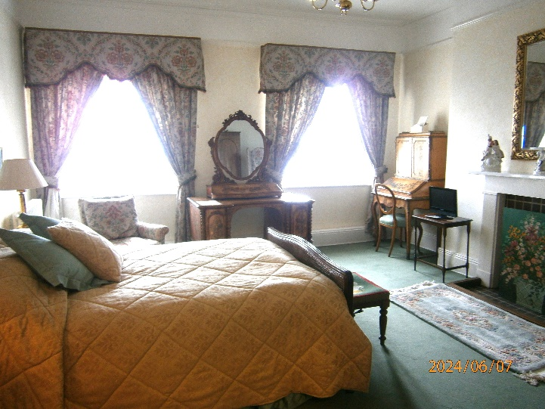
In the meantime, Nancy Astor threw herself into the social responsibilities of being a member of the British aristocracy. She proved to be a brilliant hostess and made several acquaintances through her networking and socialising. In addition to their country estate, the Astor’s owned a splendid home in St James Square in central London which proved to be perfect for entertaining with its large ballroom and luxurious reception rooms. The setting for many a decadent dinner party, the building still stands true to its former grandeur today, although now housing a naval and military club.
As Nancy met with more people she found herself mixing in political circles. Meanwhile, her husband entered the political arena in 1910, winning an election as a Unionist to represent the borough of Plymouth.
Waldorf Astor had a successful political career in the House of Commons and became involved in liberal reforms such as the National Insurance Act of 1911 and the “People’s Budget” which sought to tax the richest in society in order to fund welfare projects. In 1919 his father’s death resulted in his inheritance of the Viscount title and his automatic progression to the House of Lords.
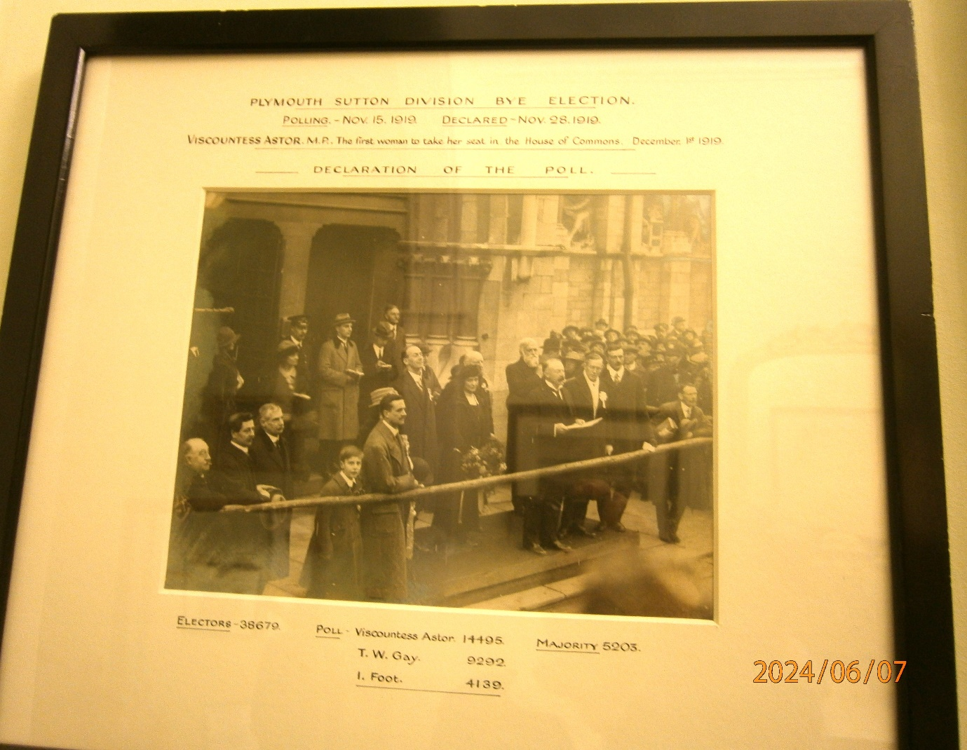
This triggered a by-election for his seat, an election which the newly titled Viscountess Nancy Astor won. This result made Nancy Astor the second woman to be elected to the House of Commons. The first had been Constance Markievicz who never took her seat in the Commons due to her Sinn Fein party abstention policy.
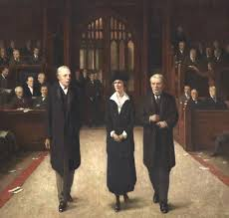
On 1st December 1919 Lady Astor took her seat in the House of Commons, a historically significant event which would change the political and social sphere for years to come. Nancy’s sharp mind and American wit proved a advantage in her political dealings. She was not one to shy away from the spotlight and she remained outspoken on the issues she felt strongly about. She chose to support lowering women’s voting age to 21 years of age rather than 30 years and chose to advocate women’s rights in her speeches. She was a female voice in a sea of male dominated political voices. Her voice and position as an MP was important.
Her dedication to a variety of causes was evident in and out of parliament. She supported education expansion and women’s roles in the civil service, not to mention the minimum age limit for drinking to be set at eighteen which remains today.
By the time of the Second World War, the global landscape was changing. Neither Nancy nor her husband wanted to engage in a war with Germany and preferred the policy of appeasement. Despite this, Nancy and her husband did contribute to the war effort by running a hospital for wounded soldiers and using their own wealth in funding projects in the city of Plymouth. Nancy also proved influential in Winston Churchill‘s rise to power in 1940.
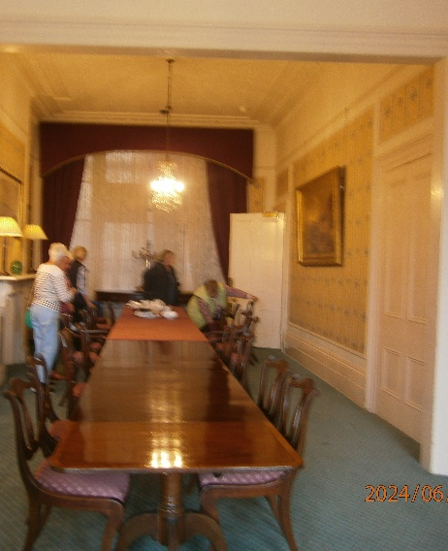
Nancy continued to serve as an MP until the end of the war in 1945 when she was advised by her colleagues and husband not to stand again. Her outspoken voice had evolved into more erratic behaviour and by the end she had lost touch with the new social and cultural dynamics of the day. The time had come for her to step down and with that she retired, leaving twenty-four other women to take their seats in parliament in the same year.
The house was filled with antique furniture, photos, curios and paintings left behind when The Astors moved out.
We were even able to sit on the chairs used by Royalty. It is a working house, not a museum.
Our visit ended with a cream tea in the dining room where civic dinners are held, and served to us by Steve, who was also doubling up as butler and kitchen porter; with one eye on his watch as he was to drive the Mayor at 6.30pm to the theatre. Steve has a very varied and complex job which he obviously enjoyed.

