2010 Choir
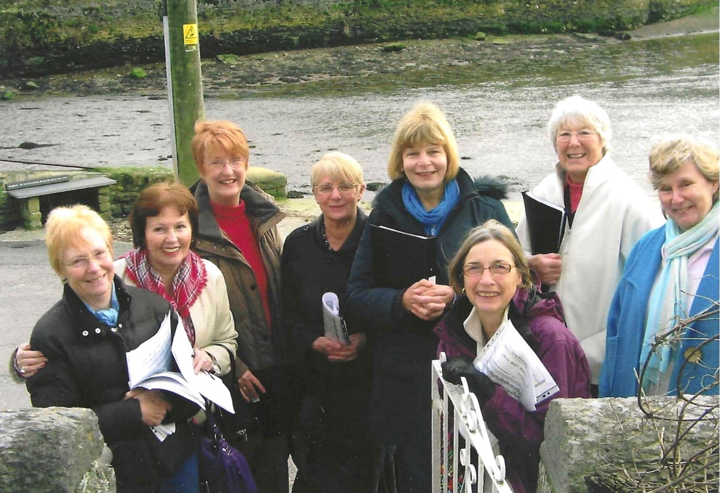

L-R Angela MacPherson; Emma Parker; Judith Stephenson; Sheila Pearce; Carol Williams; Brenda Merritt; Ann Crawford & Jane Barnett

