WHO WHAT WHERE?

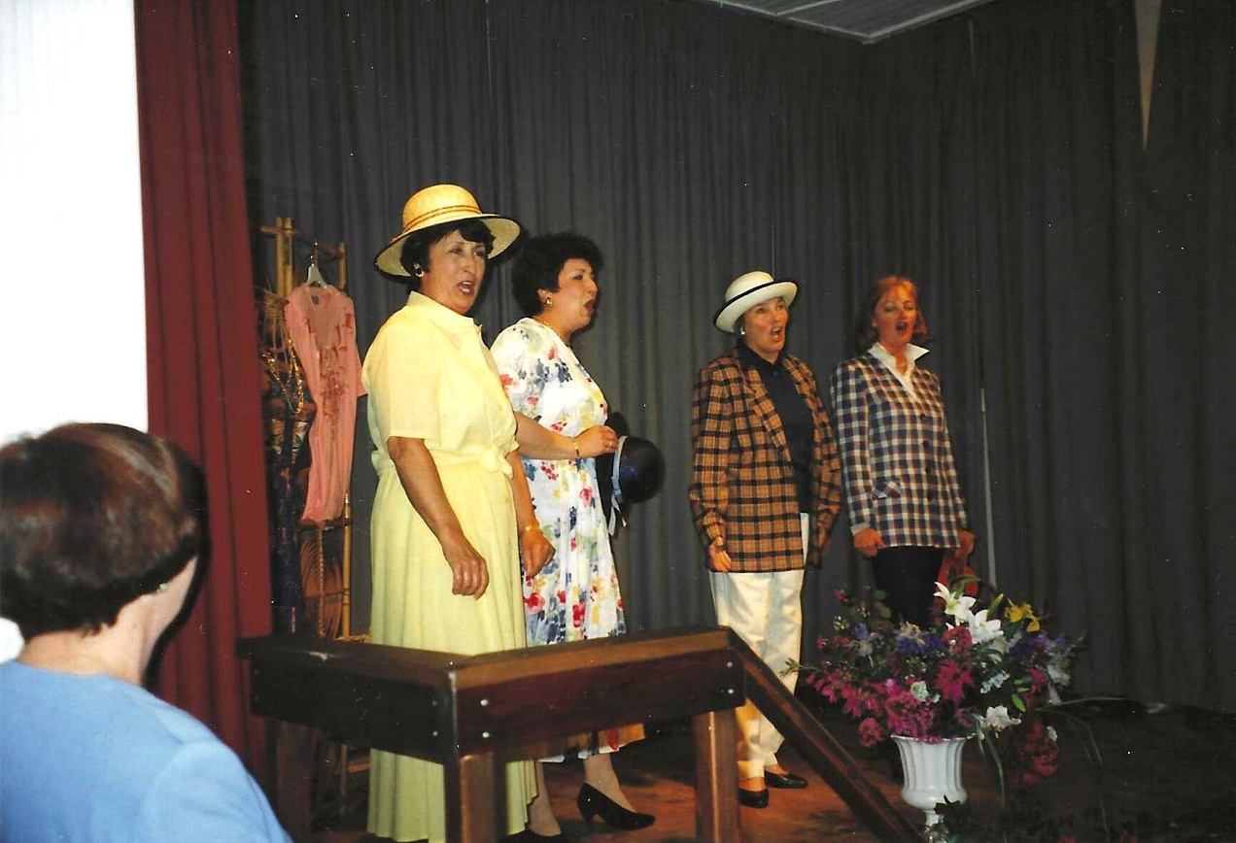
3rd one along Pat Entcott next to her Jill Swift

