Raising funds for PUMA with a lunch at Jill Alexanders’ house

On June 20th, Jill Alexander kindly cooked a superb lunch at her house.
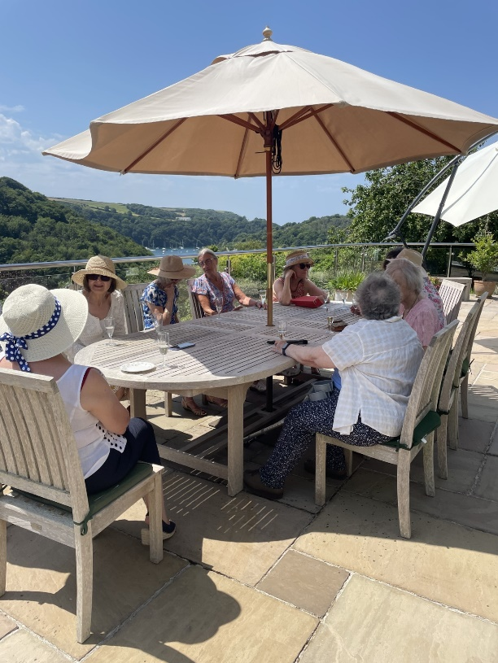
28 of us enjoyed Canapes on the terrace, with a fabulous view of the river, before sitting down to lunch.
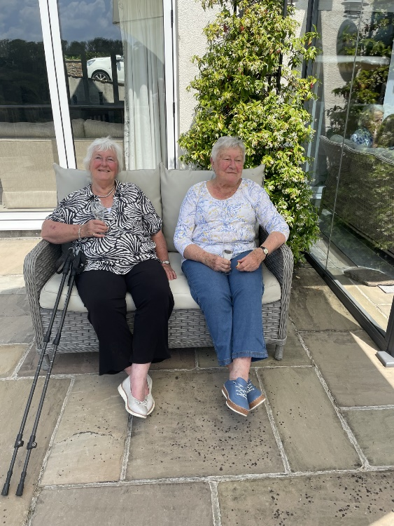
We had a choice of Chicken in a Tarragon sauce, or Salmon, all served with new potatoes

and vegetables.
Desert was also a choice, but all I remember were to chocolate pots!
