2010 Sew-athon Operation Sunshine
Craft Group July
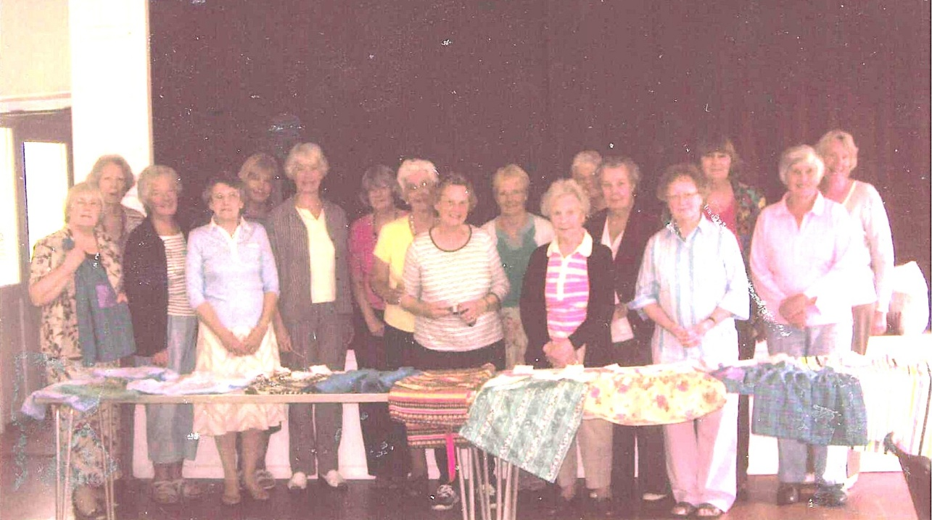
L-R Rosemary Furzeland, ? , ?, ?, Carol Williams, Nicky McDougall, ? , ?, Enid Whiteman, Angela Macpherson, Mary Thomas, ?, ?, Joan Westall, Jean Ellis, ?, ?,

