2010 Committee Lunch
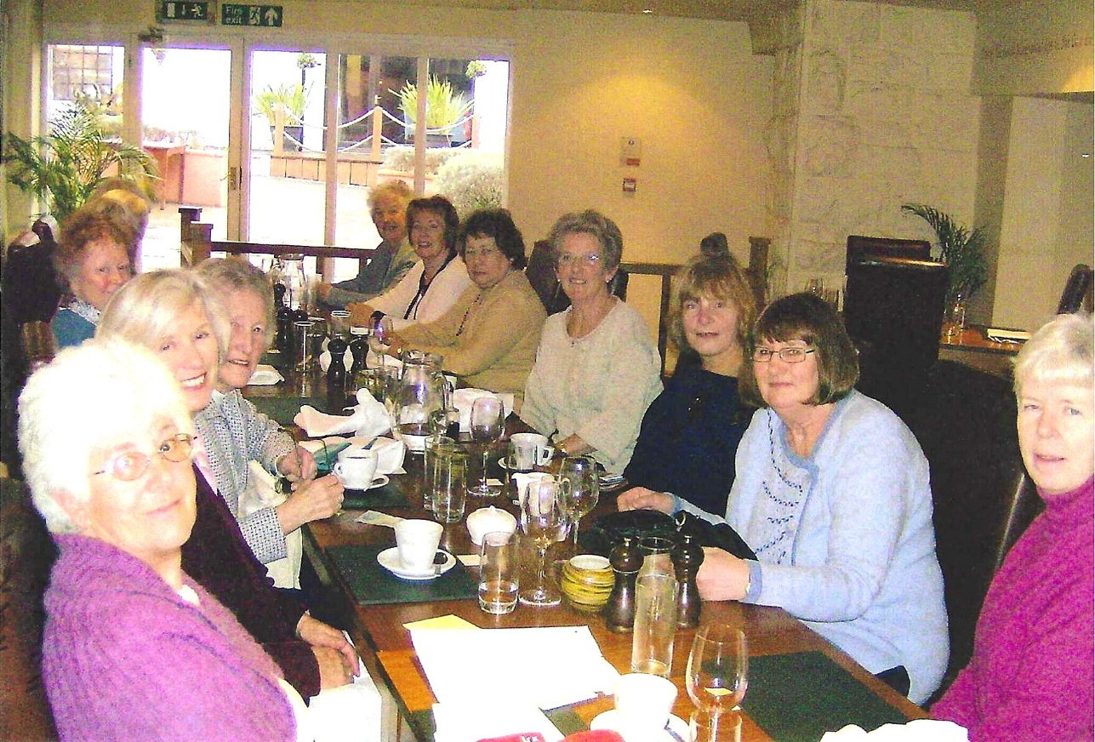

L side: Hilda Julien; Margaret Pritchard?; Betty Christie; Joan Westall
R side: Kate Lawley; Jean Ellis; Carol Williams; Janet Cattanach; Marilyn Sherlock; Emma Parker; Rosemary Furzeland

