2007 The Amazing Tale of Cinderella
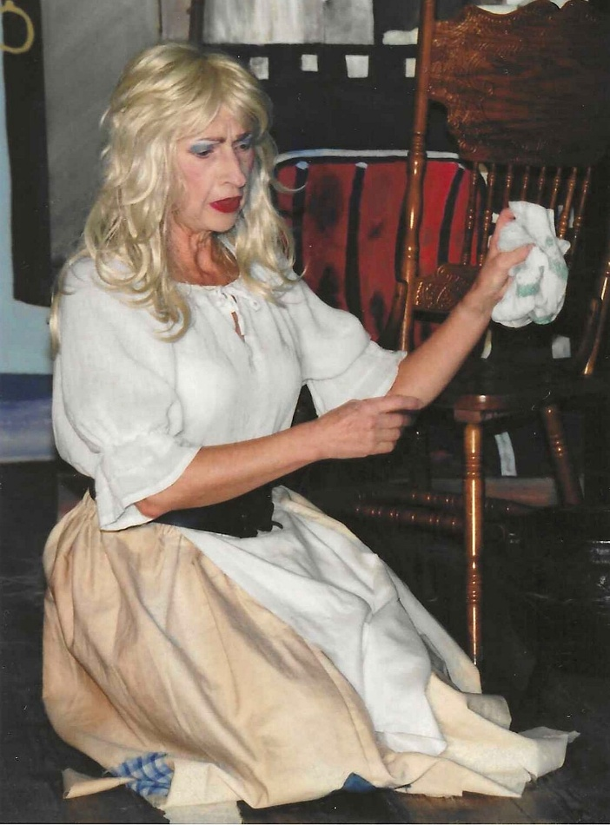

Brenda Merritt

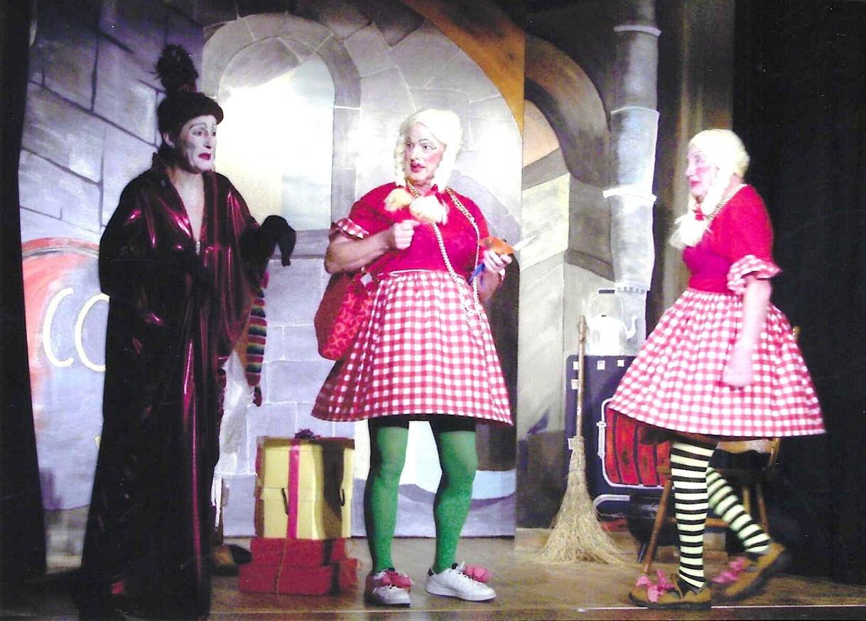

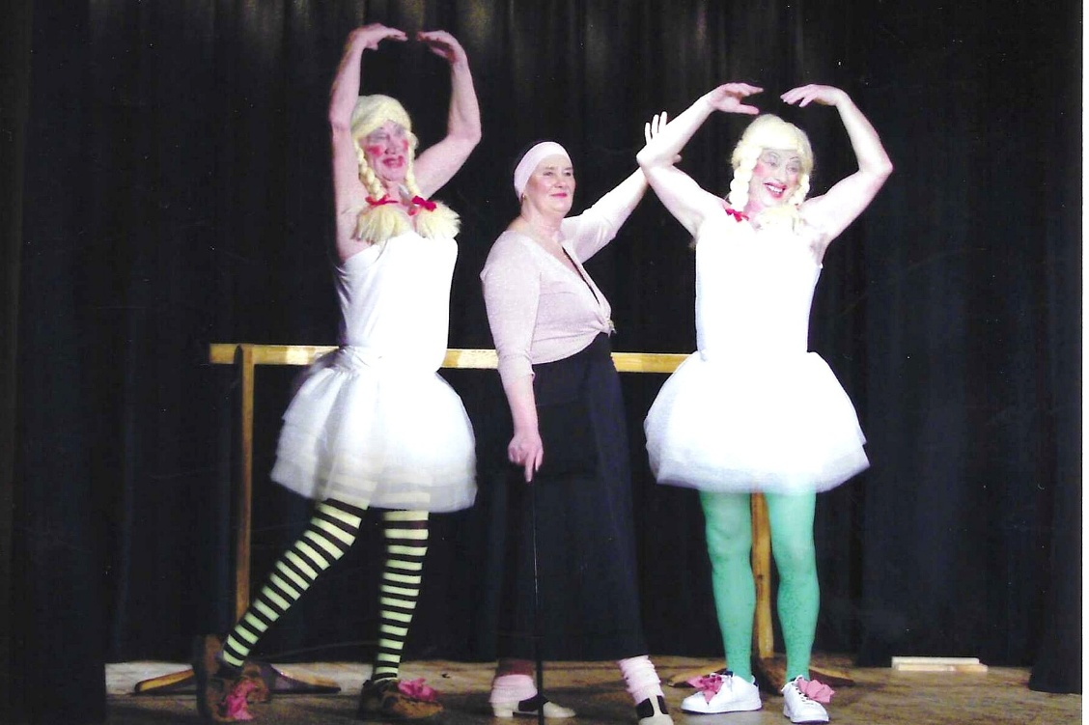

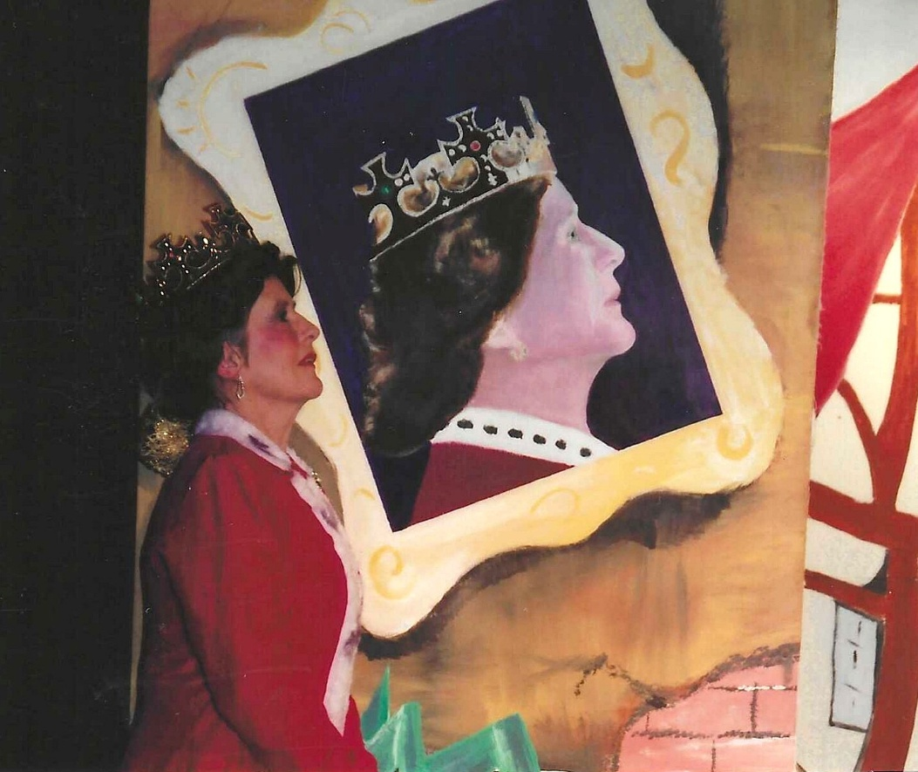

Janet Cattanach

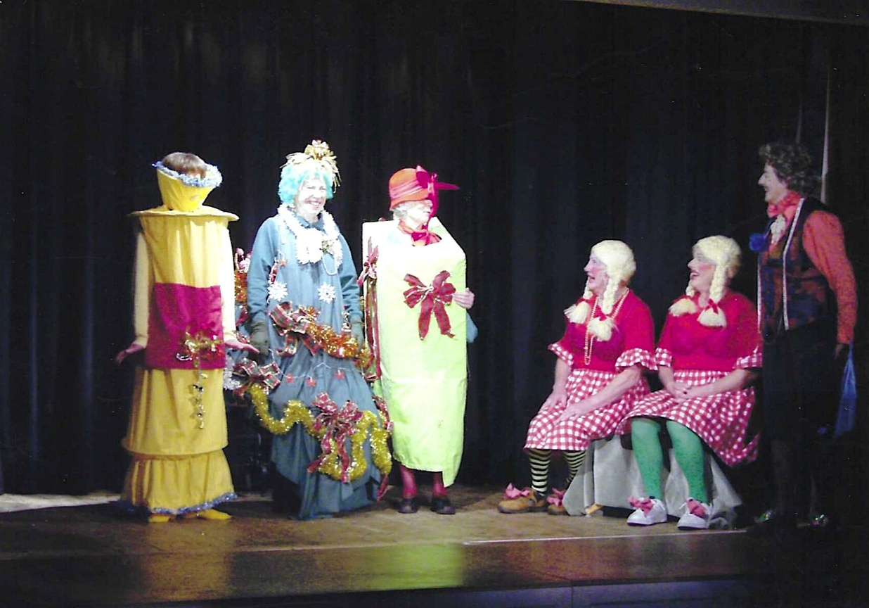

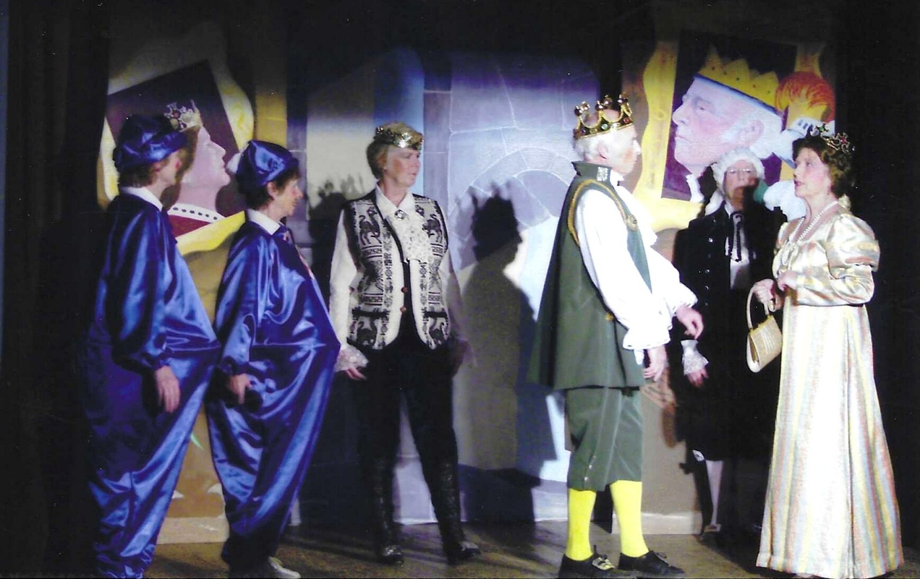

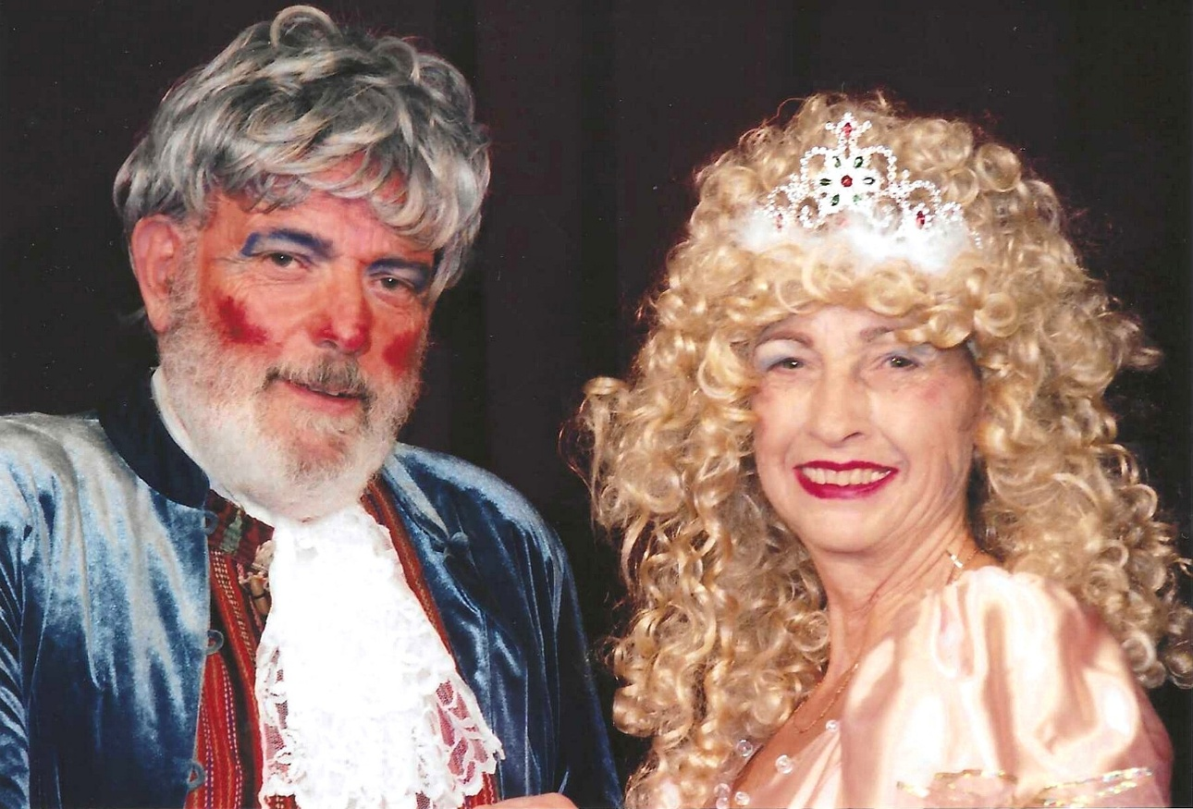

Brenda Merritt and John Alexander
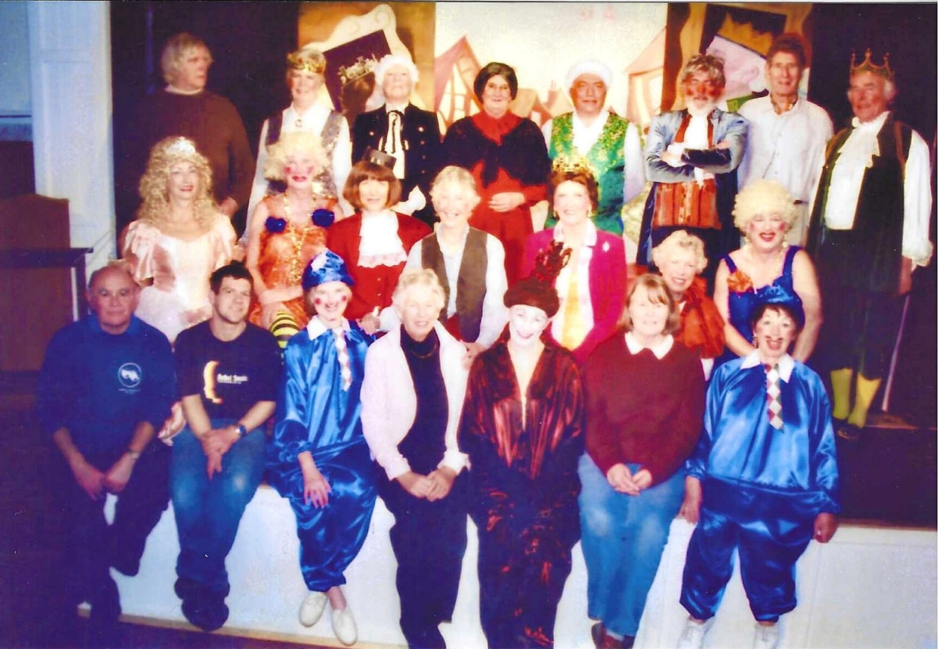

Back Row L-R Val Venning; ?;?;?;?; John Alexander; ?;?
Middle Row Brenda Merritt; ?; Cathy Matthews; ? Janet Cattanach; Christine Wilson; ?
Front Row; ?’?’?’?’?’ Jeanne Venning; Pam Carter

