Willow Weaving at Down Thomas 13/5/2026

9 of us from Newton & Noss joined members of Yealmpton & Brixton WI at Down Thomas for willow weaving .
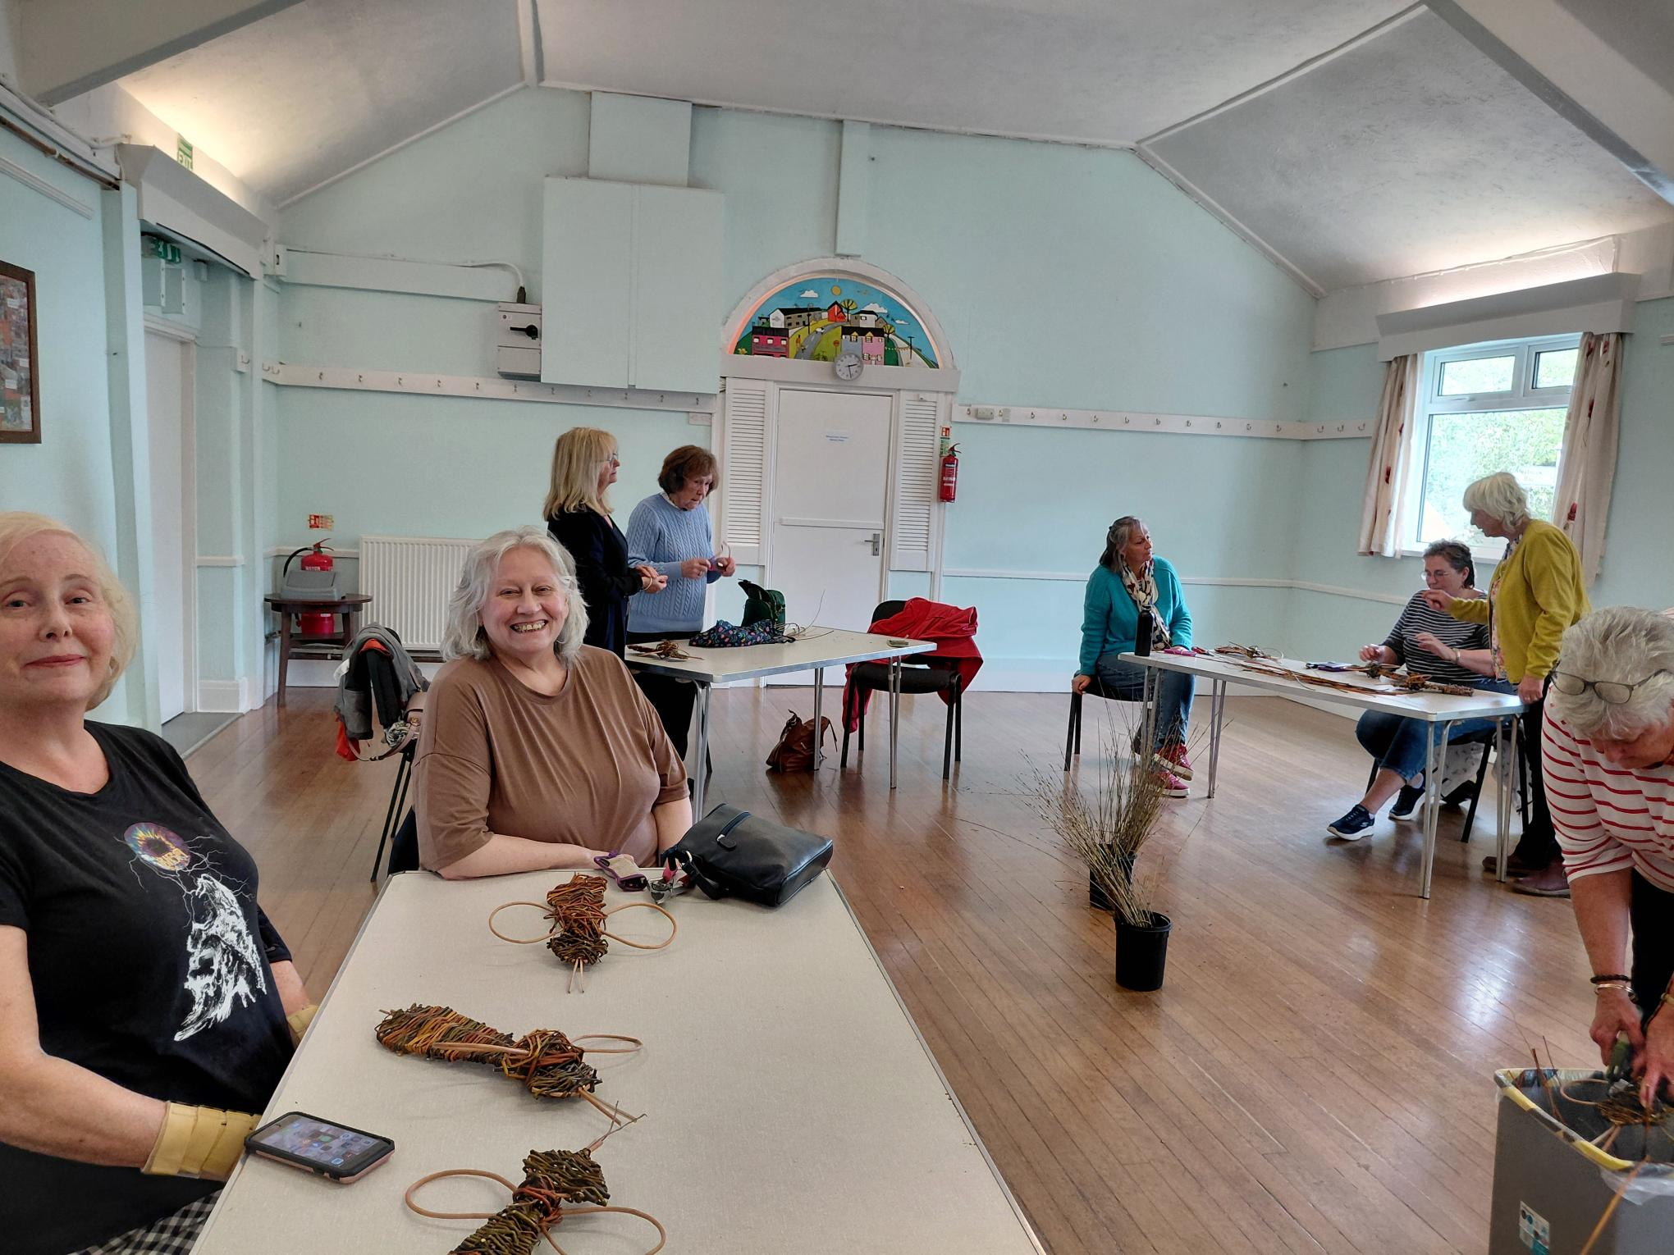
We were L to R: Carrie Dixon; June Blackburn; Jenny Scott; Gill Tune; Lucy Stevens; Bryony Lloyd; Glyn Gibb; Jackie Ross; and photo was taken by Lesley Dempsey.

We were making bees under the guidance of Vivienne. The workshop was sponsored by Life on the edge.

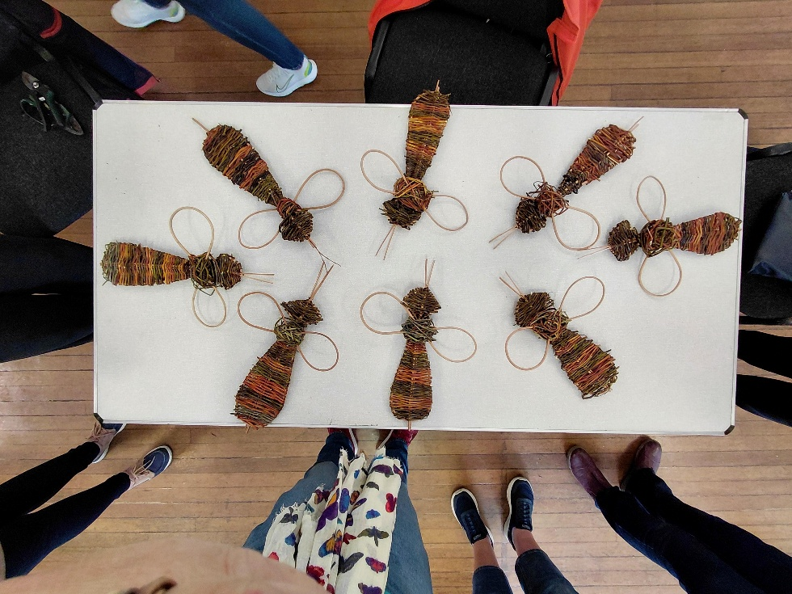

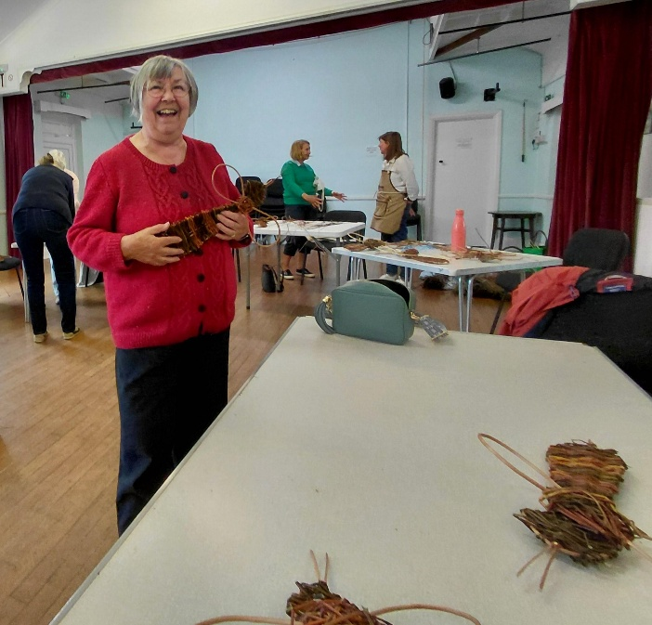
Vivienne had made the outline of the bee body and head for us. It took longer than I thought to weave the willow to fill in the bee. It was also hard on the hands, but enjoyable work. Then we had to attach the wings before Vivienne split the cane sticking out of the bee’s head to make antennae.
It was. Our bees were meant to be Carder Bees. All were slightly different.
Lesley and her bee.

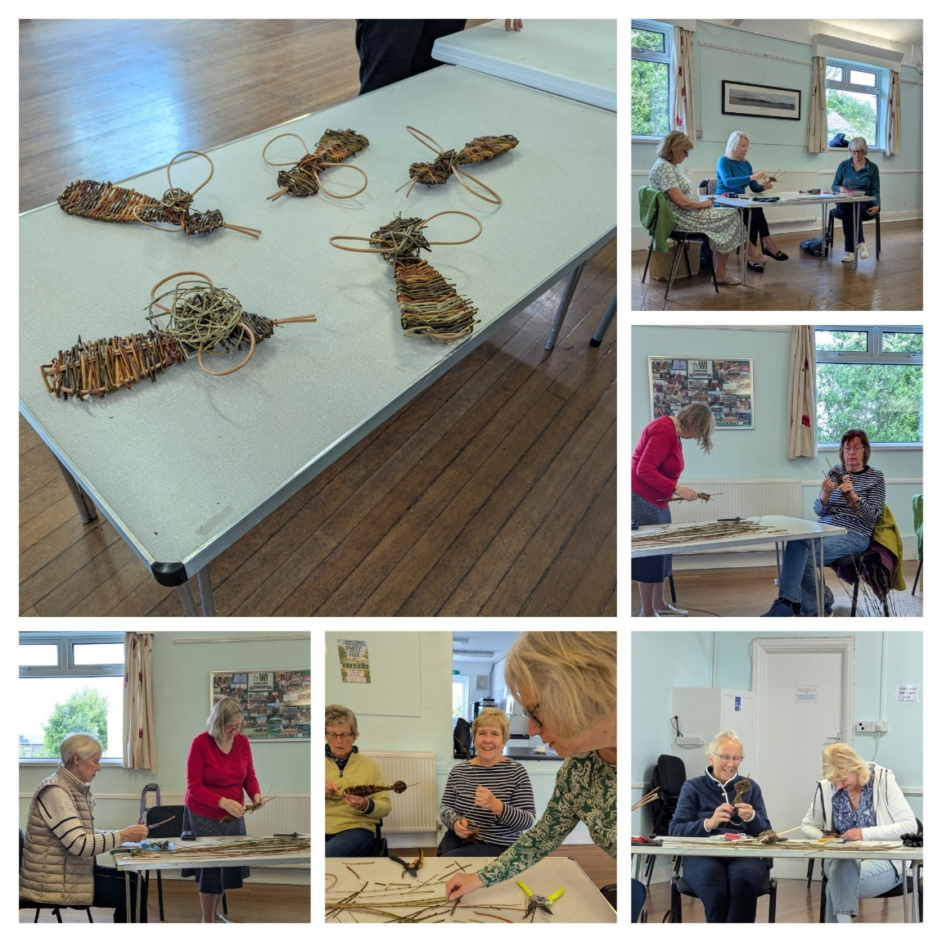
We look forward to our next workshop in June.
