Diana Little’s fundraising Race for Life
In memory of WI member Janet Cattanach
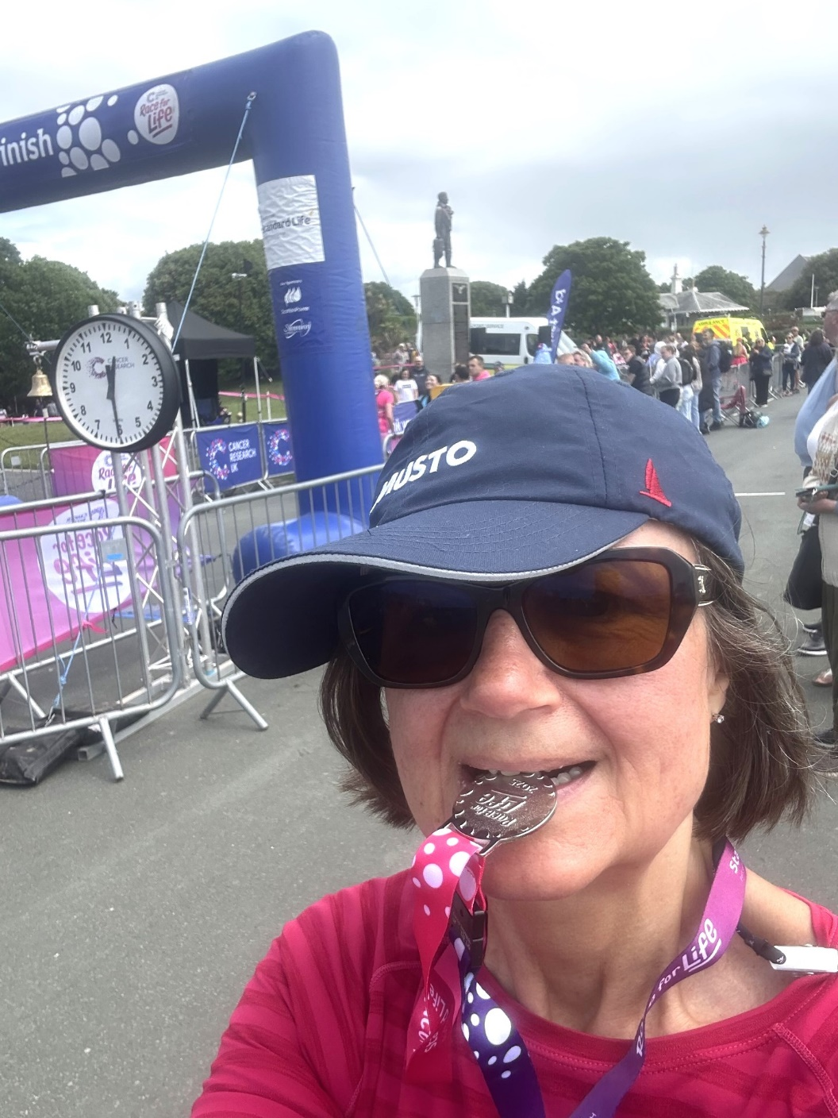
Done it!

From zero jogger to 10k jogger in one race🏃‍♀️ 🤣😂🤣. For 1 day only!

Never intended to jog the course but accidentally started with the joggers!

My time 1hr 15mins.

Super proud ‎& great fun 🤩

A BIG THANK YOU TO EACH AND EVERYONE OF YOU WHO HAS SO GENEROUSLY DONATED TO THIS WORTHY CAUSE.

I’ve raised £2,550 so far for Cancer Research👏👌💕.

£2500 could fund the PETReA trial for 5 days. This trial aims to help decide how to treat lymphoma, a cancer of the white blood cells.

(Diana Little is a member of the Newton Ferrers & Noss Mayo WI)

