1993 Group Spring Meeting. March 24th
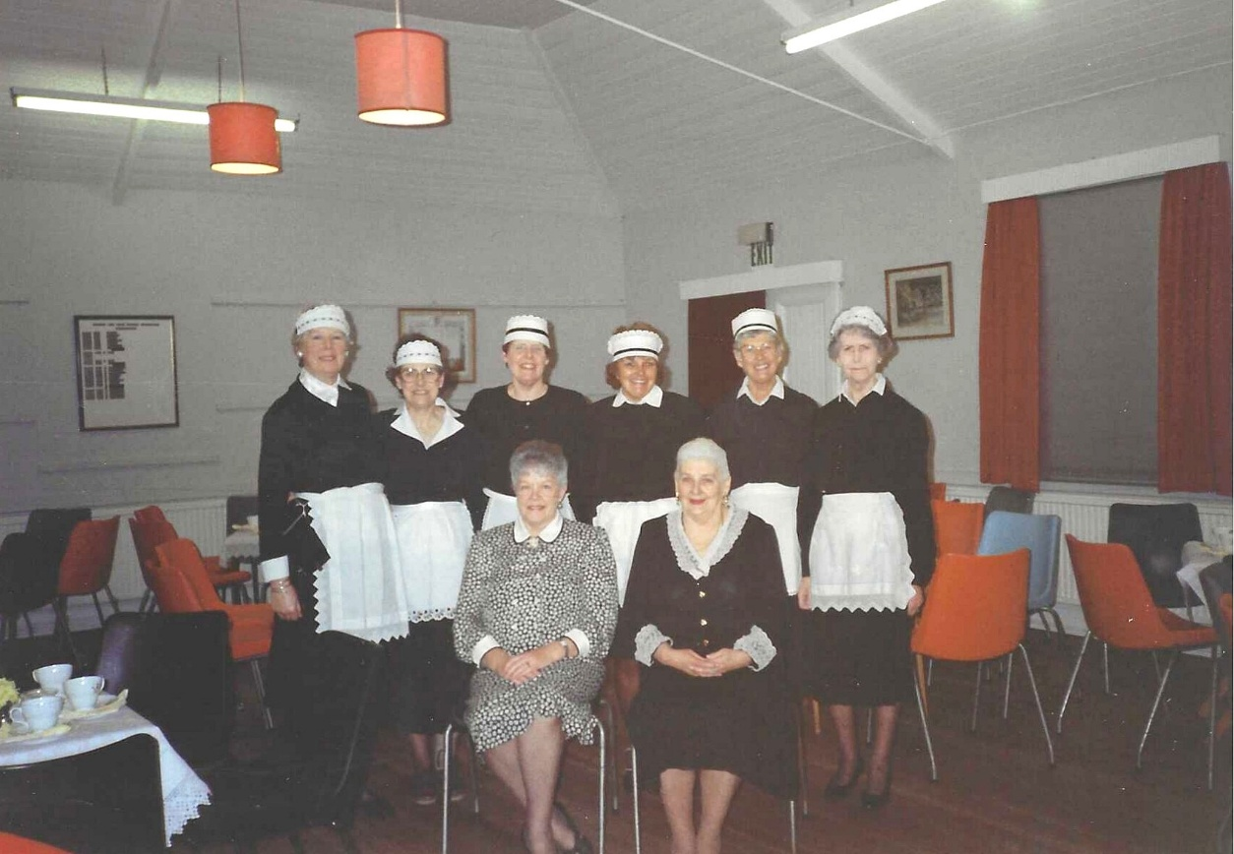

On the right is Paddy Scammell and Judy Shaw
On the Left is Anne Crawford

