WI Centenary Presidents Garden Party
August 2015
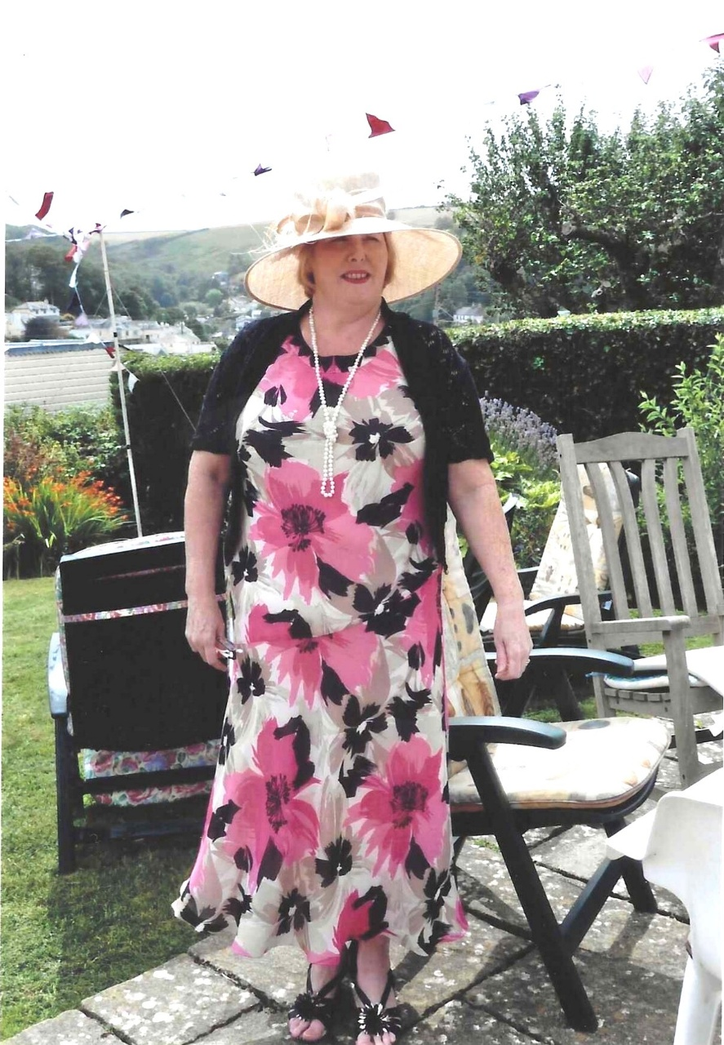

Carrie Dixon
1st Year of Presidency


Marcia Webster (blue Cardi)
Angela Macpherson (standing)
Jenny Glover (Pink hat)



Pat Middleton; Jill Johnson (pink)
Angela Macpherson (Standing)

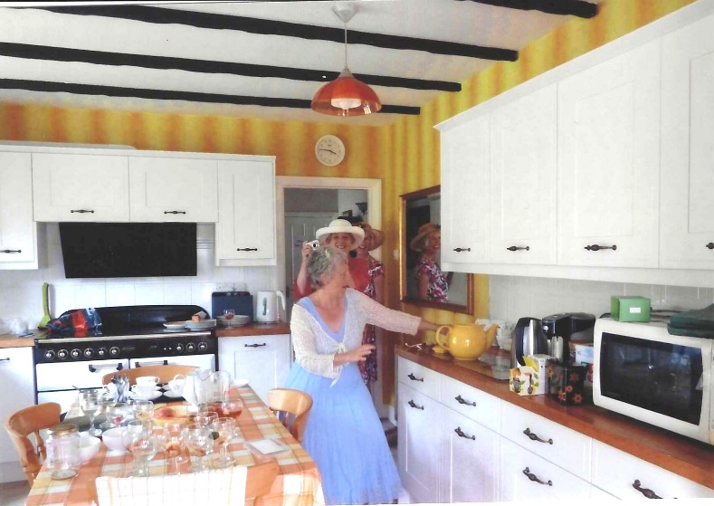

Annette Court-Hampton; Janet; Margaret

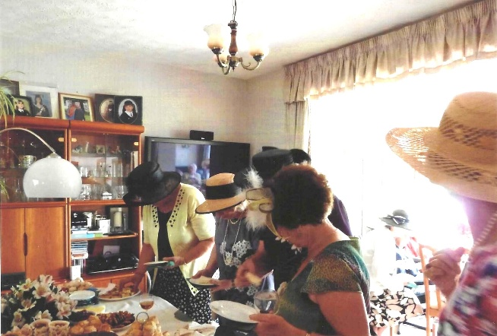
Jean Ellis (Navy Hat)
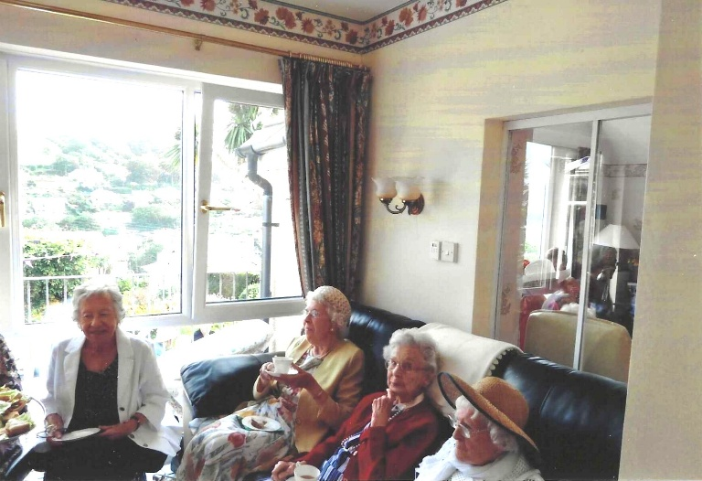
Pam Carter (green)

Mary Thomas

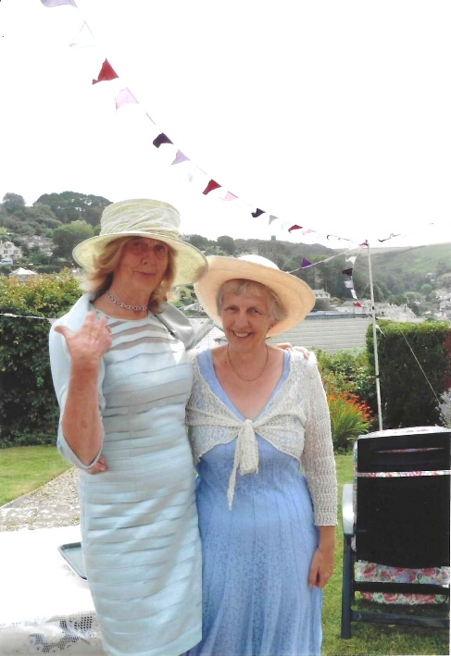

Vicky Ingram & Annette Court-Hampton

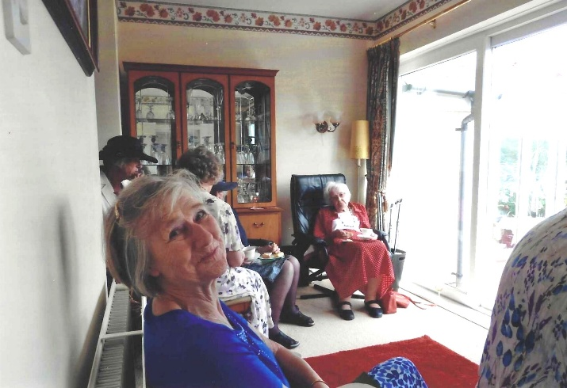

Yvette Steward (Foreground)

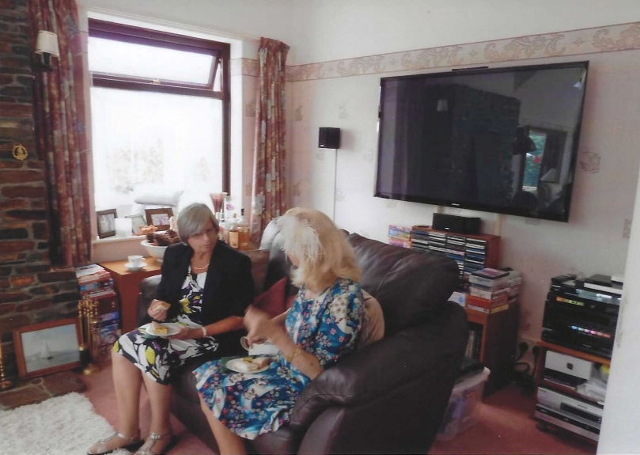

Liz James & Elary Chetwynd

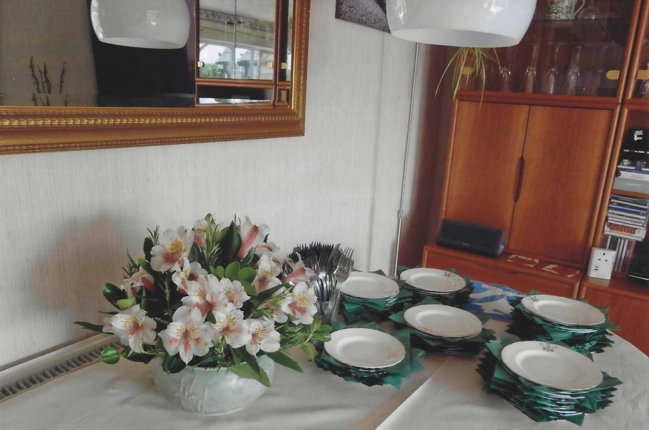

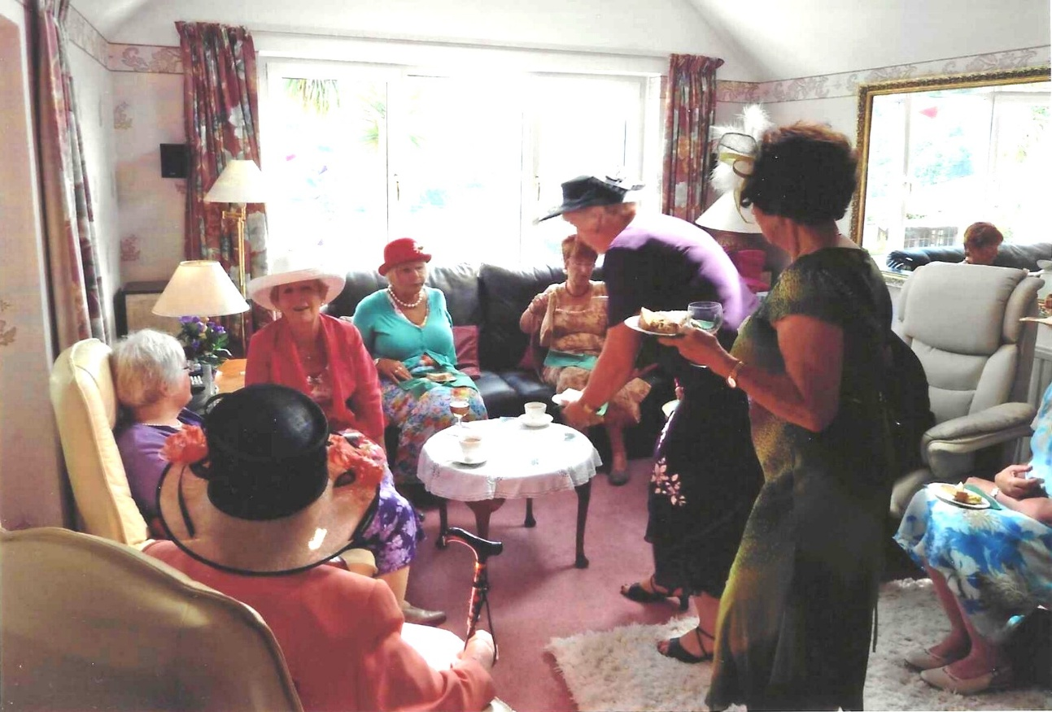

(R-L) Pam Carter; Kate Lawley; Judith Stephenson; Carol Williams
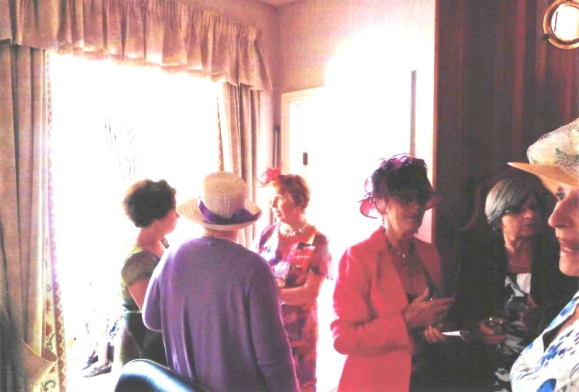
Rosemary Furzeland (lavender)
Pam Carter (green dress)
Emma Parker (floral)
Joyce Stickley (red)
Liz James (black jacket)

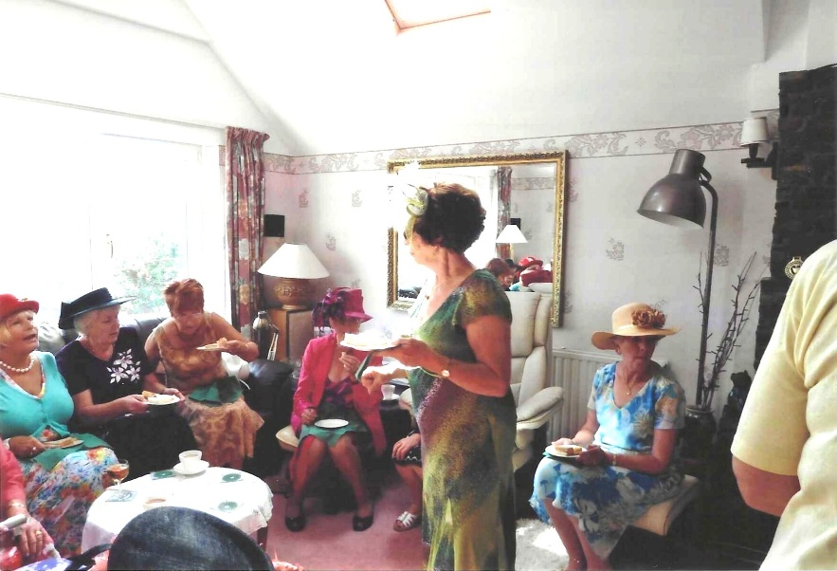

Carol Williams (turquoise top)
Kate Lawley (black top)
Judith Stephenson (rust)
Joyce Stickley (red)
Pam Carter (Standing)
Jill Alexander (straw hat)

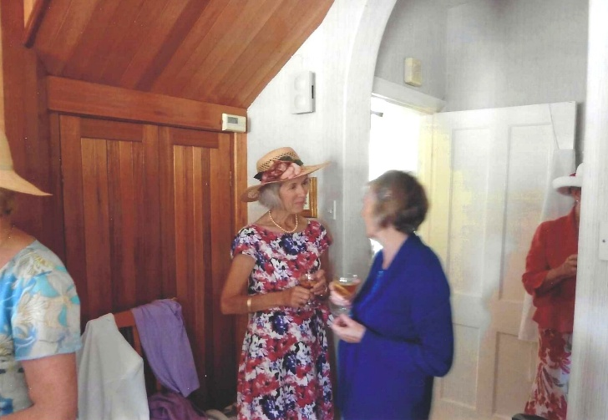

Margaret Pritchard
Yvette Steward (blue)

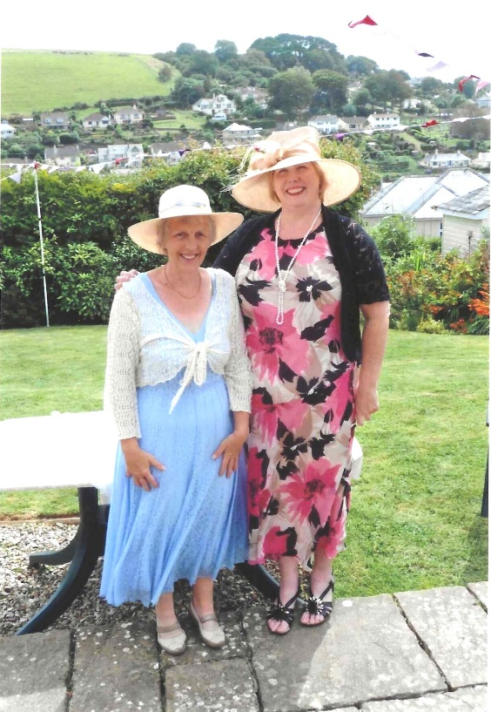

Carrie Dixon & Annette Court-Hampton

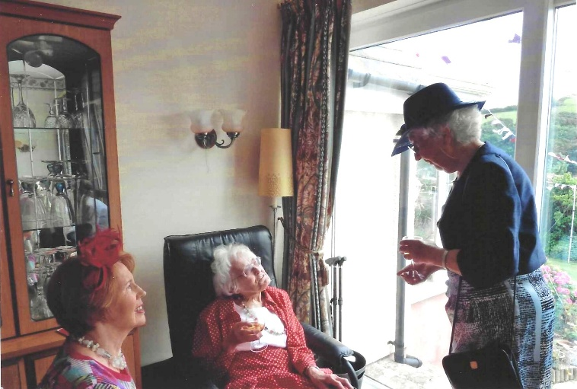

Emma Parker (floral dress)
Joan Miller (standing)

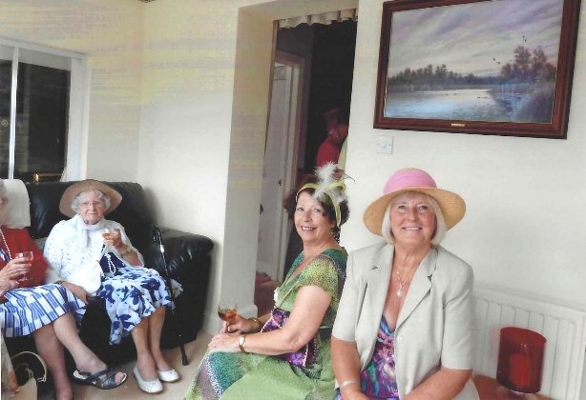

Emma Gulliford (Visitor, white cardigan)
Pam Carter (Green Dress)
Jenny Glover (pink hat)
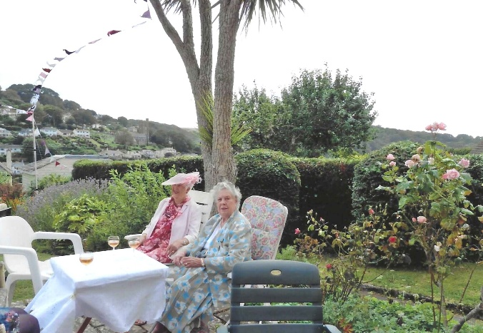

Jill Johnson (pink hat)

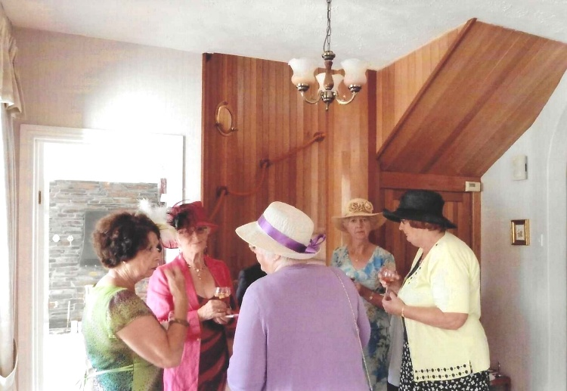

Pam Carter (green dress)
Joyce Stickley (Pink)
Rosemary Furzeland (Lavender)
Jill Alexander ( Pale Blue)
Jean Ellis (cream)

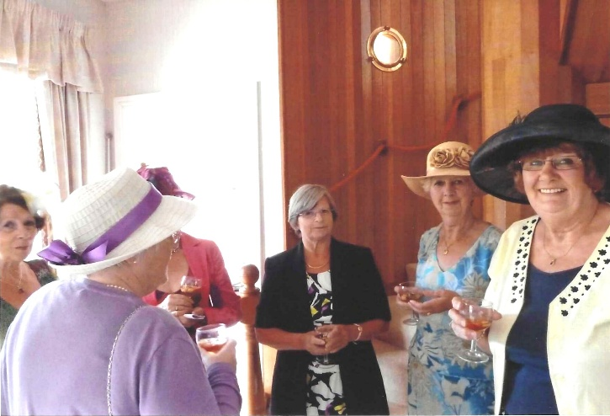
Rosemary Furzeland (Lavender)
Liz James (black & White)
Jill Alexander ( Pale Blue)
Jean Ellis (cream)

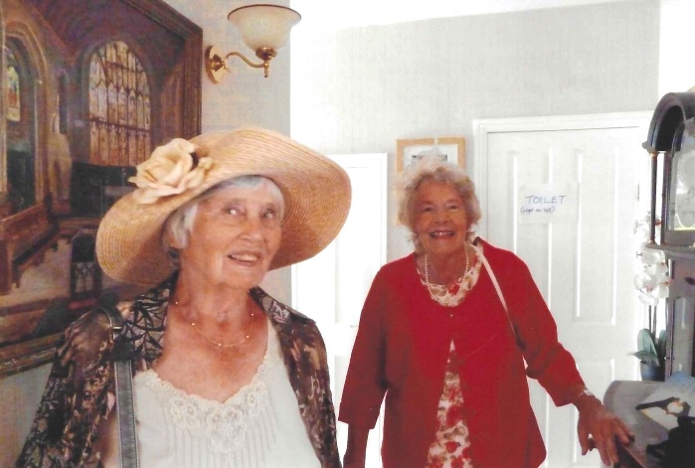

Brenda Scott (hat)
Tessa Fenner (red)

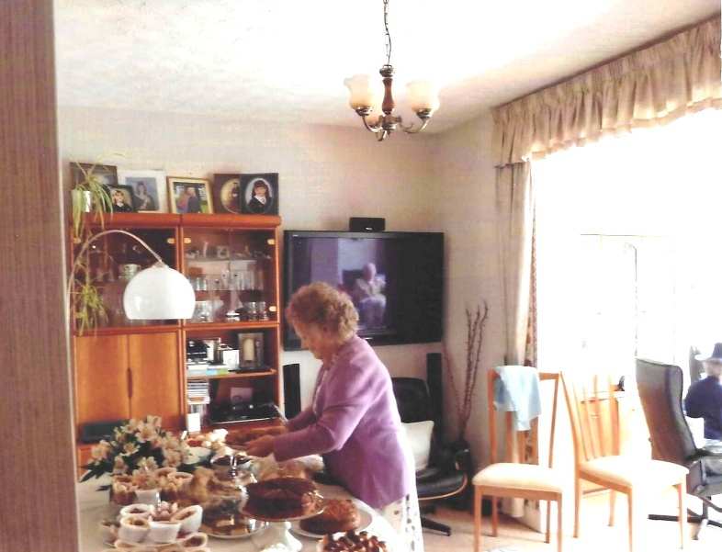

Joan Westall

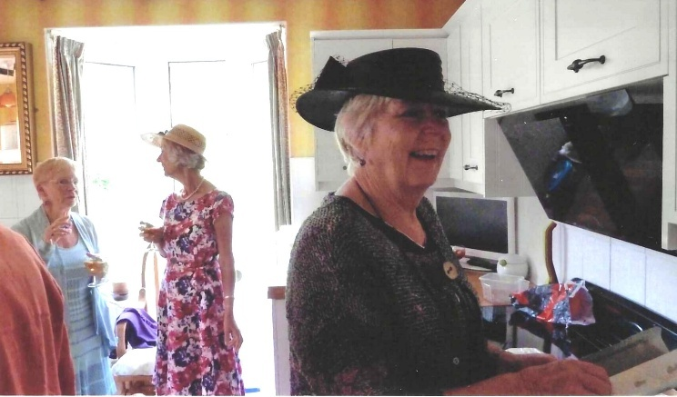

Angela Macpherson (Left)
Margaret Pritchard (centre)
Kate Lawley (black Hat)

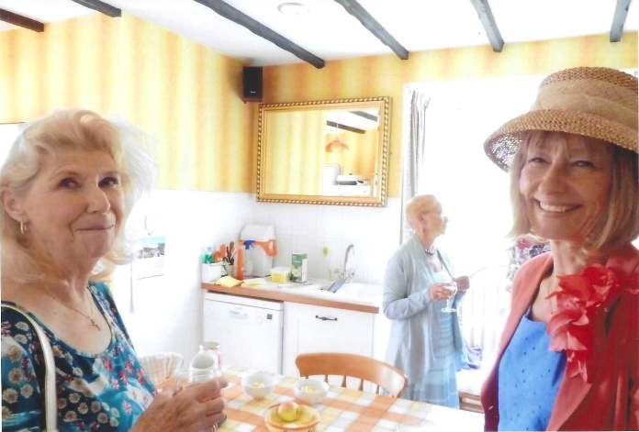
Elery Chetwynd (left)
Pat Middleton (right)
Angela Macpherson (Background)

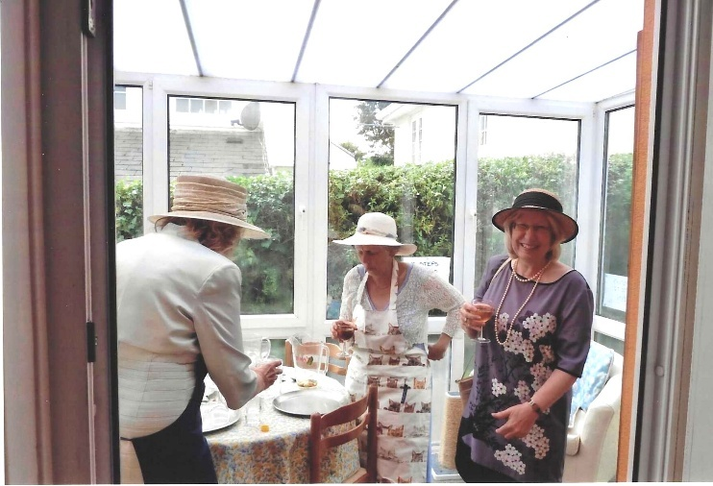

Vicki Wiseman (left\)
Annette Court-Hampton (Apron)
Lynne Tullett (right)

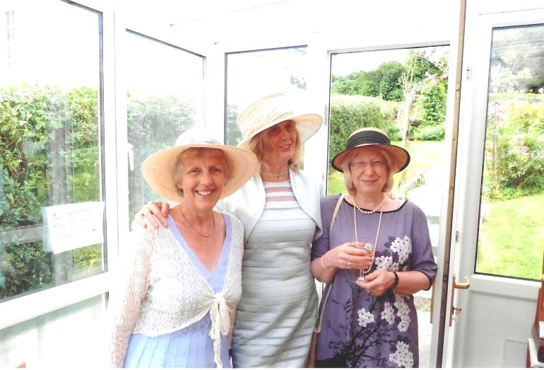

Left to right
Annette Court-Hampton
Viki Ingram
Lynne Tullett



Carol Williams (standing)
Pat Ury



Lynne Tullett
Vicki Winton

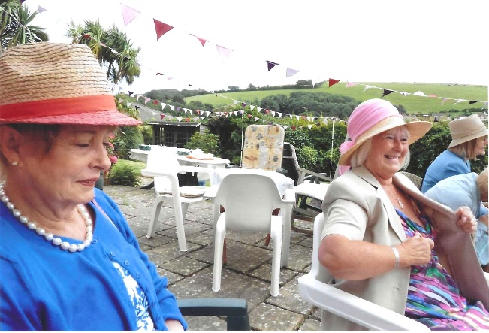

Marcia Webster (left)
Jenny Glover

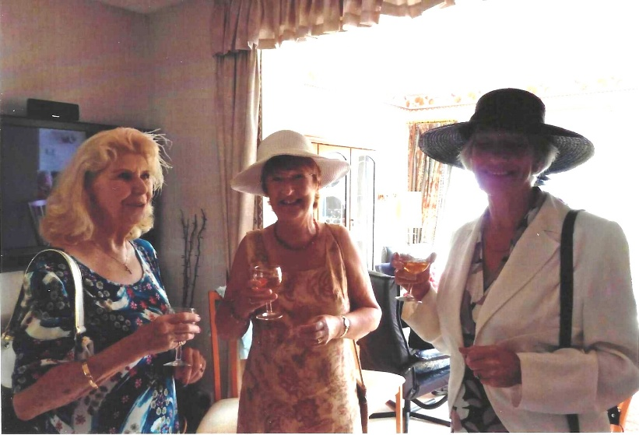

Ellery Chetwynd (L)
Judith Stevenson (C)
Nikki McDougal (R)

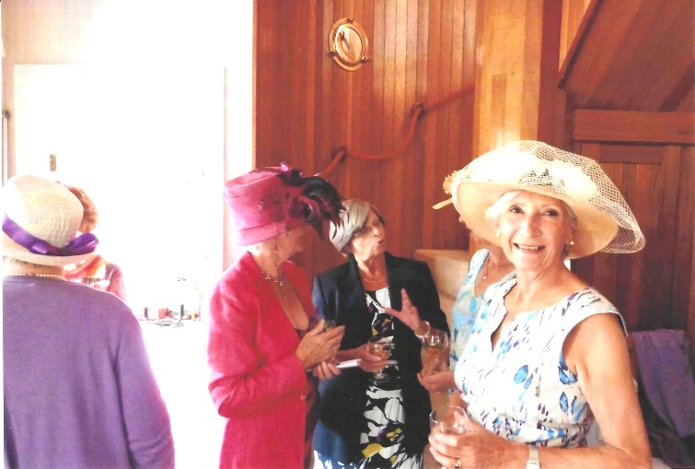

Joyce Stickley (L)
Liz James (C)
Vicky Winton (R)

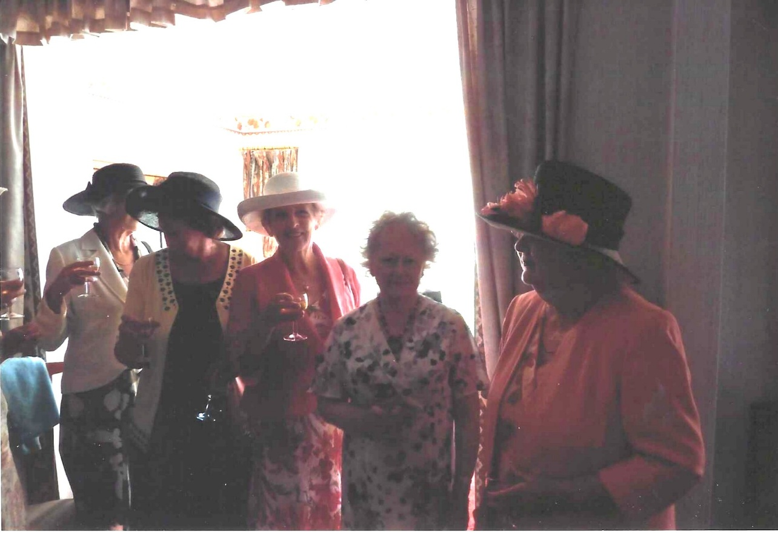
L-R Nikki McDougal; Jean Ellis; Janet Cattanach; Joan Westall & Sylvia Hunt

L-R Lynn Tullett; Elary Chetwynd; Judith Stevenson; Jean Ellis & Janet Cattanach
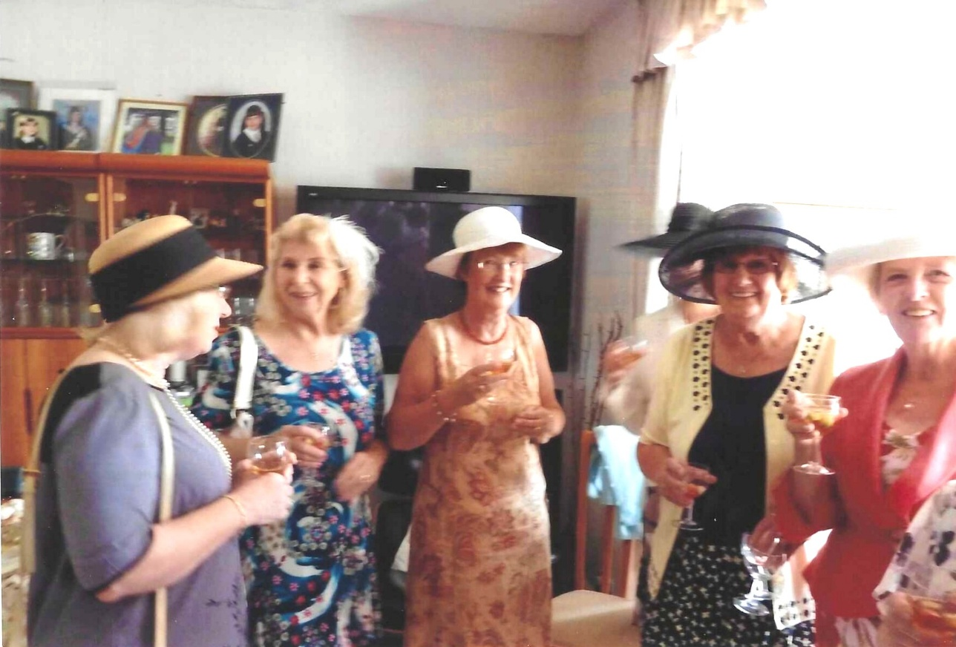

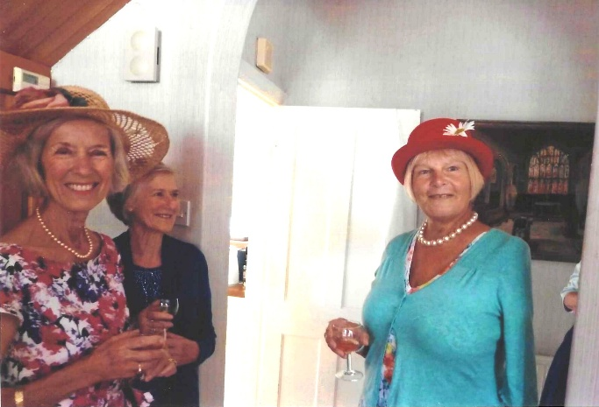

Margaret Pritchard
Yvette Steward
Carol Williams
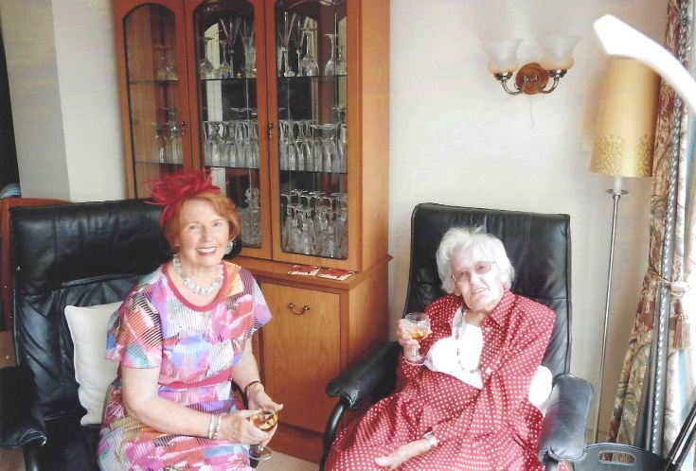

Emma Parker
Mrs Yates

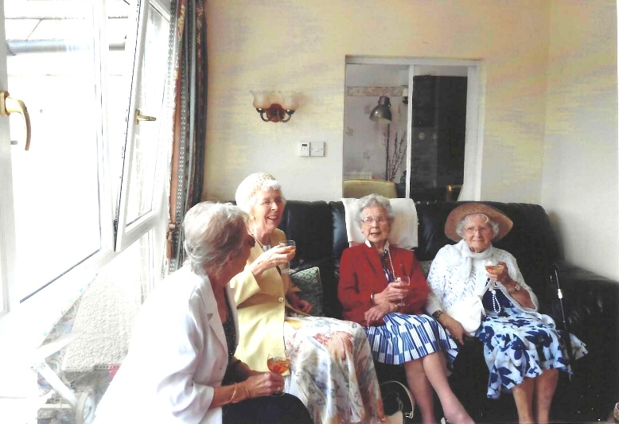

Mary Thomas (red)
Emma Gulliford (Jeans Mother-in-law)

