Devon WI 75th Anniversary
The banner was passed to all Devon WI’s. Newton & Noss WI collected it from Wembury WI by boat
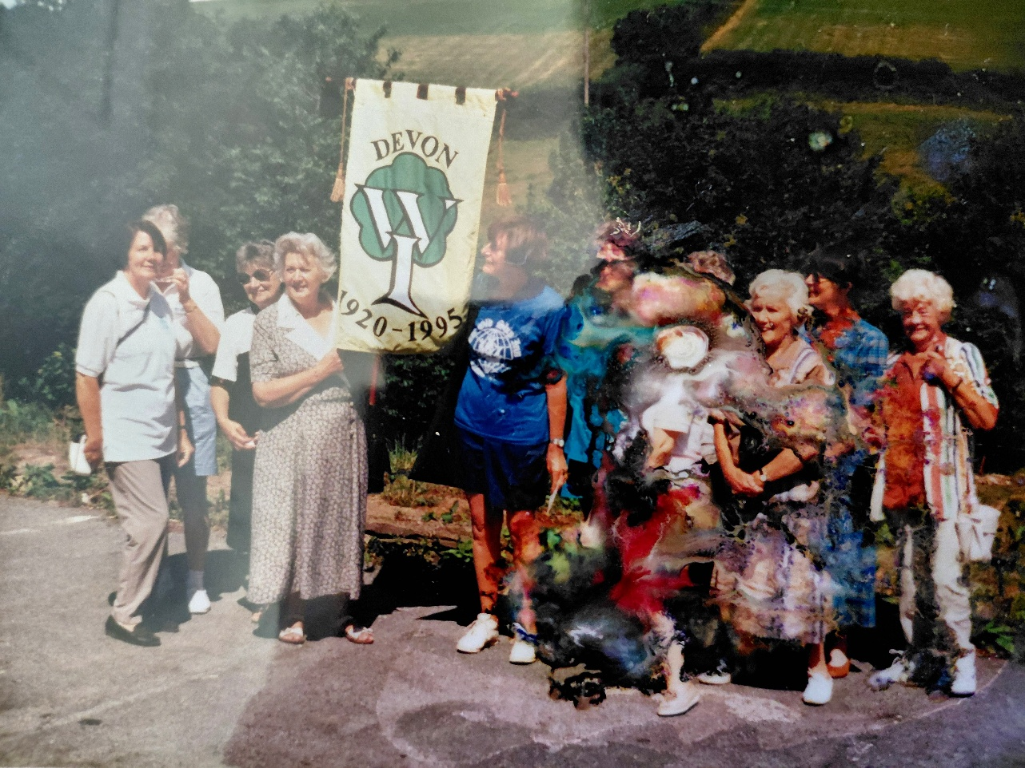

1

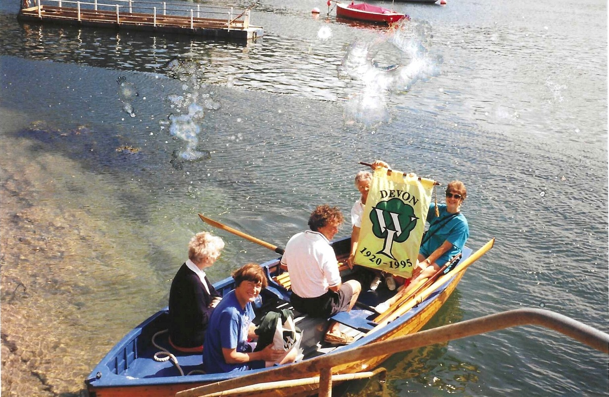

In the boat is Judy Shore (on the left); & Margot Preece (on the right) Holding the banner. In the bow is Kate Wood in blue Tshirt, who has been our President.
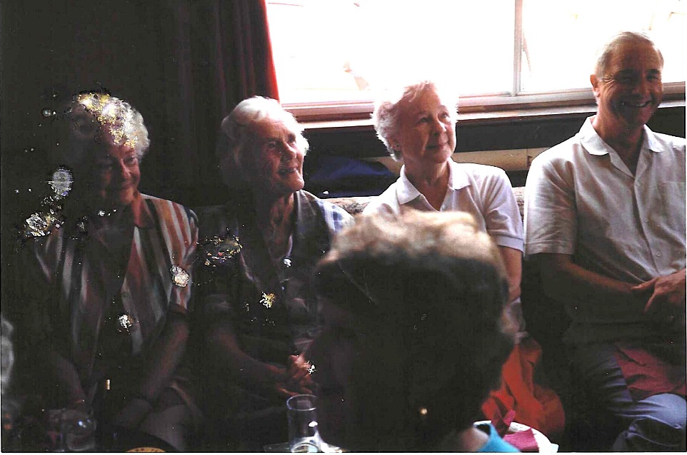

3

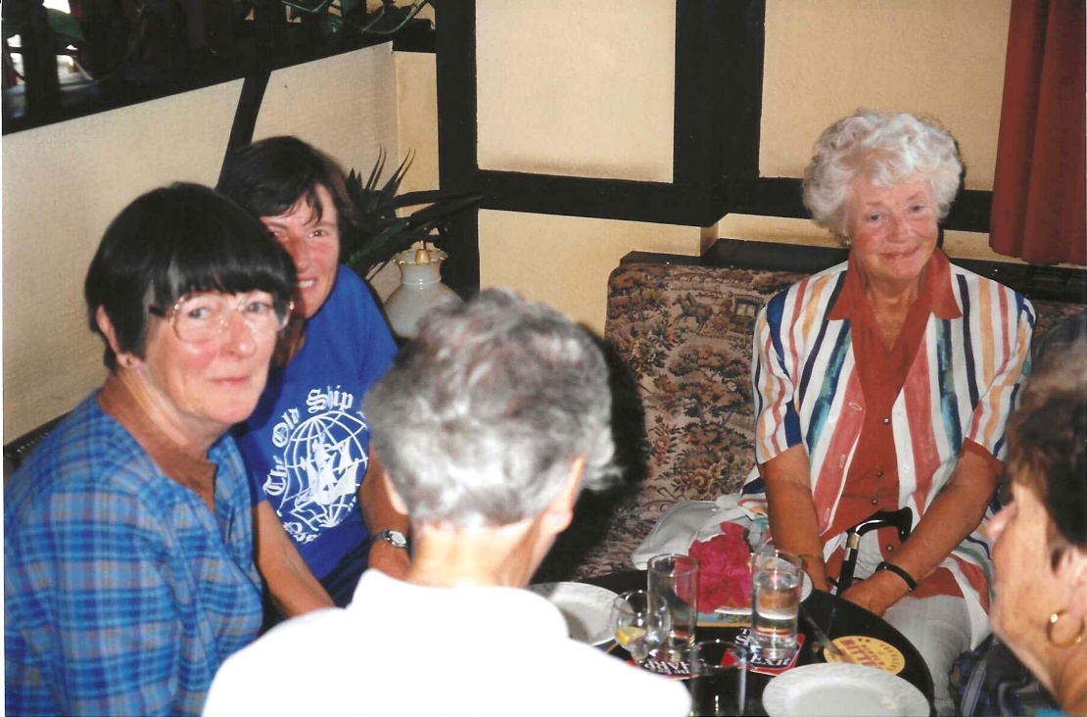

4

