Powderham Castle Garden Festival

Jackie had organised a trip to Powderham Castle Garden Festival on 3rd May 2024.

Up take by members on this trip wasn’t good. 3 of us went; with a 10.00am pick up from the green.
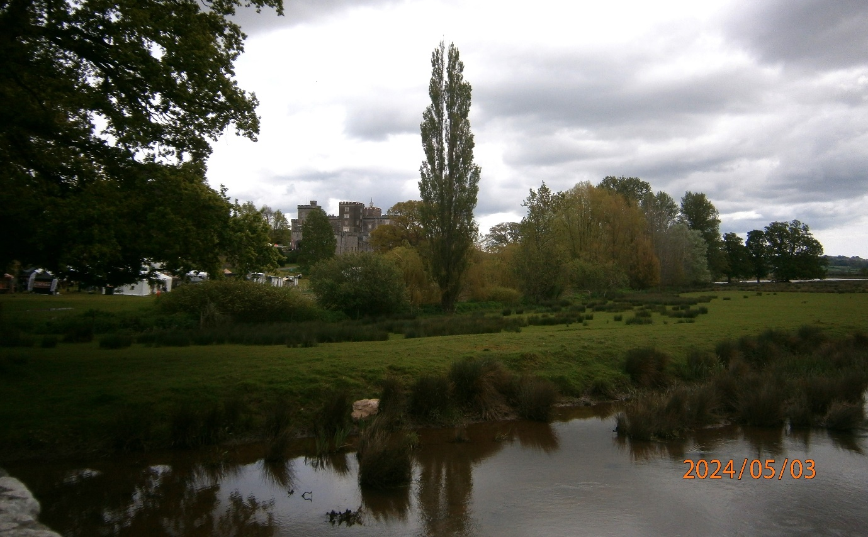
The weather was brilliant, blue skies in the main, with a brisk breeze.

The journey up was straightforward, and we arrived just gone 11.00am.

Powderham is a grade 1 fortified manor house, and is on the banks of the River Exe, a short hop from the city of Exeter. Starting with a structure built sometime after 1390, the present castle was expanded and altered extensively in the 18th and 19th centuries. The castle remains the seat of the Courtenay family, Earls of Devon.

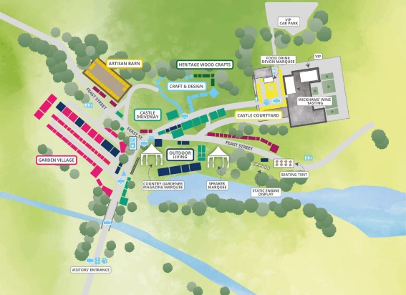
Its gardens and parklands are grade 2 listed. It is situated on flat, formerly marshy ground on the west bank of the river Exe estuary where it is joined by its tributary the river Kenn.
Once we had parked under the beautiful branches of a large copper beech, we walked down to the show ground, getting our first glimpse of the Castle.

Even though Jackie had agreed a price of £10 each for a party of eight, we were still allowed through at that price, and given a map of the exhibitors and more importantly, the toilets!
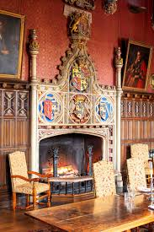
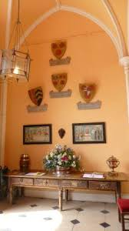
Crossing a humped back bridge, we were greeted by a line of vintage cars. They made me feel old as I had owned one of them!

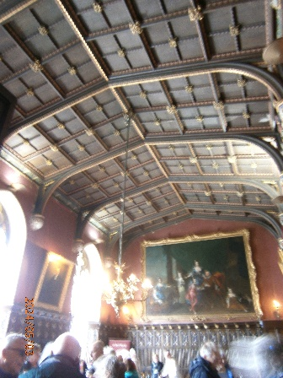
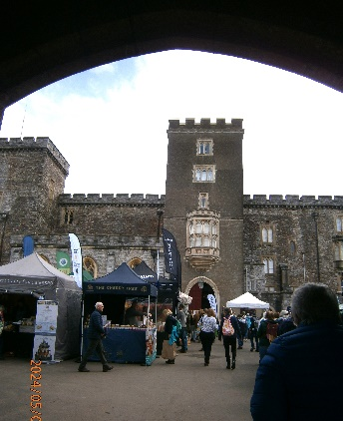
We decided to make our way straight toward the castle. Starting at the top and working our way down. There was a VIP area in the castle for meals drinks and wine tasting, which we unwittingly gate crashed. It did mean we had a glimpse inside the castle! The entrance hall displayed the family crests, and the next room in, where the wine tasting was, had a beautiful fireplace. This room in turn, lead into a room with bookcases, with the VIP dining at the far end; all set with white tablecloths, very shiny cutlery, and smartly dressed waiting staff. – Very different to the coffee stall with its plastic chairs and table we found outside in the courtyard. The coffee was good though, and the rest very welcome.

The courtyard contained mainly food and drink stalls, like the South Devon Chilli Farm, a honeybee stall where they were selling honey and beeswax products, and local wine and spirits stalls.
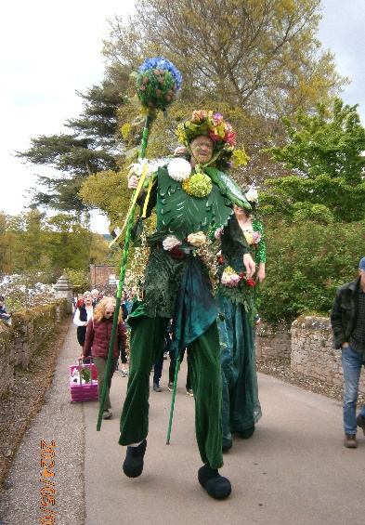
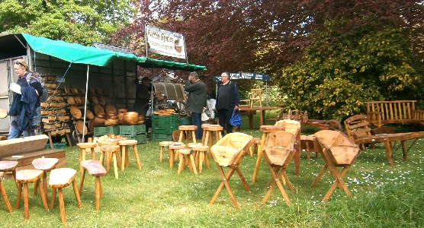
The crafts area consisted mainly of bead jewellery, willow art, silk clothing from India and wood turning.

There was even a couple on stilts dressed as spring.

We lunched further down at the aptly named “feast street”. I went for Thai food, while Jackie and Yvette made a beeline for the hog roast with stuffing apple sauce and red cabbage coleslaw in a brioche bun. It was all very tasty.

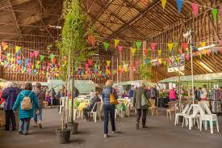
The Artisan Barn was full of glass work, handmade jewellery, hand spun wool, air plants, handmade candles, mosaics and wood carvings. We decided it was expensive for example one stall was selling purses made from cork, they were £6. On a recent trip to Portugal, I found them for 1 Euro which was about 80pence!

The average price for cushions and blankets was £40. Jackie fancied a feather duster, but at £40 left it on the shelf!

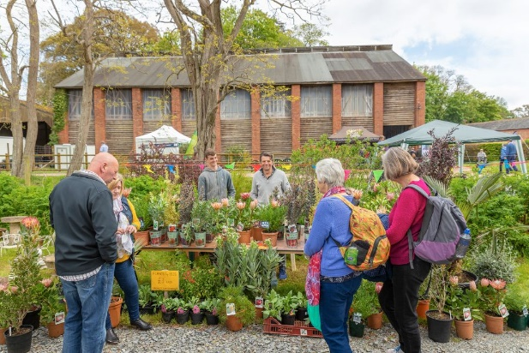
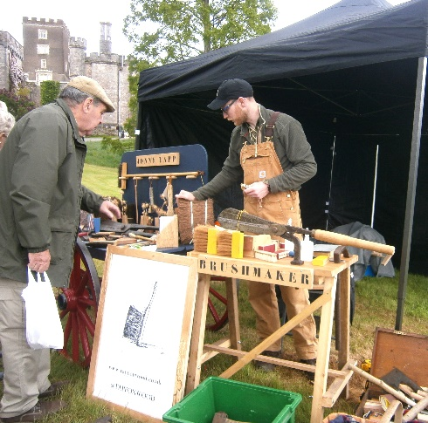
The heritage Wood craft area had a traditional brush maker by the name of ‘Tap on wood’. Jackie had relatives in the area with the surname ‘Tapp’. There was also basket making and dolly pegs in progress.

The garden village was full of garden tools and gadgets as well as plants which were flying off the shelves. I managed to buy the last French Tarragon plant for my herb garden.

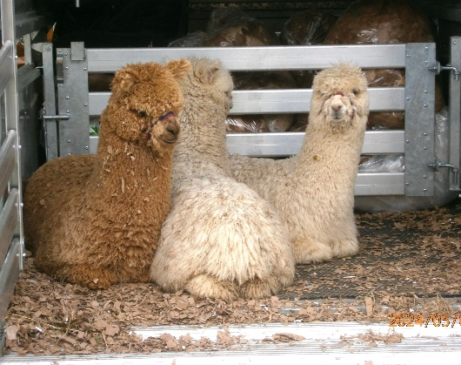
We started to make our way back towards the car, saying a last goodbye to the Alpaca’s which were not quite a year old.

We did a slight detour to the farm shop, and a very interesting shop called Chandni Chowk, which sold Indian clothing, throws, cushions and beautiful rugs. I think if you had to ask the price you couldn’t afford them!

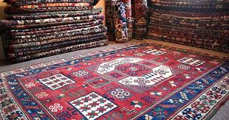

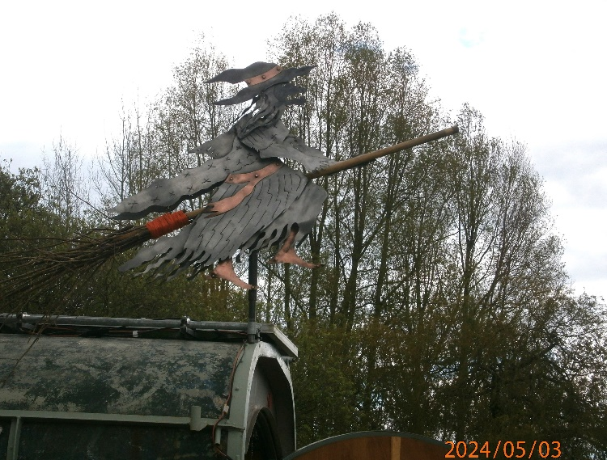
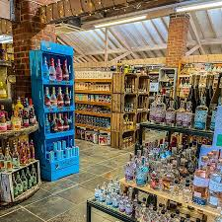
Making our way back to the car under our landmark beech tree, it was a relief to sit down!

The car is there somewhere.
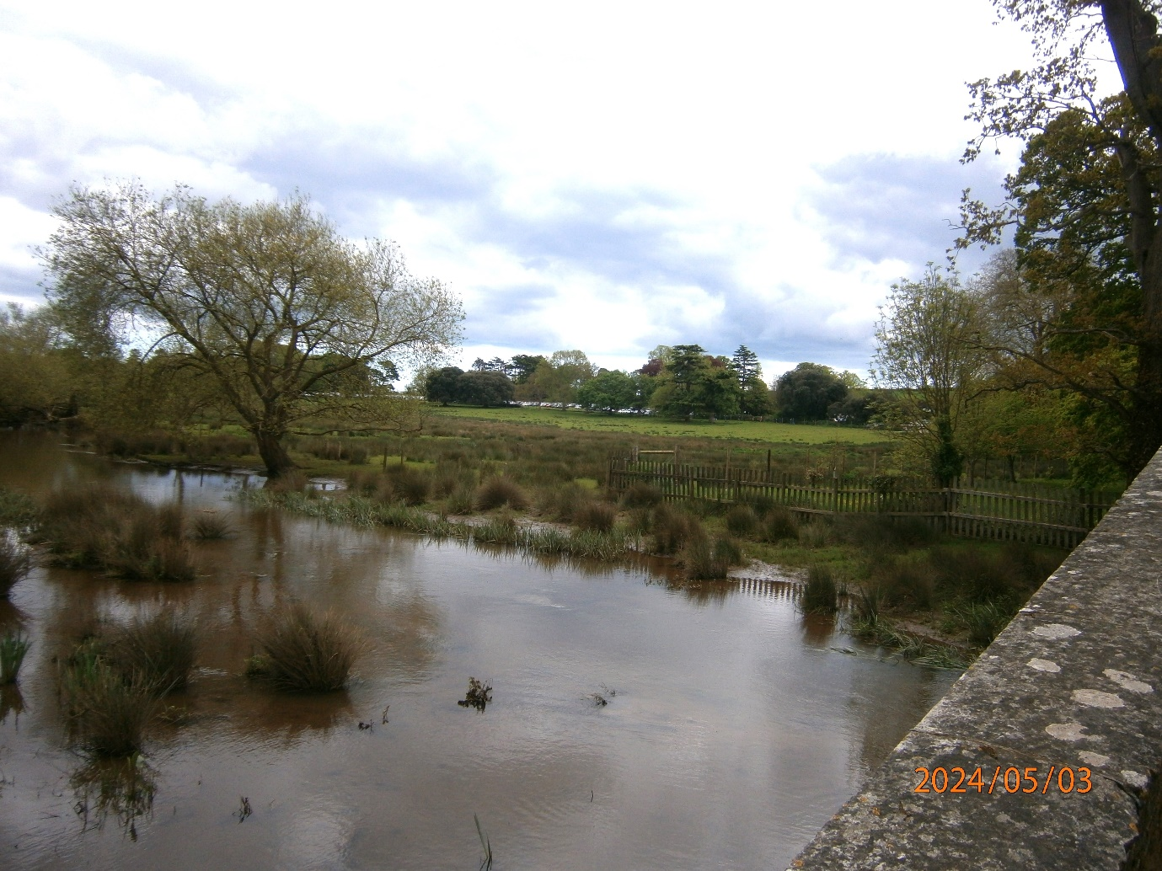
We followed a very pot holed dirt lane back to the road and had a smooth journey back until we got to Haldon Hill where a car towing a caravan had broken down.
Once past them, we made good time, and were back in the village by 3.30pm.

