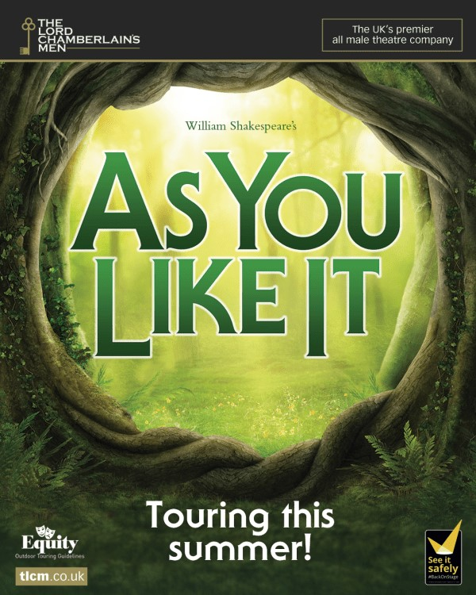

July 2022
The Lord Chamberlains Men – one of the UK’s finest touring companies presented this play as Shakespear first saw it performed – in the open air, by an all male cast, with Elizabethan costumes, music and dance.
Separately, Rosalind and her dear friend Celia, the noble Orlando, & the usurped Duke Senior & his courtiers get banished & set up their new lives in the Forest of Arden. Free from the constraints of their former lives, lovers tussle, wits & fools spar, familial bonds are challenged, and everyone wrestles with what it really means to be yourself.
In exile they become exultant as a true love and true identity is found in the forest. This rustic romp is packed with music, laughs, cross-dressing confusion and a dash of wrestling

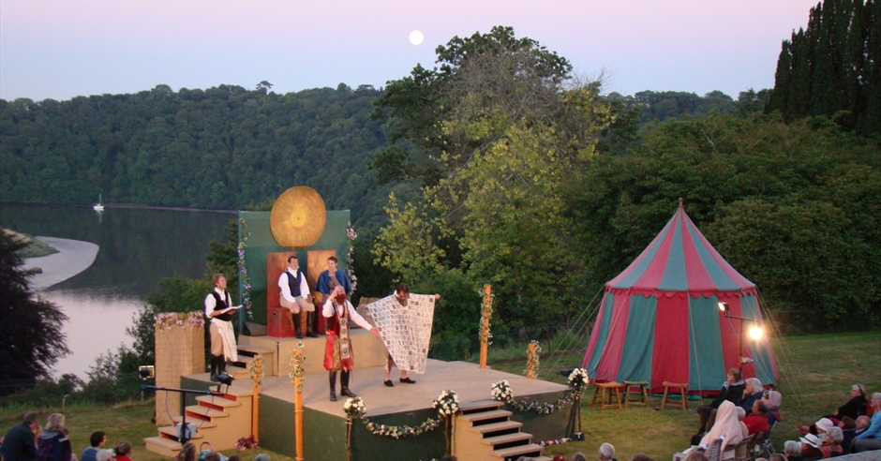

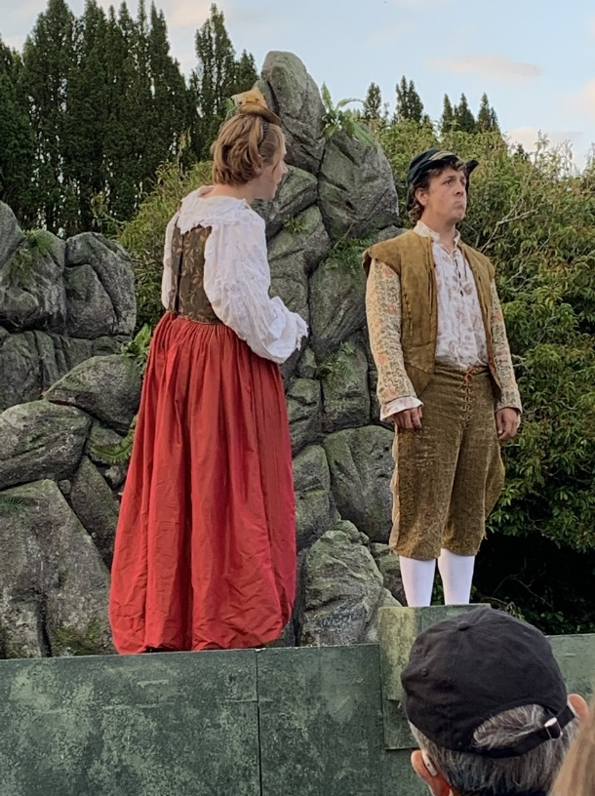
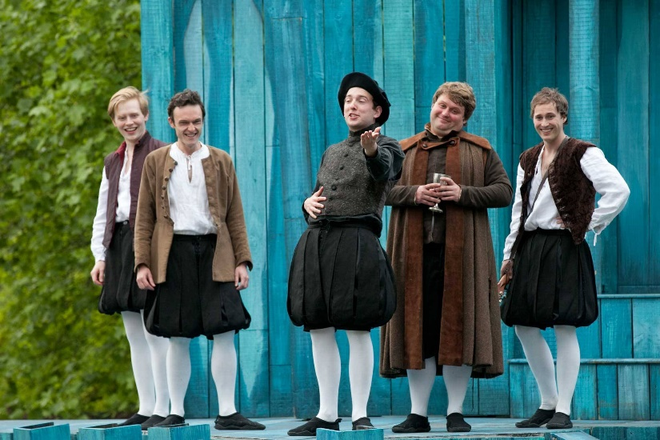

The fool doth think he is wise, but the wise man knows himself to be a fool
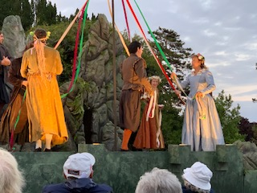

Love is merely a madness!

