A Million Dreams April 2026
On the 18th April 3 of us, Margaret Pritchard, Joyce Sticley & myself went to a performance of “A Million Dreams”.
One of our fellow members, Jean Ellis, was taking part along with her husband Mel.
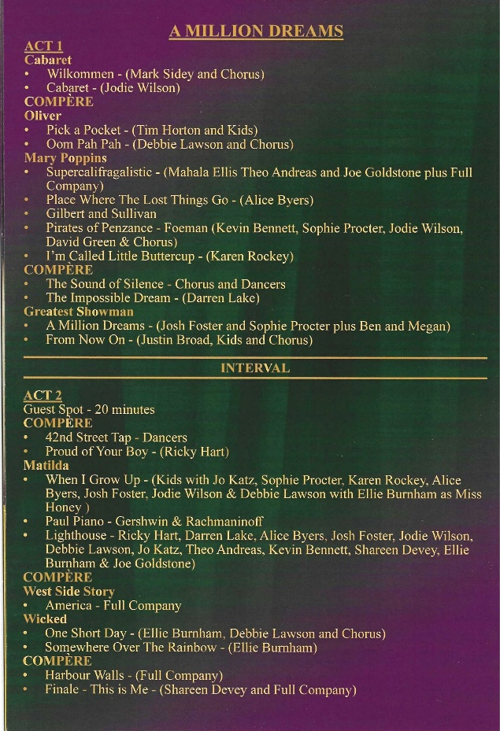
The production was raising funds for Children’s Hospice South West. CHSW aim to make the most of short and precious lives, by offering a sanctuary where families can find respite, expert palliative care, and end-of-life support in a home from home environment.
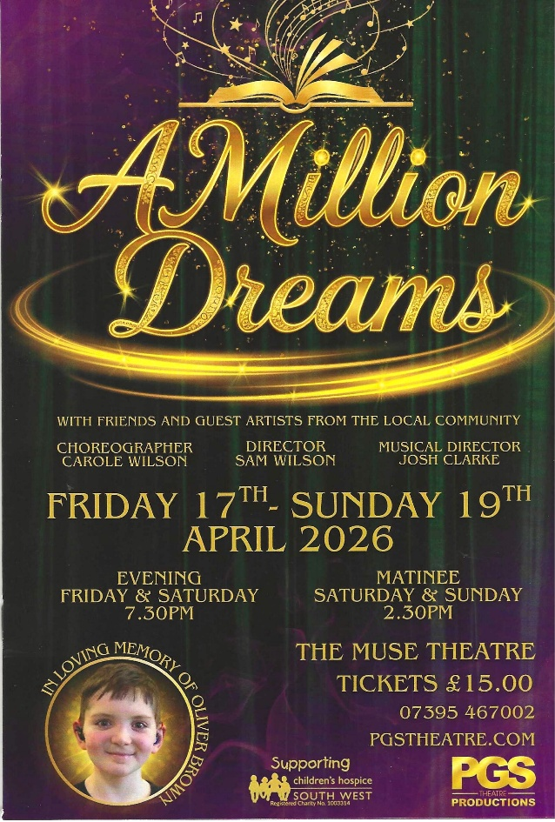
It was a showcase of talent from Plymouth Musical Activities Club; APC dance studios; Starlite dance studios and Plymouth Gilbert & Sullivan Theatre group; celebrating the life of Oliver Brown, who would have been 18 this year. Oliver was diagnosed with blood cancer aged 9 and passed away aged 12.
The production was compered by his younger brother Benjamin, and was poignant and happy in equal measure. Featuring songs and music loved by Oliver and his family.
We all enjoyed it enormously.
Written by Lesley Dempsey

