Pentillie 2024
Hamlet
It was rather a damp day with horizontal mist which turned to horizontal drizzle by the time we set off for Pentillie Castle.
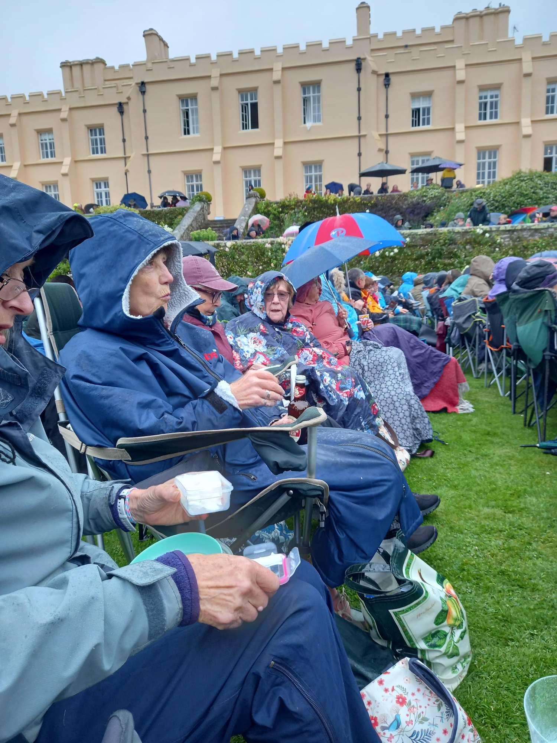
We had a very uneventful drive and by 17.30 were bowling along the impressive driveway to park on the front lawn.
When the performance started at 19.00 we were quite damp, having eaten limp sandwiches, soggy crisps and drunk rain cooled coffee and diluted wine.
Unfortunately, because we had all arrived at different times, we weren’t sitting together. So before the Performance started we were playing spot the WI member.
There were quite a few people from our villages that we knew too.

In this photo taken by Lesley is Pat Middleton, Cathy Matthews, Shirley Pegg, Gill Tune & Jackie Ross

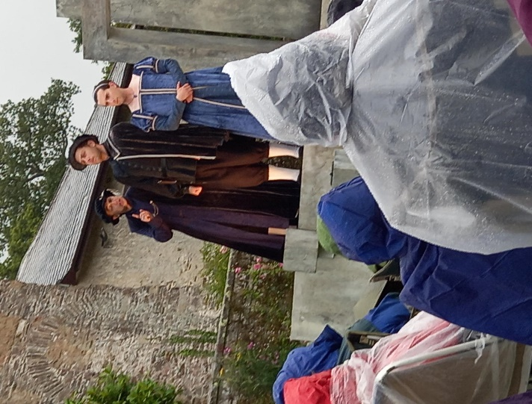

Hamlet
Hamlet saw a ghost, whose tale
Of lust and murder turned him pale
Ghost dissolved when dawn grew dewy...
[Question is - was Hamlet screwy?]

The fair Ophelia
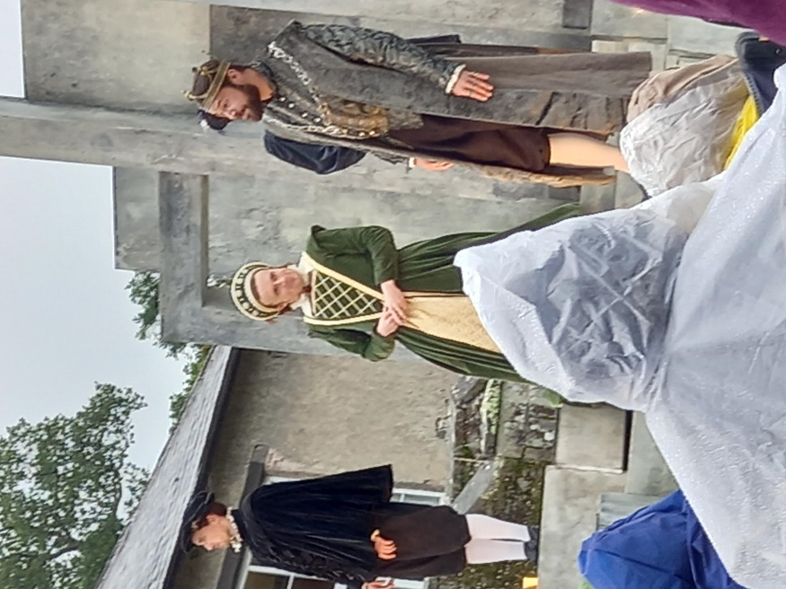
Hamlet loved Ophelia, who Turned him down when told to do
Shambles he who once was natty
[Question is - was Hamlet batty?]

Hamlet staged his father's end
Guilty uncle ,s consort penned
Blamed for choosing sex, not suttee
[Question is - was Hamlet nutty?]

Hamlet killed his lady's pa
Sent to England, gone too far,
Copy book was getting potty
[Question is was - is Hamlet potty?]

Hamlet, back in Denmark, found
Poor Ophelia madly drowned
Wished he too pushed up the daisy
[Question is - was Hamlet crazy?]

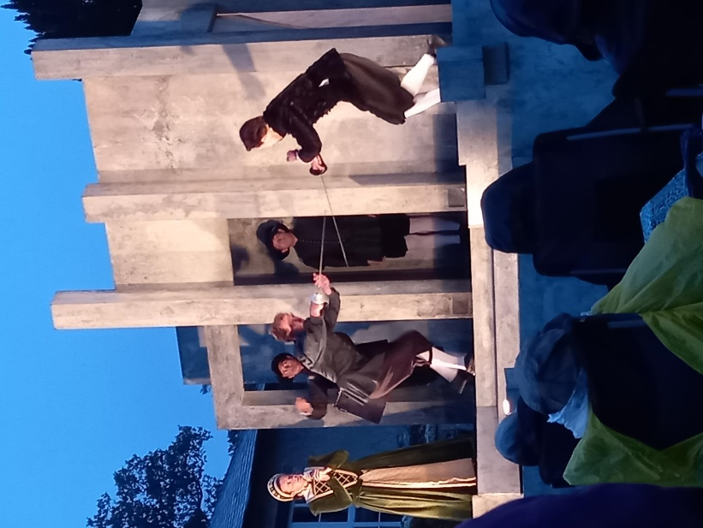
Hamlet fenced with furious brother
Fatally they struck each other
Ma drank poison, went all droopy
[Question is - was is Hamlet loopy?]

Hamlet with envenomed sword
Finally slew his Uncle Claude,
Then gave up the ghost and cried
Now I can't be certified

Mary Holtby

Needless to say, exit from Pentillie was swift, with the organisers lining our route thanking us for attending. We were all glad to be home for a hot shower and warming drink.

