2010 Visit to Operation Sunshine at Tavistock in May
Lunch at Bedford Hotel

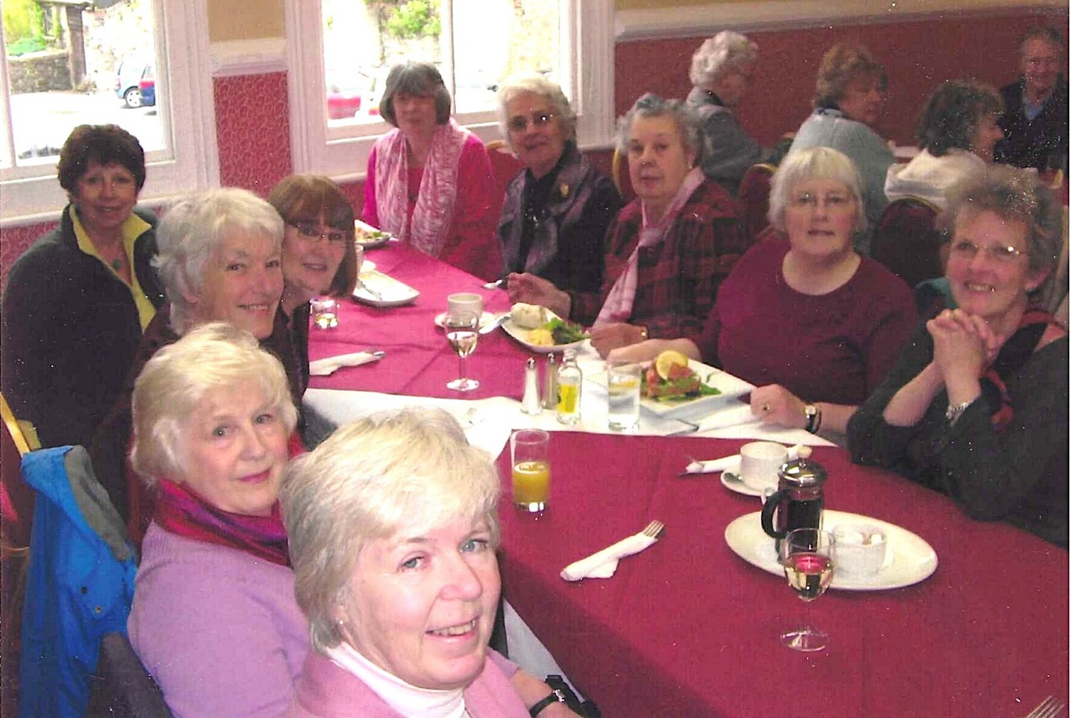
Left side front to Back:- ? Sylvia Hunt; Nikki McDougal; Jean Ellis; Pam Carter
Right side front to back:- Janet Cattanach; Rosemary Furzeland; ?;?;?

