EASTER FAIR April 2023
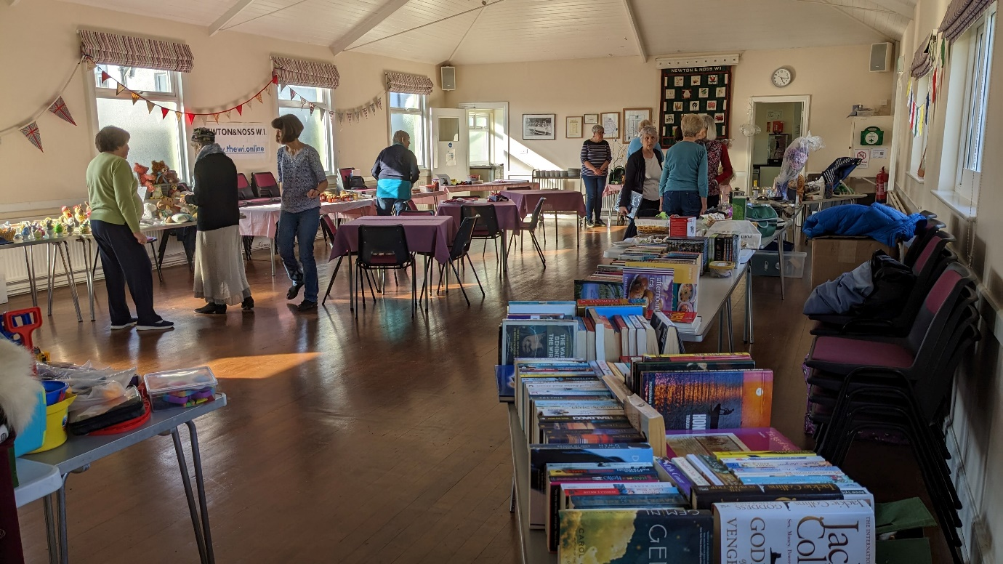
At 4 o’clock on Good Friday afternoon the WIC Hall floor looked as though several skips had been emptied onto it……there were disorganised piles of books, toys and miscellaneous household goods of all shapes and sizes. Then the WI members turned up and by 6 o’clock the designated tables were laden with the right goods, the refreshment trolley was loaded with mugs and napkins and the bunting and other Easter decorations were in place. There was a bit of a debate over where and how to put up the WI banner but that was soon resolved with a bit of ingenuity and a lot of bluetac.
In the morning the rest of the cakes and home-made preserves arrived. Obviously the WI’s reputation is widespread as these all went in the first hour and we were reduced to bagging up some of the home made Easter biscuits and macaroons from the refreshment trolley to keep sales going.
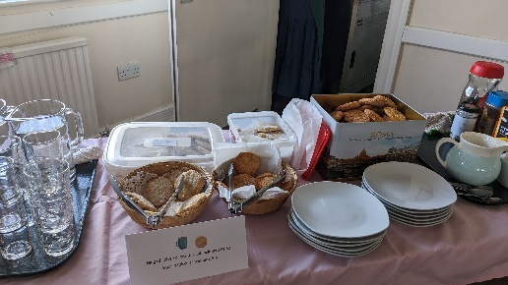
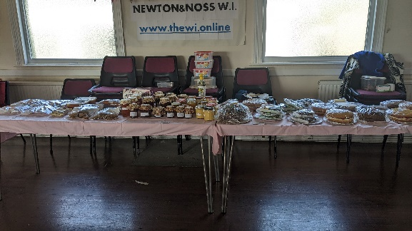
The Fair went really well; we watched parents carrying out the booty their children had spent their pocket money on, were pleased to see shopping bags filling up and sympathised with the raffle ticket sellers who had hundreds of tickets to divide up for the draw. The atmosphere was joyful and here and there we could catch a glimpse of another flowery Easter hat.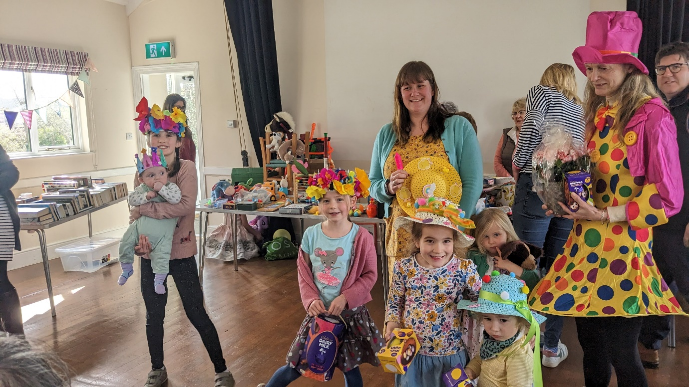
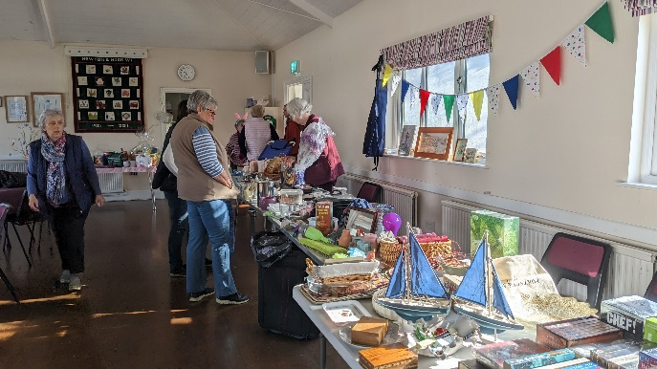
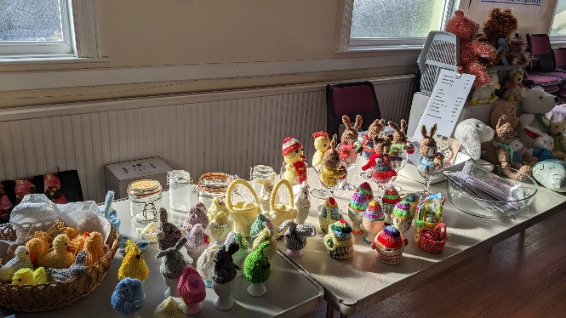
Thank you to everyone in Team WI for her contribution to helping to raise over £1,000 for our funds.
